Polish Aid Grant

Final Report - Kopernik

- Organization & Program Information

Project name | Local Food Utilisation: A Stunting Prevention Initiative
Project number | n/a
Name of the institution | Yayasan Kopernik
Name of the partner institution/contractor | Lembaga Timor Moringa Indonesia
Project implementation period | July - December 2022

- Description of the project implementation

Information on the achieved goal of the project
Timor Tengah Selatan (TTS) or South Central Timor in East Nusa Tenggara province is one of the regions in Indonesia with the highest stunting prevalence of children under two years old, with 35% of children reported as stunted (TP2AK, 2018). Even though numerous stunting-prevention programs have been implemented in this region over the years, stunting prevalence in the region remains high.
With the support from Polish Aid, in 2021 Kopernik conducted unmet needs research and designed stunting prevention interventions based on the research results. The main objectives of the interventions were to improve the nutritional intake of households with pregnant women and mothers with children under the age of 2 and reduce stunting prevalence. The interventions were implemented in Kuatae village, along with an impact evaluation process to assess interventions’ effectiveness. The initial results of these interventions are showing promise in addressing the identified unmet needs and contributing to prevent stunting incidence.
These promising solutions for the prevention and reduction of stunting were then replicated in this year’s project to further determine their effectiveness. Based on our desk research and consultation with the local stakeholders, we chose Kesetnana village, one of villages with highest stunting prevalence (57%) in South Central Timor, as the main project location and treatment group. We compared several results of the interventions that were implemented in Kesetnana village (treatment group) and to the control group in Oinlasi village (control group).
Below are the key achievements of the interventions we implemented this year, as reflected by the impact evaluation and experiment results:

Improvement in stunting prevention knowledge
First intervention that we implemented was knowledge building on stunting prevention. The intervention consists of a series of training and counselling sessions about stunting and its prevention practices. We also distributed the 1,000 days height charts and flip charts as simple and user-friendly tools to monitor children’s height at home and ensure their healthy growth.
Participants’ knowledge of stunting was measured by assessing participants’ ability to explain the definition of stunting, its impact on child growth and development, and preventive measures that can be taken. We collected the stunting knowledge data in the treatment group before and after the intervention, as well as in the control group within the similar time period.
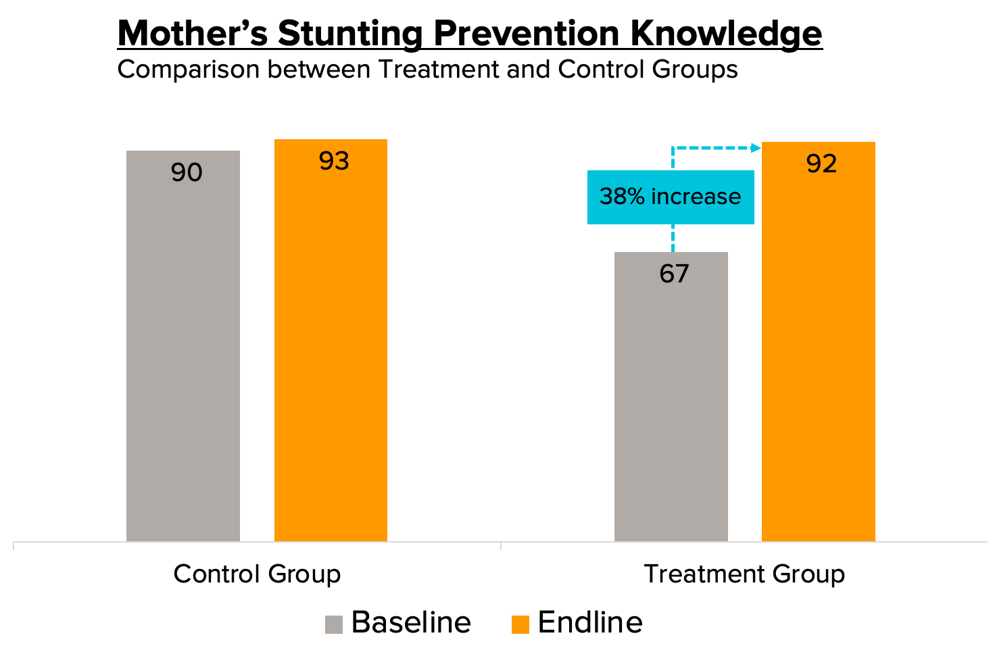
  - Result: At the baseline, the average score of stunting prevention knowledge in the treatment group was lower than the control group. After the intervention was implemented, the treatment group’s average score increased by 38% to an almost similar number with the control group. Similar increase was not found in the control group, as there was only 3% increase in the control group average score.
This result indicates that the intervention was effective in increasing participants’ knowledge on stunting prevention.

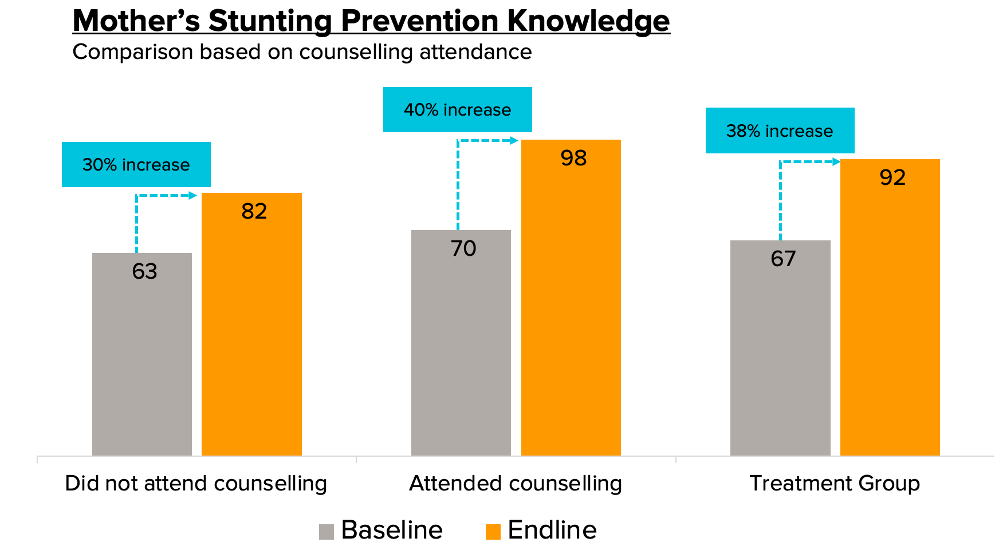
  - Result: In addition to treatment-control group comparison, we also compared the average score based on counselling attendance. Counselling sessions were included in this intervention to provide a safe space for participants to discuss issues and share experience and challenges related to parenting, self-development, and health they face in their households in the smaller groups.
The result shows that the knowledge improvement was higher in the group of participants who attended at least one counselling session (40%), compared to those who did not attend at all (30%).
This result indicates that the counselling sessions were an effective addition to the stunting prevention education, as it facilitated better learning experiences for participants.

Applying lessons gained from the training sessions
To evaluate the effectiveness of the first intervention, we also assessed stunting prevention practices which were applied by the project participants after the intervention.

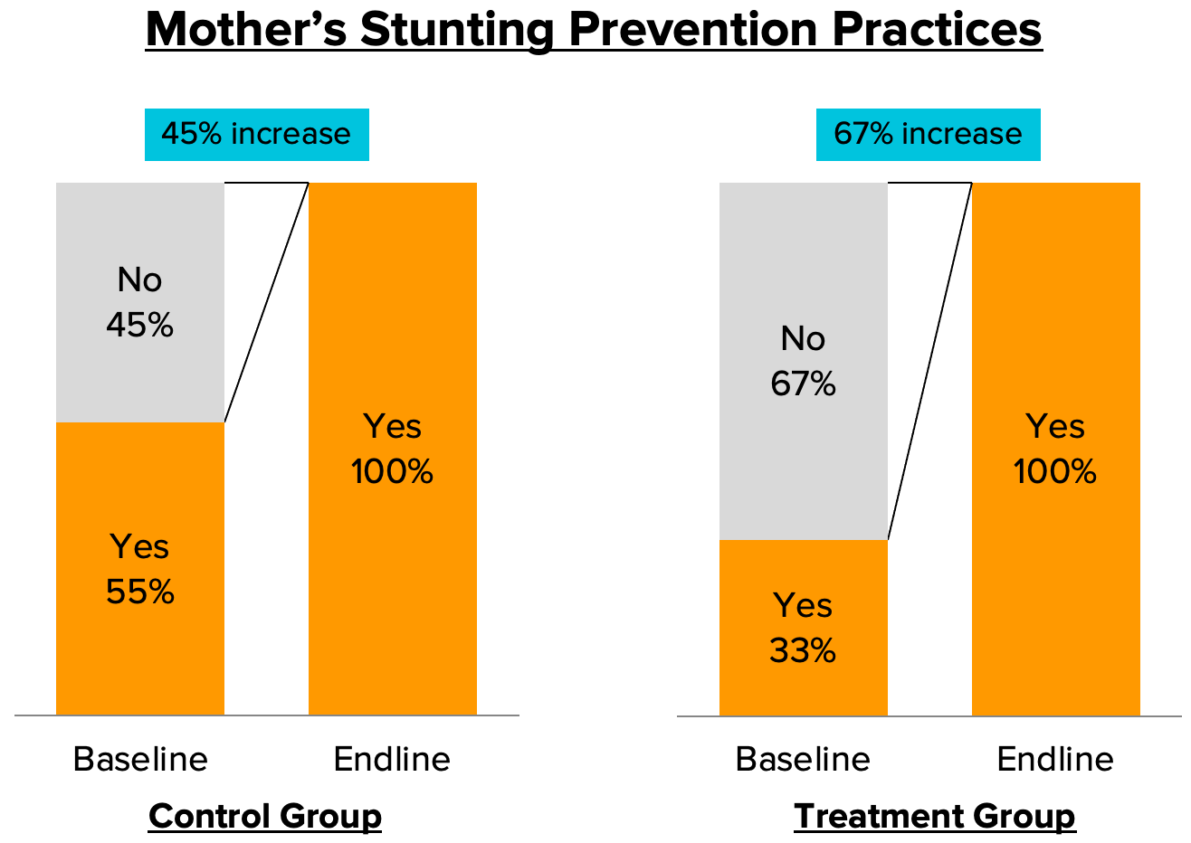
  - Result: The result shows that at the endline, both participants of the intervention and their counterparts in the control group reported that they have implemented at least one of the stunting prevention practices. There was a higher increase in the treatment group (67%) as compared to the control group (45%), which was potentially associated with the lower baseline level at the treatment group.
This result indicates that despite the positive trends reported in the participants’ stunting prevention practices, the improvements could not be attributed only to this intervention.
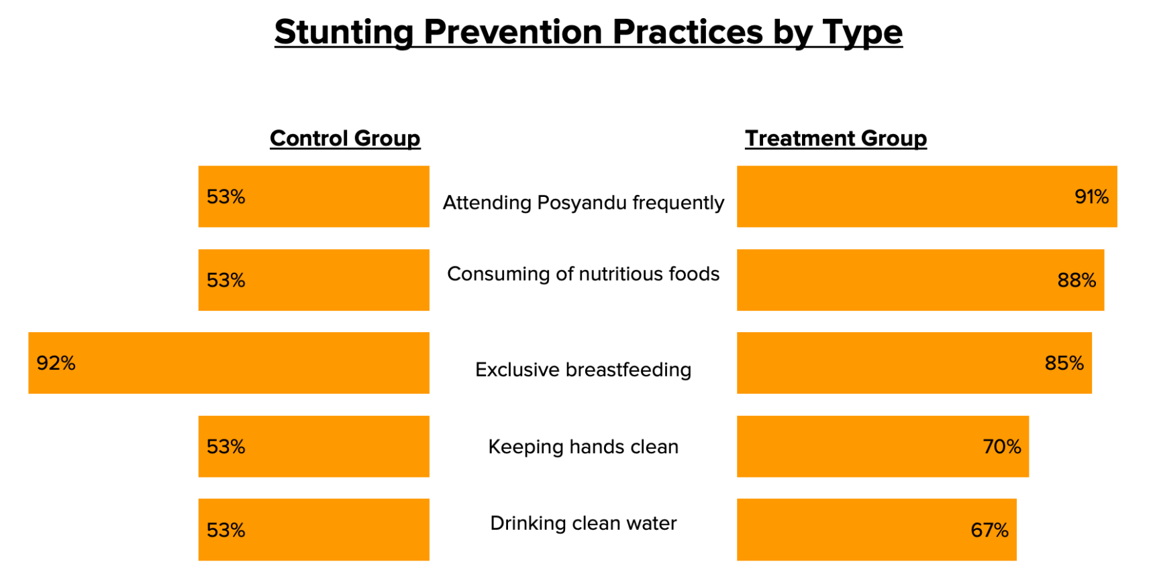
  - Result: As a follow-up from the previous indicator, we also assessed the types of practice implemented to prevent stunting. In the control group, the most frequently reported practice was exclusive breastfeeding. While in the treatment group, the most

frequently reported practices were attending Posyandu1 frequently, consuming nutritious food, and exclusive breastfeeding.
This result indicates that the participants have a more comprehensive understanding of stunting prevention practices compared to the control group.

Improving in knowledge about local food and its utilisation
Second intervention we implemented was nutrition-sensitive agriculture education. The intervention focused on food security and utilisation of locally available nutritious food. Activities include nutrition-sensitive agriculture educational training, local food identification, recipe development, and a cooking competition.
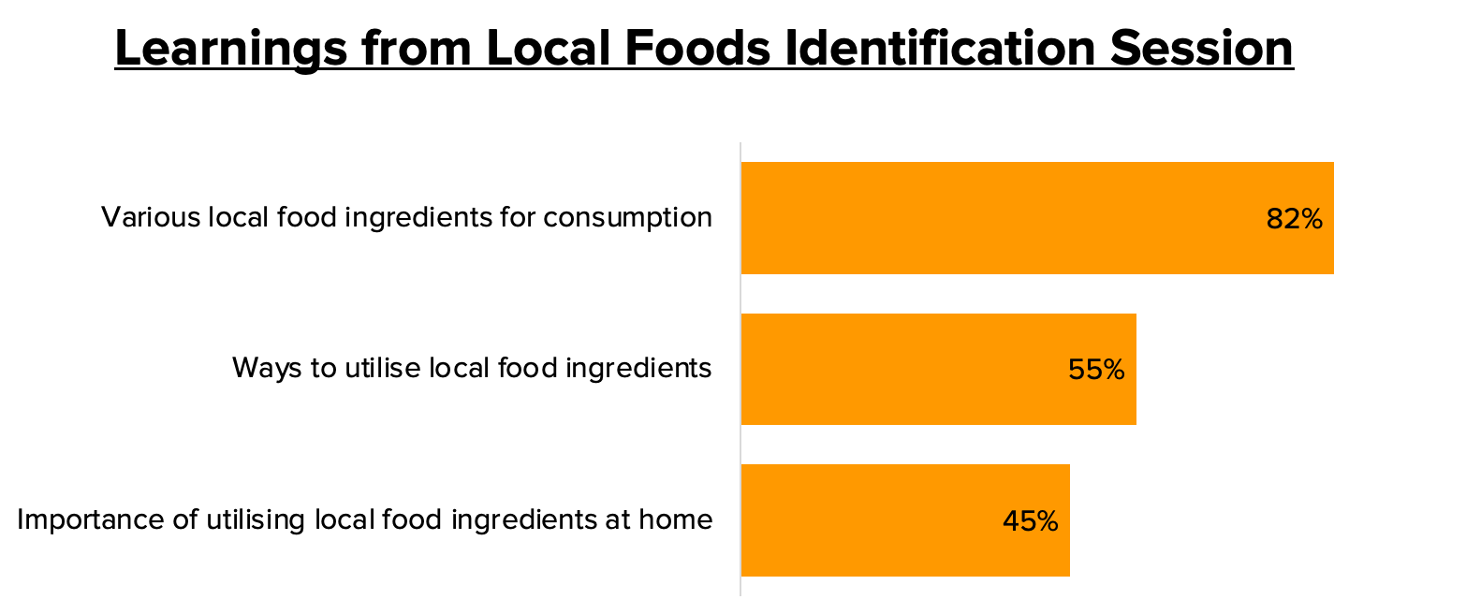
  - Result: After participating in a workshop session to identify and map local food ingredients that are available around the village, the majority of participants reported that they have learned new various local food ingredients that they can consume (82%) and how to utilise and process them (55%). 45% of the participants also learned reasons why it is important to do so.

1Pos Pelayanan Terpadu (Integrated Service Post), community-based health services at grassroots level, which provide services such as children’s health and growth monitoring.

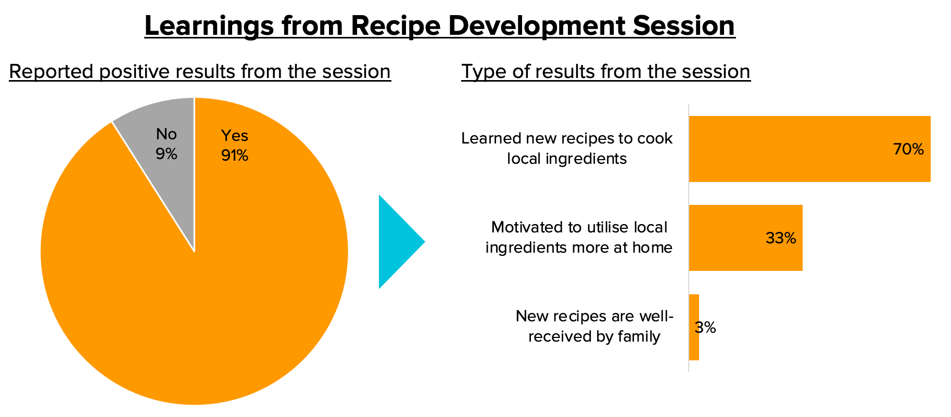

  - Result: After participating in a workshop session to develop innovative recipes utilising local ingredients, 91% of the participants reported that they have gained positive results from the session. 70% of them learned to cook new recipes and 30% have become motivated to utilise more variety of local ingredients at home. A small number of participants (3%) who have tried to cook new recipes at home – even before the cooking competition event – also reported that their family members received the food well.
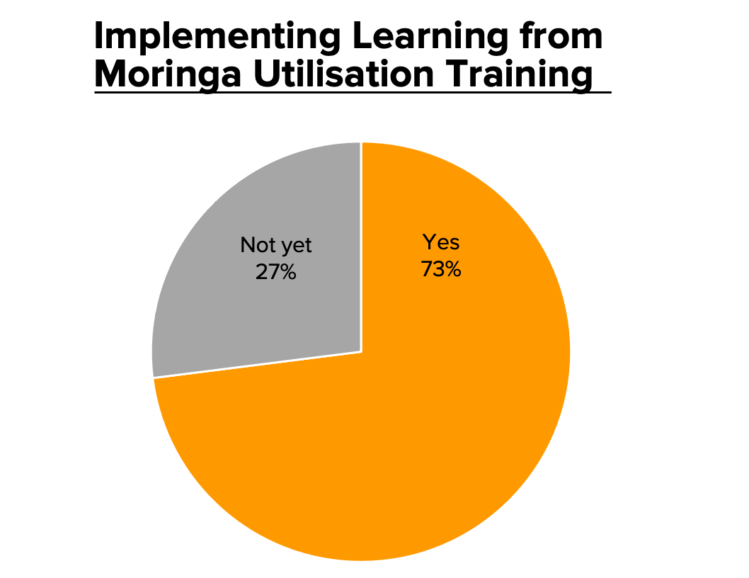
  - Result: After participating in a workshop session in utilising moringa, one of local superfood, into various types of cuisine, 73% of participants reported that they have implemented the workshop lessons. Common types of cuisine they have tried to prepare themselves include: moringa porridge, soup, cake, and tea.

Information on the implemented activities:

Baseline survey
Kopernik conducted a baseline survey in Kesetnana and Oinlasi villages to:

- Collect demographic data of pregnant women and mothers with children under the age of 2.
- Collect data on the initial knowledge about stunting and its prevention, as well as current practices of local food utilisation at the households.

Intervention 1: Building Community Knowledge on Stunting Prevention
- Kopernik provided training sessions to cadres, pregnant women, and mothers with children under the age of 2 about stunting and its prevention. We utilised and distributed the 1,000 days height charts and flip charts as simple and user-friendly tools to monitor children’s health and growth at home.
- Kopernik also conducted biweekly counselling sessions for pregnant women and mothers with children under the age of 2. These sessions were aimed to strengthen the stunting prevention education by providing a forum to share and discuss about parenting, self-development, and health in the households.

Intervention 2: Nutrition-sensitive Agriculture Education
Kopernik encouraged and supported pregnant women and mothers with children under the age of 2 to improve the quality of food and nutrition intake, by implementing two main activities:

Local food utilisation
In partnership with Lakoat Kujawas, Kopernik conducted a series of activities aiming to increase the utilisation of nutritious local food, which consisted of:
  - Local food identification. We conducted a participatory workshop to identify and map locally available nutritious food in the village.
  - Recipe development. We worked with the project participants to develop new recipes by utilising the identified locally available nutritious food.
  - Local food cooking competition. We conducted the first ever cooking competition in the village, which emphasised the utilisation of local nutritious food. Participants were divided into several groups to cook the recipes they have developed, using nutritious food ingredients that are available in their village. The cooking competition was being held along with the Dissemination Event.

Moringa utilisation
Kopernik conducted two moringa education sessions. The first session was focusing on the benefits and nutritional facts about moringa to combat malnutrition, as well as a workshop on how to process moringa into various cuisines and products.
The second session focused on agricultural practices of growing moringa. After an introduction session on how to grow moringa at home or in participants’ garden, Kopernik together with Timor Moringa also distributed 120 moringa seedlings to 41 pregnant women and mothers with children under the age of 2, 50 moringa seedlings to Posyandu cadres, and 150 moringa seedlings to the farmers group.

Intervention 3: Establishing a Community Garden
With the support of the head of Kesetnana village and a farmers group, we established a community garden in Kesetnana village with the aim to provide the community members with access to sustainable and nutritious local food.
The project participants planted a variety of vegetables in the garden, including 150 moringa seedlings. Over the course of three months, we have successfully harvested the vegetables three times. All harvest resulted in around 75 kg of fresh vegetables, which were distributed to project participants.

Endline Survey
Kopernik conducted an endline survey in Kesetnana and Oinlasi villages to:
- Collect data on knowledge about stunting and its prevention, and the application of local food at the participants’ home, after intervention was conducted.
- Collect the participants’ aspiration and insights about the activities that they attended over the course of six months.

Dissemination Event: Sharing Learning
To wrap up the project, Kopernik and our partners conducted a Dissemination Event in Kesetnana village in order to:
- Share the project achievements and insights to various stakeholders, such as local governments and local NGOs.
- Promote project achievements, such as local food that were prepared and cooked by the project participants in the cooking competition, as well as the vegetables harvested in the community garden, to various stakeholders.
The dissemination events were attended by approximately 80 guests, including a representative of South Central Timor Regent, the Vice Regent of South Central Timor, the Chairwoman of Family Welfare Movement in South Central Timor and her team, other local government officials, customary leaders, journalists, and project participants, as well as a representative of the Polish Aid team.

Changes made to the project during its implementation

Timeline adjustment due to the village leadership transition
The dates for the baseline survey coincided with the village leadership transition. There was a simultaneous election of village heads in South Central Timor district and the village hall (the training and workshop venue) was used as the election site.
In addition, several project participants were also hired as election staff and would be unable to participate in the project’s activities. To ensure that the following interventions would be implemented on time, we adjusted our project timeline and accelerated the baseline survey process by hiring additional surveyors.

An additional counselling session: Healthy House
Based on the baseline survey, we found that many of the participants’ houses have inadequate sanitary and hygiene conditions. In addressing this finding, we added an

additional counselling session about Healthy House or Rumah Sehat, with the aim to improve the participants’ knowledge on how to make their houses clean in order to improve their family health and wellbeing.

An additional counselling session: Daily Meals
Another baseline finding showed that participants often only provide their children with two meals a day. We found out that it was because they believed that they only have to provide the meal when their children are hungry, instead of setting certain times for the meal. We also aligned our intervention based on this finding. We conducted a counselling session about the importance of feeding children three times a day using nutritious food.

Information on the beneficiaries of the project
The total number of beneficiaries were 78 people. The primary beneficiaries of this project were pregnant women and mothers with children under the age of 2. The secondary beneficiaries were cadres and a farmers group.

Pregnant women and mothers with children under the age of 2.

 | Pregnant women | Mothers | with children under the age of 2
Number of people | 3 | 38
Percentage | 7% | 93%
 | Min: | 20
Age range | Max: | 49
 | Median: | 32
Education | No education: | 2%
background | Elementary school: | 10%
(%) | Middle school: | 20%
 | High school: | 56%
 | Diploma/Bachelor: | 12%
Occupation | Housewives: | 88%
(%) | Farmers: | 3%
 | Kiosk sellers: | 7%
 | Others: | 2%

- Posyandu cadres. Kopernik provided training to 25 cadres about stunting and its prevention. The cadres represented five Posyandus in Kesetnana village.
- Village midwives. Kopernik invited two midwives to participate in our series of training.
- Farmers group. In establishing the community garden, Kopernik engaged the Tafeun Monit Farmer Group, one of the farmer groups in the village, which consists of 10 people. Kopernik also trained the group members with practical knowledge about moringa agriculture.

Information on possible difficulties in the implementation of the project

Baseline survey that coincided with the leadership transition in the village
We postponed the baseline survey for two weeks due to coincidence with the village leadership transition. To ensure that the following interventions would be implemented on time, we accelerated the baseline survey process by hiring additional surveyors.

Snail infestation in the community garden
During the period of project implementation, Kesetnana village, as well as South Central Timor in general, experienced a high frequency of rainfall. Such weather conditions resulted in excessive growth of the snail population which became pests in the community garden. The snail infestation lasted for almost a month and heavily damaged almost all the plants that the farmers group had planted. To address the issue, our project partner procured and utilised pesticides to reduce the rapid growth of the snails. The infestation was significantly reduced a month after the treatment.

Relatively clustered population distribution
Kesetnana is a large village where villagers’ settlements are relatively clustered across the village area. In comparison to Kuatae village where the previous phase of the Stunting Prevention Initiative was implemented, Kesetnana village area is more than four times larger. The distances between many participants' houses to the training and workshop venue are far, so they need to allocate time, energy, or resources to attend the training and workshop sessions. This issue also affected the operational costs associated with the baseline and endline data collection.

Promotion of the project
For promotional purposes, we published a few posts about the project on our social media channels, as follows:
- Instagram: 28 September 2022: Stunting Prevention Experiment

- Facebook: 28 September 2022: Stunting Prevention Experiment

- LinkedIn: 23 July - Indonesia’s National Children’s Day

Photographic material
Please attach five photos of the project implementation to the report. In order for them to be used in printed publications of the Ministry of Foreign Affairs, they should have a resolution of not less than 300 dpi, with a dimension of 300 mm wide. The size of a single file should not exceed 25 MB. In the next field, please provide the following information about each of the photos you upload:
- Name and surname of the photographer, or the name of the organization for which he works.
- Date and place where the photo was taken.
- Brief information about who and what the picture shows (people, situation).

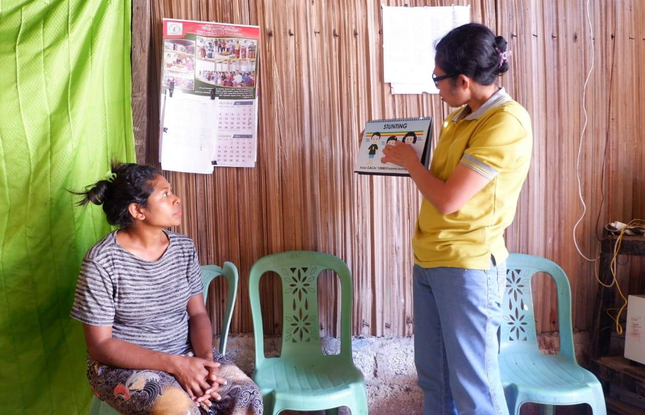
1. Baseline Survey
Taken by: Gidion Moses Neolaka (Timor Moringa) The photo can be accessed through this link.
We started the project by conducting a baseline survey to collect data on demographic
information of the mothers, mothers’ initial knowledge about stunting and its prevention, and utilisation of local food in the households.

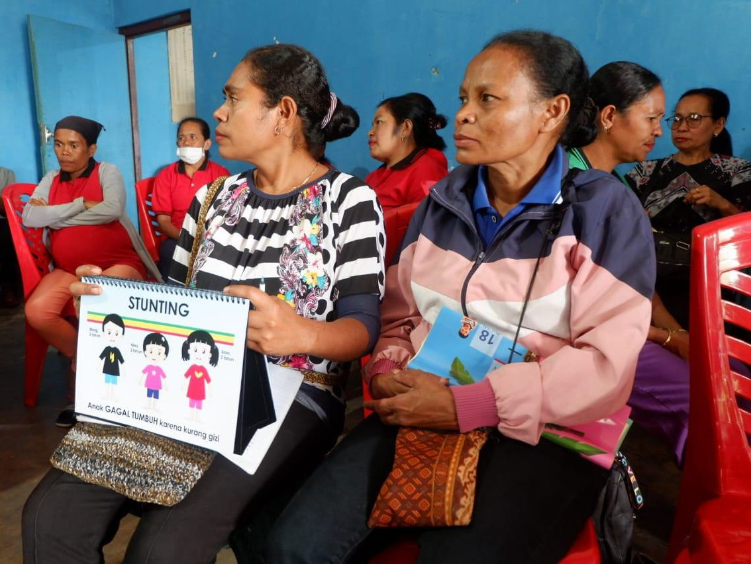
Stunting Education Training
Taken by: Gidion Moses Neolaka (Timor Moringa) The photo can be accessed through this link.
Partnered with the 1000 Days Fund, we conducted Training of Trainers (ToT) to Posyandu cadres about stunting and its prevention using interactive flipcharts and height charts. We equipped the cadres with knowledge and materials in order to train the project participants about stunting and its prevention.

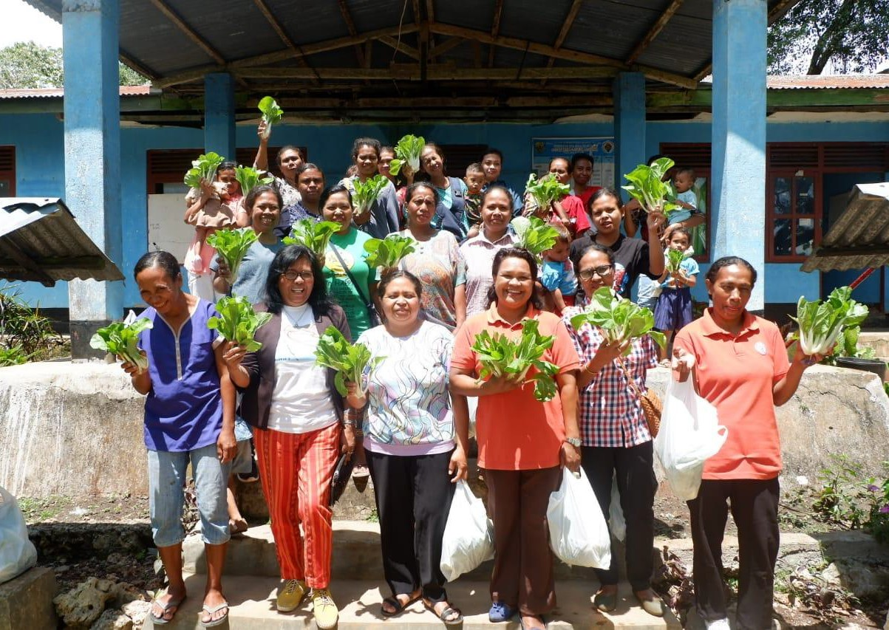
Harvesting
Taken by: Gidion Moses Neolaka (Timor Moringa) The photo can be accessed through this link.
In Establishing the Community Garden activity, Kopernik and project participants have successfully harvested the vegetables in three cycles over the course of three months. All harvest resulted in around 75 kg of fresh vegetables, which were distributed to the project participants.

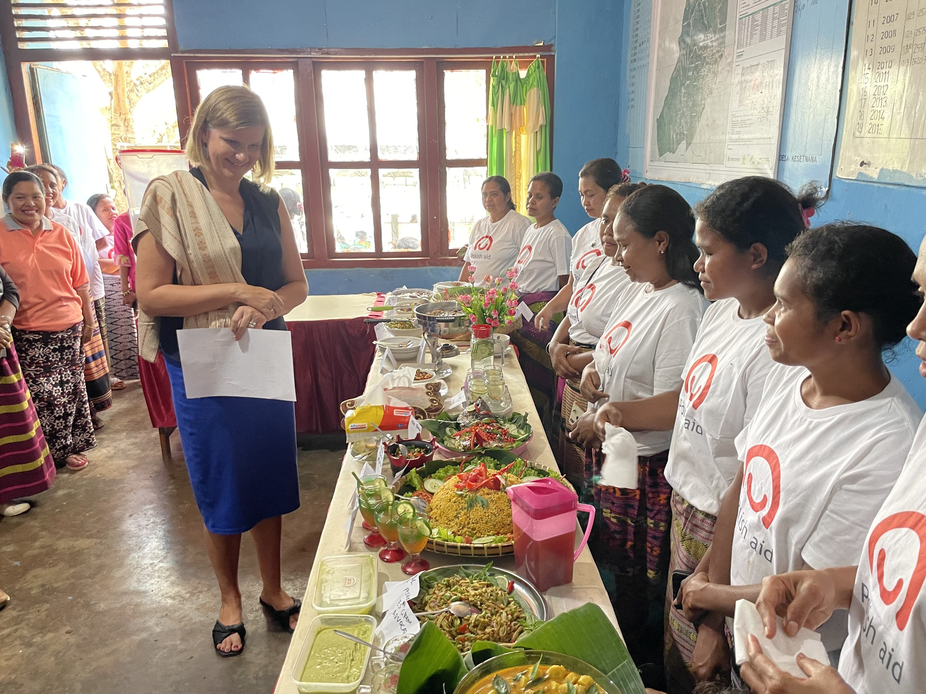
Local Food Cooking Competition

Taken by: Andre Dananjaya (Kopernik)
The photo can be accessed through this link.
We conducted the first-ever cooking competition focusing on utilisation of local food ingredients in Kesetnana village. There were five groups participating in this competition, and each group cooked a menu featuring their local food, using the recipes they have previously developed. The event went very well with all participants being very excited and proud of their cooking and creations. We involved several guests to become the judges.

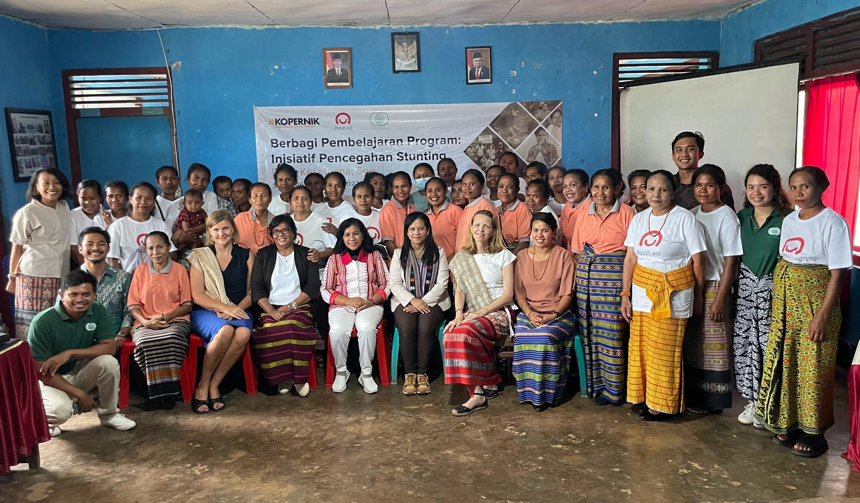
5. Dissemination Event
Taken by: Andre Dananjaya (Kopernik)
The photo can be accessed through this link.
Kopernik organised a dissemination event in Kesetnana village on 26 November 2022. The event focused on sharing about the project activities, findings and achievements, and was attended by approximately 80 people – all project participants and partners, as well as key stakeholders such as the head of Kesetnana village, and representatives of South Central Timor Regent Government.

Results of the project (for promotional purposes):
Please describe only actually conducted actions and achieved results. The description should take around 4 short paras (1000-1500 characters) including: Summary of results of the activities and their results (max 500 characters); Indication of the actual time of the implementation of the project; Description on how the project has led or may lead to a sustained change for the beneficiaries and how the project can continue to bear fruits after it
has been concluded.
Kopernik conducted three interventions: Building Community Knowledge on Stunting Prevention, Nutrition-sensitive Agriculture Education, and Establishing a Community Garden. The activities were implemented from July to December 2022.
The main achievements of the project include:
1. Increase of stunting prevention knowledge among project participants by 38%.

- All project participants applied the knowledge they gained during the training about stunting prevention in their daily lives. The most frequently reported applied practices were attending Posyandu frequently, consuming nutritious food, and exclusive breastfeeding.
- 91% of the project participants reported that they gained positive results upon participating in the nutrition-sensitive education workshops.

We also identified three sustained changes:
- The project participants were inspired by our local food-related activities. They stated that some of the identified local food were something new for them and that some available plants in the village can be utilised as nutritious food. After we conducted the Recipe Development activities, they could apply the knowledge gained in their own kitchen.
- The Community Garden Establishment activities caught the attention of the head of Kesetnana village. He wanted to use some of the garden harvest as the supplementary feeding for children during Posyandu monthly sessions. The head of Kesetnana village also expressed his support by allocating a village fund to continue this initiative.
- Our interventions were designed to provide theoretical and practical knowledge on improving health and nutritional intake of households with pregnant women and mothers with children under the age of 2. Participants expressed that they never received any comprehensive interventions like this before. Some of them also stated that it was a
life-changing experience since they got to know and learn many important things as mothers or soon-to-be mothers.

Additional materials from the project
(Please attach any additional materials – documents, publications, films, recordings etc. Two attachments possible, each of max. 25 MB (each of them could be a collection of files packed by Zip or RAR). If more attachments are available, please upload them to an external disc and provide a link.
  - Details of the project interventions design can be accessed here.
  - All project documentation can be accessed here.
  - Dissemination event presentation (in Indonesian) can be accessed here.

