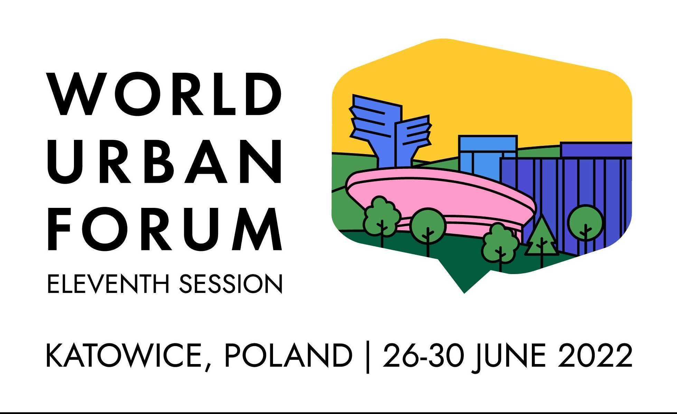
EXAMPLES OF THE POSSIBILIES TO ENGAGE IN THE WORLD URBAN FORUM IN KATOWICE,
26-30 JUNE, 2022
The World Urban Forum (WUF11) is the most important global event dedicated to urban policy, sustainable urbanization and urban development. The organizers of WUF 11 are the UN-Habitat (United Nations Human Settlements Programme) and Poland (Ministry of Development Funds and Regional Policy and the City of Katowice). The leading theme of WUF is “Transforming our Cities for a Better Urban Future”.
The key goal of WUF is to promote a new concept of urban and human settlement development based on the principles of inclusive and sustainable urban economy, but also:
- raising awareness of the importance of sustainable urbanization;
- exchange of experiences and gathering knowledge;
- creating a network of global and regional cooperation.
The discussion at the Forum will focus on the following detailed topics:
- Equitable urban future
- Greener urban future
- Innovation and technology
- Building urban resilience
- Urban planning and governance
- Future urban economy and finance
PARTNER ENTITIES MAY ENGAGE IN WUF11 IN THE FOLLOWING FORM (the list of engagement opportunities will be supplemented and updated):
I. Organization of events under the official WUF 11 programme coordinated by the UN-Habitat (selected through an open competition):
- Networking event
The aim of networking event is to establish cooperation, exchange knowledge and skills. The independent panel should be related to the main topic and specific topics of WUF11. A networking event can last 1.5 hours and may be attended by up to 100 people. The organizers can use the technical facilities, which include audio-visual equipment, projectors, laptops and presentation screens. Interpretation services are additionally charged.
- Training event
The trainings will be an opportunity for participants to gain practical skills and knowledge on issues related to the WUF11 theme with an emphasis on urban equality, green development, urban resilience and innovation that support the implementation of the New Urban Agenda and the achievement of the Sustainable Development Goals.
Each training session will last 3 hours, allowing participation of 30-50 people on a stationary basis. There is a limit of one event per organization to ensure a balance and equal opportunity for all applicants. Interpretation services are additionally charged.
- SDGs in Action event
Through a series of SGDs in Action events the UN-Habitat would like to encourage a discussion on the implementation of the Sustainable Development Goals at the local level, in particular through cooperation in five areas: culture, economy, society, environment and management.
Each such event will last 1.5 hours and may be attended by up to 100 people. The organizers can use the technical facilities, which include audio-visual equipment, projectors, laptops and presentation screens. Interpretation into Polish, English, French and Spanish is provided.
- Voices from Cities event
The primary goal of this series of events is to foster a wide-ranging discussion on the challenges faced by cities and the native solutions to solve them, and how these solutions can be adapted and adjusted to a variety of urban environments. All these events will aim to foster cooperation between cities.
The Voices from Cities event can last 1.5 hours and admit up to 100 people. The organizers can use the technical facilities, which include audio-visual equipment, projectors, laptops and presentation screens. Interpretation into Polish, English, French and Spanish is provided.
- Urban Library event
The events from the Urban Library series are to be a platform for debate between WUF11 participants, authors and speakers who, on the basis of publications, books and research, will discuss the implementation of the New Urban Agenda at the local level.
Each Voices from Cities event will last 1.5 hours and can be attended by up to 100 people. The organizers can use the technical facilities, which include audio-visual equipment, projectors, laptops and presentation screens. Interpretation into Polish, English, French and Spanish is provided.
- Stand or exhibition at the WUF EXPO
Your achievements and interesting solutions and ways in which cities can deal with housing, transport, energy and accessibility challenges can be showcased at stand or exhibition at the WUF EXPO. Applications for exhibition space are available through personal profiles after online registration on the WUF11 platform. After receiving the registration confirmation, you can book the exhibition space on behalf of your organization. The submitted applications will be analysed and selected by the evaluation committee.
More information on the WUF11 website, https://wuf.unhabitat.org/urban-expo.php ; email: unhabitat-wuf@un.org.
The submitted applications for the organization of events in the above-mentioned formats and stand organization at WUF EXPO will be analysed and selected by an international evaluation committee in the competition procedure. Submitting a proposal to organize a given event is possible through personal profiles after online registration on the WUF11 platform.
The deadline for declaring the willingness to organize the above-mentioned events is 7 March 2022. More information to be found on the WUF11 website in the registration section, https://wuf.unhabitat.org/; email: unhabitat-wuf@un.org.
II. Programme events coordinated by Poland (Ministry of Development Funds and Regional Policy, Institute of Urban and Regional Development and City of Katowice), in addition to the main Forum agenda.
- Block of events devoted to the European dimension of urbanization in the context of global challenges (the so-called European path).
The path is implemented by the Ministry of Development Funds and Regional Policy and the Institute for Urban and Regional Development (IRMiR); 16 panels in total will be organized in 4 thematic blocks: 1) Green City, 2) Just and Inclusive City, 3) Sustainable Urban Mobility, 4) Affordable Housing. Within each thematic block, four sessions are organized (in the format of a discussion panel, presentations in the TED format or another), organized by leading institutions / organizations from the European countries, which are the entities actively working for the transformation of cities at various levels: European, national, urban and in the third sector, science and business (hosts of the panel). Applications can be sent to the host of a given panel – more information after 15 February 2022 on the IRMiR website http://obserwatorium.miasta.pl/wuf11;
- Organization of an event as part of the "WUF in your city" initiative, coordinated by the IRMiR. Throughout 2022, interested entities can organize (also in virtual format) events related locally to the WUF11 theme in a given city and region and obtain a certificate of the accompanying event WUF11 – details to be found on the IRMiR website: https://obserwatorium.miasta.pl/wuf11/wuf-w-twoim-miescie/
- Possibility of sponsoring some of the activities carried out during WUF11 in Katowice, in particular in the area referring to the so-called Town of Young People;
- Participation in the nationwide “Urban_In. A city for everyone” competition, organized by the Ministry of Development Funds and Regional Policy dedicated to young people aged 15-35 – details on the website of the competition organizer – the SWPS University, https://swps.pl/my-uniwersytet/aktualnosci/aktualnosci/31715-konkurs-urban-in-miasto-dla-kazdego
WE ENCOURAGE YOU VERY MUCH TO PARTICIPATE IN THE WORLD URBAN FORUM
IN KATOWICE, ON 26-30 JUNE 2022

If you have any questions, please contact us at: wuf11info@mfipr.gov.pl

