Poles on development assistance

Findings from a Kantar Public Study for the Polish Ministry of Foreign Affairs

Warsaw, December 2022

Table of Contents
Information about the survey 3
Key findings 4
Survey findings 7
Introduction 7
1. Public opinion on Poland’s need to provide assistance to less developed countries 7
2. Awareness of Poland’s assistance to other countries & sources and content of information 13
3. Awareness of international development problems 19
3.1. Countries which are poorer and less developed than Poland 19
3.2. Sustainable Development Goals 21
4. Areas, forms and directions for assistance 25
4.1. Areas of assistance 25
4.2. Forms and channels of assistance 26
4.3. Geographic targets of assistance 29
5. Volume of Poland’s aid 31
6. Recognisability of the development cooperation logo 33
7. Pole’s involvement in assisting less developed countries 34
8. Assistance to Ukraine 35
‘Development Assistance 2022’ – Framework Questionnaire 39
Key to question O4a 44

Information about the survey

CLIENT: | Polish Ministry of Foreign Affairs
SUBJECT: | POLES ON DEVELOPMENT ASSISTANCE
FIELDWORK TIMING: | 2–7 December 2022
SAMPLE: | Nation-wide representative sample of 1,005 Poland’s residents aged 15+
NUMBER OF INTERVIEWS: | Omnibus – a regular multi-subject in-home survey conducted using face-to-face questionnaire-based interviews
MAXIMUM STATISTICAL MEASUREMENT ERROR: | +/-3.1% at 95% confidence level

Key findings
- Around two thirds of Poles (65%) believe that Poland should support the development of less developed countries. The opposite opinion is held by far fewer respondents (19%). 16% of the respondents could not take a clear position on Poland’s assistance activities towards countries in need. The belief that Poland should support the development of less developed countries dominates in all socio-demographic groups. A particularly high level of acceptance is found among the youngest respondents and those with higher education. Against the organization of assistance activities by Poland for less developed countries, rural residents people aged 40-49 and 20-29 spoke out more often than others. The net support score (i.e. the difference between the percentage of positive opinions and the percentage of negative opinions) for Poland's organization of aid activities towards less developed countries has decreased compared to the previous measurement - by 7 points.

- When justifying their position, supporters of Poland’s assistance to less developed countries most commonly pointed to a moral duty (41%). Other arguments took further positions: helping others may be beneficial to Poland (29%), the necessity to provide assistance under international commitments assumed by Poland (29%) and the possibility of returning the favour because richer countries helped Poland in the past (28%). Slightly more than a quarter of Poles indicated that assistance provided on the ground in less developed countries can help to counteract illegal migration (26%). Compared to 2019, only the percentage of responses that it is a moral obligation decreased significantly.

- Poles who believe that Poland should not support the development of less developed countries the most often said that Poland is too poor to help others (43%). The second most common argument (40%) concerned the fact that Poland should solve its own problems first. In 2022, compared to the 2019, the percentage of answers referred to the fact that Poland is a poor country, Poland was not helped by anyone, and that such help is badly used, increased.

- Overall, 13% of the respondents declared that in the last 2–3 months preceding the survey they had encountered information about Polish aid to less developed countries. 87% of the respondents had not heard of such aid. To a lesser extent than in other age groups, such information had reached the respondents in their fifties (8%), and most often the eldest people and those who live in big towns (of up to 499,000 inhabitants). The higher the education of the respondent, the higher the level of information was declared. Between 2019 and 2022, there was no significant difference in the level of information about Poland's assistance to less developed countries. This lack of changes also indicates that, after ten months after the outbreak of the war, the topic of support has died down or people who have been involved in helping other countries so far hear about it.

- Those who encountered information about Poland’s assistance to less developed countries in the last 2–3 months preceding the survey said their knowledge on this subject was mainly derived from television (75%). In 2022, the importance of television decreased significantly, and the share of the Internet increased. Other mass media are less popular.

- In the respondents’ opinion, 83 countries on average are thought to be less developed than Poland among 195 countries in the world. 15% of those surveyed indicated under 100 countries, and 13% mentioned more than 100. However, as many as 68% of the respondents were unable to estimate the number of countries in the world which were in an inferior situation versus Poland.
The higher the education of the respondents, the Poles rank Poland higher in the classification. More countries than others were also indicated by the inhabitants of the largest cities. Poland is perceived worse by thirty-year-olds and people over 70 years old. Compare to 2019, in 2022 the biggest change is the increase in the percentage of people who could not answer this question (increase by 8 percentage points), which did not reach such a high percentage in any of the previous waves of the survey. In addition, the percentage of responses “up to 49 countries” and “over 100 countries” decreased significantly.

- Overall, 6% of Poles have heard of the Sustainable Development Goals that should be achieved by 2030. 94% of those surveyed have never heard of them. People who heard about them indicated that they had received information on combating disproportions (especially in relation to access to education, healthcare, drinking water, food, access to all needed resources), climate and environmental protection, renewable energy sources and a shift away from gas and coal, responsible consumption, aid to Africa, sustainable agriculture.

- According to the respondents, the three major obstacles hampering the development of less developed countries include problems with access to drinking water (41%), lack of health care (39%) as well as infectious diseases, including HIV and AIDS (25%). Compared to 2019, the percentage of indications that access to drinking water and the inability to produce an adequate amount of food is the greatest challenge has increased significantly. However, the conviction that armed conflicts are such a challenge has decreased.

- Among the areas where Poland has most to offer to less developed countries, Poles selected health care (43%) and education (37%) in 2022. Compared to the situation in 2019, the opinions of Poles regarding the support that Poland should provide to less developed countries have slightly changed: the percentage of people who believe that our country should help other countries in the development of agriculture and in preventing crises and rebuilding after conflicts, and to a lesser extent: improving the level of education and supporting democratic reforms and protecting the environment.

- In 2022, when asked how Poland could contribute to supporting the development of less developed countries, Poles most often indicated support for health care in these countries (37%) as well as sending volunteers (30%). Less common attention was paid to support methods such providing funds for children education (24%), Polish companies’ investments in these countries (19%) and enabling students from less developed countries to study in Poland (18%). Other forms of support were mentioned less frequently.

- According to the prevailing opinion, Poland should transfer funds to less developed countries through Polish NGOs and companies (47%) and specialised international organisations (42%). More than a quarter of Poles (27%) believe that funds should be channelled through specific Polish investments in these countries. More than one fifth (23%) of the respondents indicate that the transfer of funds should be the responsibility of local organisations. In 2022, compared to 2019, the percentage of mentions of Polish NGOs and companies increased, and international organizations were mentioned less often.

- The main destinations of Poland’s assistance preferred by Poles include African countries (50%). Poles are far less likely to believe that Poland’s assistance should go to our eastern neighbours (26%), with nearly all mentioning Ukraine (99%), In 2022 an increase was recorded in the case of our eastern neighbours. These changes are caused by the war situation in Ukraine.

- The most Poles (40%) believe that, in comparison with its potential, Poland spends as much money as needed for development assistance to less developed countries. Among those who voice reservations, 17% believe that we spend too much, and 13% think we spend too little. First of all, people with higher education and inhabitants of the largest cities more often believe that Poland spends too little money. People who claim that these expenses are too high are primarily twenty-year-olds, residents of rural areas, but also the largest cities. Compared to 2019, the percentage of indications that Poland allocates the appropriate amount of aid has now decreased by 11 percentage points. In turn, the belief that Polish aid spending is too high increased by 11 percentage points - the percentage of such people reached the highest level in the history of the survey.

- 7% of Poles recognize the logotype of the Polish Development Cooperation Program and 5% associate it with aid actions for Africa, which may be due to the fact that Poles recognize the use of the logo in the context of helping Africa. As many as 74% of the respondents directly admit not knowing it, and the logo is most commonly thought to be used by the Polish Humanitarian Organisation (9%). The eldest people, those with primary education and residents of the largest cities are more likely to be familiar with the logotype.

- 8% of Poles were involved in assistance to less developed countries in any way. Engaged people are more often people aged 50 and more, with secondary and higher education, living in rural areas. On the other hand, people who do not see the need for help are more often people aged 30-49 years old and the eldest people, people with primary education and inhabitants of rural areas. Compared to 2019, the commitment to helping less developed countries has increased. At the same time, the percentage of people who do not see the need to get involved in helping has decreased.

- 71% of Poles believe that Poland should support Ukraine in a situation of war in that country. 18% of respondents hold the opposite opinion. Young people and those with higher education are more likely to believe that Poland should help. People who disagree are more often people aged 30-39 and seniors, as well as people with education below higher, as well as residents of the largest cities. Poles who believe that Poland should support Ukraine said so mainly because they believe that by helping Ukraine Poland increases its own security (56%), that Poles have a moral duty to help our neighbour (44%). Opponents motivated their answer mainly by saying that Poland should first solve its own problems before helping others (43%), or that Poland is too poor to help others (41%).

- More than a half of Poles (54%) believe that Poland’s help for Ukraine and Ukrainian refugees will be beneficial for our country in the long term. The opposite view is held by 26% of those surveyed. People who are convinced of the benefits for Poland are primarily the youngest. The higher the education and the larger the city of residence, the more often the respondents pointed to the benefits of assistance. Those people believe that the next steps that should be done for Ukraine are to increase humanitarian aid in Ukraine (55%), medical aid in Ukraine (46%), and food aid in Ukraine (46%). People who believe that helping Ukraine may be unfavourable for Poland are more often men and fifty-year-olds. Above all, they claimed that support for refugees in our country should be limited (51%).

- More than half of the respondents would decide to allocate additional funds to help Ukraine and refugees from Ukraine. A third of Poles (32%) would not like to such expenses. From people willing to help financially, 11% would allocate less than PLN 5 per month, one in four (26%) would allocate PLN 5 per month, while 16% of Poles would allocate PLN 10 or more. The higher the education and the smaller the city of residence, the greater the willingness to spend. People who would spend money for this purpose are a bit more often women, 60-year-olds. People who are unwilling to help financially are more often men and people aged 20-29.

Survey findings

Introduction

Between 2th and 7th December 2022, Kantar Public conducted another survey concerning Poles’ opinions on development assistance. The first edition of the survey was conducted in September of 2004 and then the survey was repeated in subsequent years.
Wherever possible, the findings from this year’s survey have been juxtaposed and compared with results of previous surveys (for some questions, the changes of wording between editions made such comparisons difficult).
In 2022, a set of questions on assistance to Ukraine was added to the survey.

Public opinion on Poland’s need to provide assistance to less developed countries

Just under two thirds of Poles (65%) believe that Poland should support the development of less developed countries. The opposite is true for far fewer people, less than one fifth (19%).
Both supporters and opponents of the idea to support less developed countries tend to express moderate opinions (57% of answers "probably should", 15% - "probably should not"). Radical opinions are in the minority (8% among strong supporters and 4% among strong opponents).
16% of those surveyed didn’t know about our country’s assistance efforts benefiting countries in need.

Many countries and international organisations support the development of less developed countries. They help them financially and materially and send specialists. The aim of that aid is primarily to support economic growth, reduce poverty, support democratic reforms, rule of law, self-governance, prevent domestic conflicts and improve global safety. Development assistance is supposed to provide sustainable support for those countries. Development assistance is not the humanitarian aid which is provided ad hoc in the case of humanitarian crises, natural disasters, military conflicts, etc. In your opinion, should Poland support the development of less developed countries or not?

Figure 1 In your opinion, should Poland support the development of less developed countries or not?

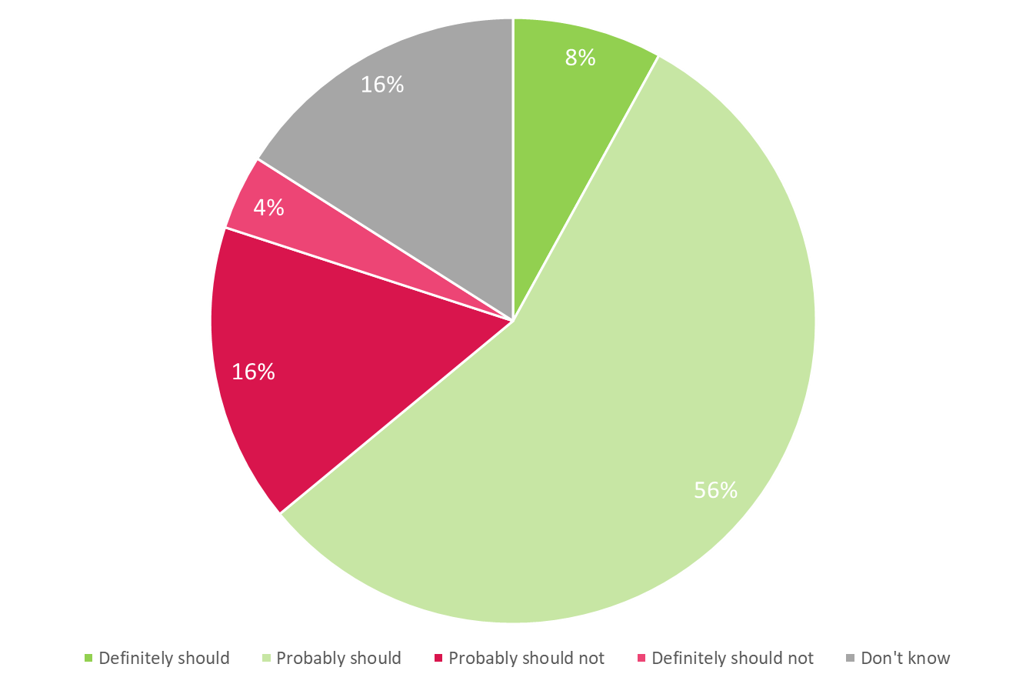

‘Don’t know’ was not read out to the respondents as an answer option

The belief that Poland should support the development of less developed countries prevails in all socio-demographic groups. It is most widespread among those aged 15–19 (72%), people with tertiary education (73%) (in contrary to 58% of those with basic vocational education). Women, slightly more often than men, claimed that Poland should support the development of less developed countries (9% of women compared to 7% of men). The support did not differ significantly by the size of the place of residence , with 64% among residents of rural areas and 62% among residents of the largest cities expressing support.
Poles living in rural areas were more likely to oppose the idea of Poland organising assistance activities for less developed countries (20%). Those aged 40–49 (21%) and 20–29 (22%) are less likely to be in favour of support for less developed countries.

The net support for the idea of Poland organising assistance for less developed countries (i.e. the difference between the percentage of positive opinions and the percentage of negative opinions) has shrunk in comparison with the previous measurement in 2019 (53 points), reaching 46 points in 2022.
In comparison with 2019, the level of net support has declined by 7 points. This happened because the group of supporters of Poland’s assistance dropped by 4 percentage points while the number of opponents increased by 3 percentage points. This indicator reached almost the same level as in 2015 (43 points).

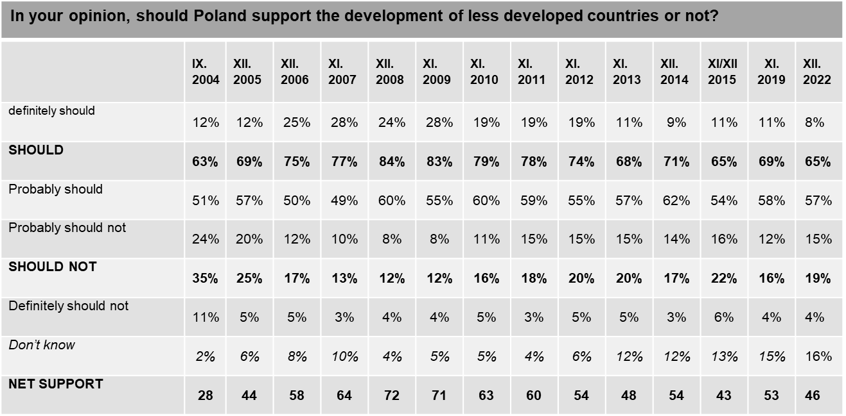

Answers given in italics were not read out to the respondents.
^{*)} In 2004 and 2005 the introduction presented on the preceding page of this edition was worded as follows: “Many countries and international organisations support the development of less developed countries. They help them financially and materially and send specialists. The aim of that assistance is to support economic growth, reduce poverty, support democratic reforms, the rule of law and self-governance, prevent domestic conflicts and improve global safety. Development assistance is not the humanitarian assistance which is provided ad hoc in the case of humanitarian crises, natural disasters, military conflicts, etc. but is aimed to support sustainable growth of poor countries.
The European Union provides considerable development assistance to poorer countries (ca. 43 billion dollars annually). Poland is also involved. Following Poland’s accession to the European Union, it is believed that Poland should significantly increase its assistance to poorer countries, including our Eastern neighbours.”
Until 2015, the following introduction was used: “Many countries and international organisations support the development of less developed countries. They help them financially and materially and send specialists. The aim of that assistance is to support economic growth, reduce poverty, support democratic reforms, the rule of law and self-governance, prevent domestic conflicts and improve global safety. Development assistance is not the humanitarian assistance which is provided ad hoc in the case of humanitarian crises, natural disasters, military conflicts, etc. but is aimed to support sustainable growth of poor countries.”

When justifying their position, supporters of Poland’s assistance to less developed countries most commonly pointed to a moral duty (41%). Other arguments took further positions: helping others may be beneficial to Poland (29%), the necessity to provide assistance under international commitments assumed by Poland (29%) and the possibility of returning the favour because richer countries helped Poland in the past (28%). Slightly more than a quarter of Poles indicated that assistance provided on the ground in less developed countries can help to counteract illegal migration (26%). 22% of the respondents felt that Poland should offer assistance because the situation in Poland depends on the developments in other countries. The least common motivation to support less developed countries was that Poland is sufficiently wealthy to do so (15%).

Figure 2 If so, why?

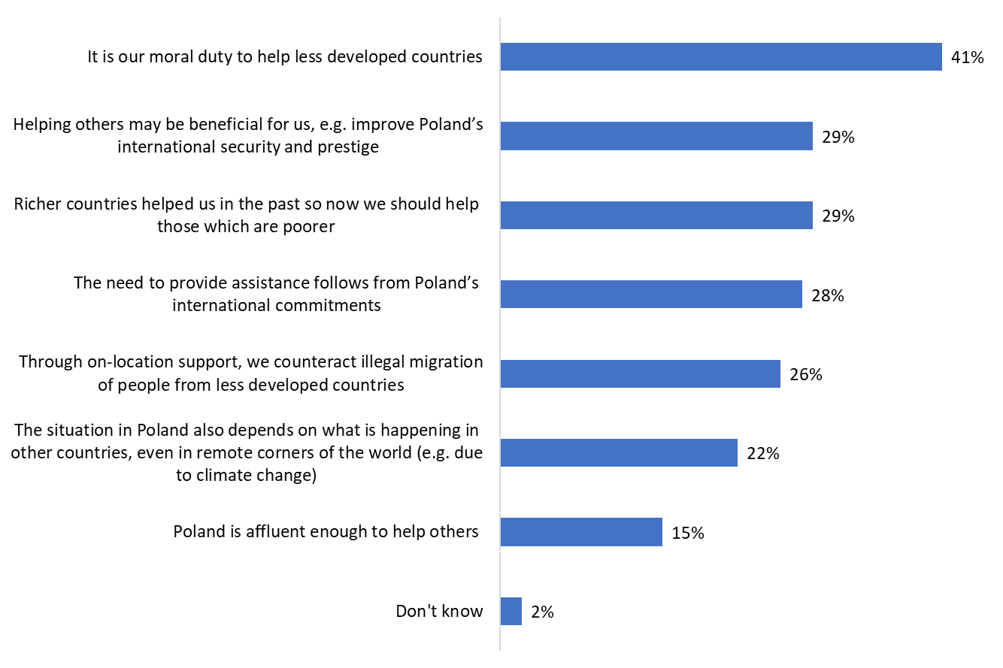
‘Don’t know’ was not read out to the respondents as an answer option

In 2022, compared to the previous survey (in 2019), the percentages of responses regarding the reasons why Poland should support the development of less developed countries did not change significantly. Only in the case of the feeling that it is a moral duty, the responses declined by three percentage points.
There has also been a statistically insignificant increase (by 2 percentage points) in the percentage of people who say that richer countries helped us, so now we should do the same.
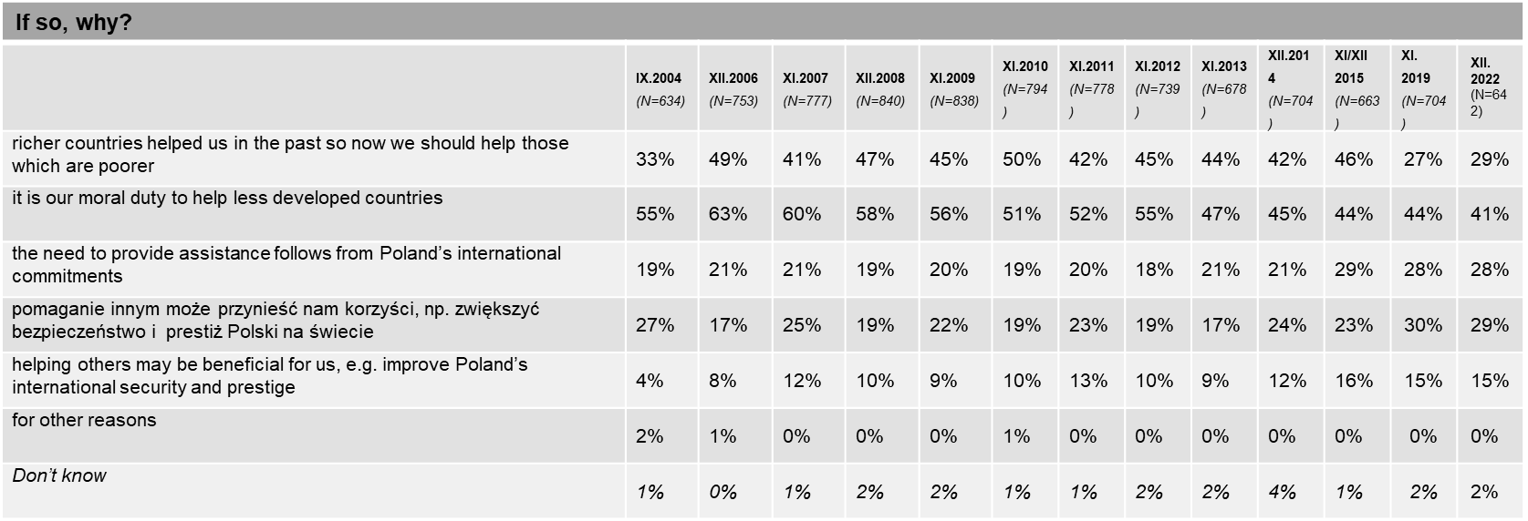

More than two-fifths of the respondents (43%) who believe that Poland should not support the development of less developed countries say that Poland is too poor to help others. The second most common argument (40%) concerned the fact that Poland should solve its own problems first. Poles were slightly less likely (24%) to say that we should not provide assistance because nobody helped Poland in the past. 20% of the respondents said that each country should take care of its own problems and 19% of Poles claimed that assistance received by less developed countries is not used properly.

Figure 3 If not, why not?
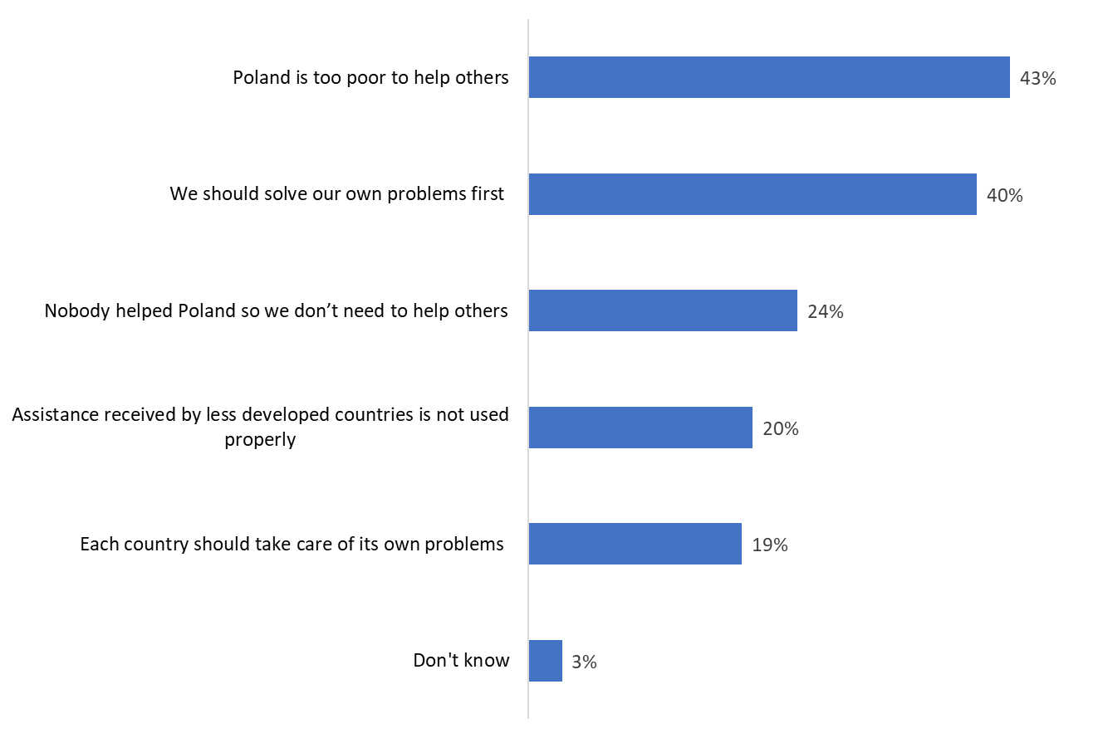

‘Don’t know’ was not read out to the respondents as an answer option

Compared to the 2019 survey, the percentage of people who motivated their negative attitude towards supporting less developing countries by the fact that Poland is too poor to help others has increased (by 11 percentage points).
In 2022, there was a decline in the percentage of people taking an attitude that each country should take care of its own affairs (from 24% to 19%). An increase was noted in the case of opinions on the misuse of assistance funds (from 11% to 20%) and the belief that Poland did not receive any aid, so it has no obligation to help other countries (from 14% to 24%).

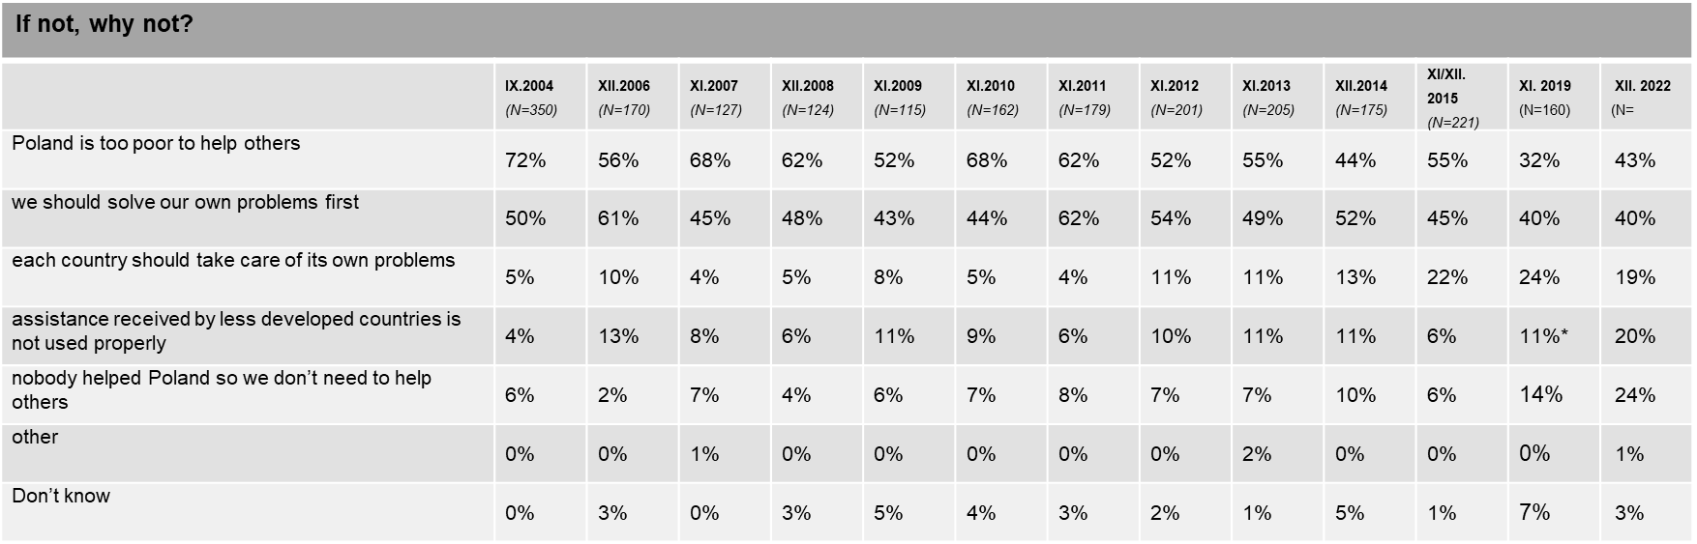

Percentages do not add up to 100% – multiple answers were allowed
Answers given in italics were not read out to the respondents

Awareness of Poland’s assistance to other countries & sources and content of information

A total of 13% of respondents claimed that they had encountered information on Poland’s assistance to less developed countries during the last 2–3 months before the survey. 87% of the respondents had not heard about it. In contrast with other age groups, the respondents in their fifties (8%) were less likely to report awareness of such information. People aged 70 and over most often came across such information (16%). The level of information is also correlated with the level of education - people with primary (10%) and basic vocational (9%) education were the least informed, and most often (17%) - people with higher education. People who live in towns of up to 499,000 inhabitants (up to 100,000 inhabitants - 14%, 100-499,000 inhabitants - 15%) more often answered affirmatively, and those living in rural areas – did that less frequently (10%).

Figure Over the past two or three months, have you come across information on Poland’s aid for less developed countries?
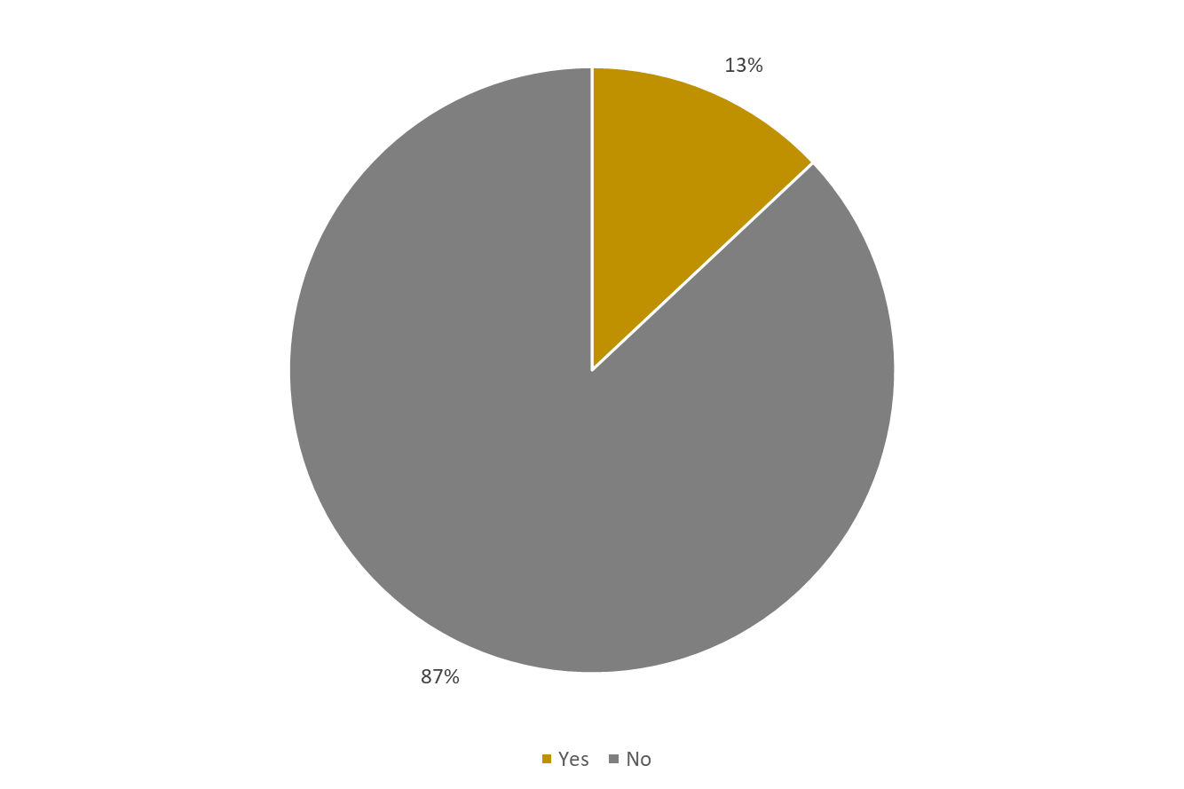
Generally speaking, the percentage of people aware of Poland undertaking assistance measures for less developed countries has not changed at all between 2019 and 2022. The current result is still one of the lowest of all that has been recorded in previous studies. This lack of changes also indicates a return to the status quo in Poland when it comes to providing aid in the context of the war in Ukraine - ten months after the outbreak of the war, the topic of support died down, despite the fact that many Poles were still involved in this aid in February or March.
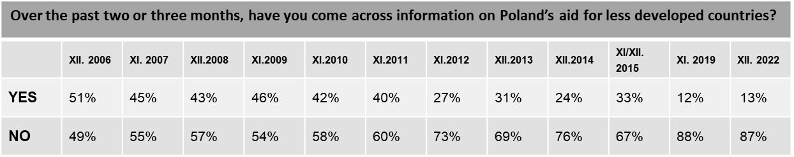

Those who had encountered news about Poland’s assistance to less developed countries in the last 2-3 months before the study received that information mostly from television (75%). Other media do not have an impact which would be comparable to that of television. Internet, the second most popular source, was mentioned by nearly a three times smaller group (30%). Among other important channels for obtaining information on Poland’s assistance activities for other countries, the respondents also mentioned radio (16%), press (11%) and the church (8%).

Figure 5 Sources of information about Poland’s assistance to other countries
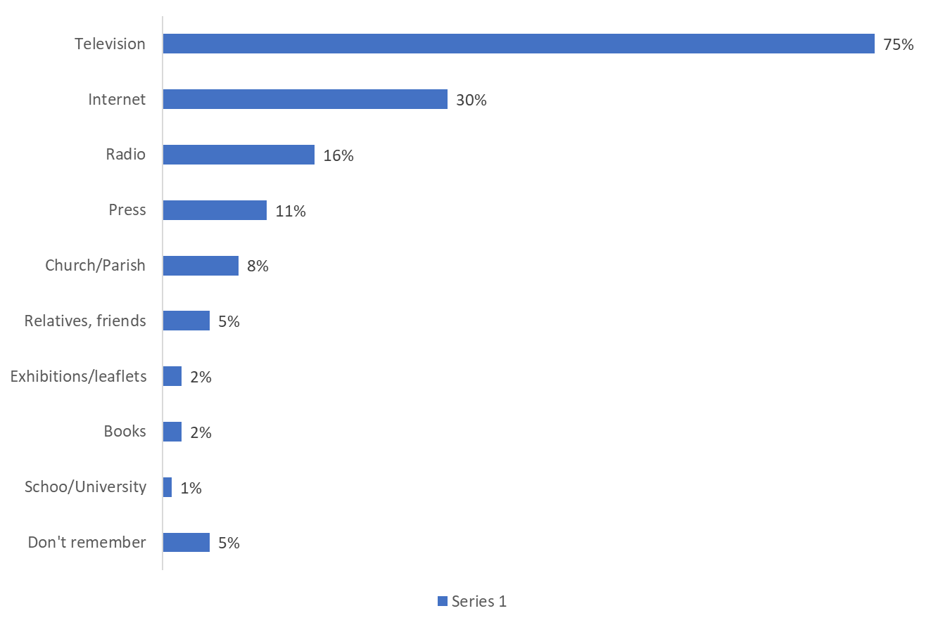

Results for the respondents who had heard about Poland’s assistance to other countries during the preceding 2–3 months

The TV, as a leading source of information about Poland’s assistance to other countries, have had undisputable position for years, although in 2019 the percentage of people who obtained knowledge from this medium was higher, by 5 percentage points. This trend is in line with the general decline in TV viewership. The Internet, on the other hand, gained in popularity in 2022, recording an increase in mentions by 9 percentage points. The press, on the other hand, lost importance to a significant extent (decrease by 3 percentage points). The importance of information sourced from the church or parish also declined in 2022, by 5 percentage points.

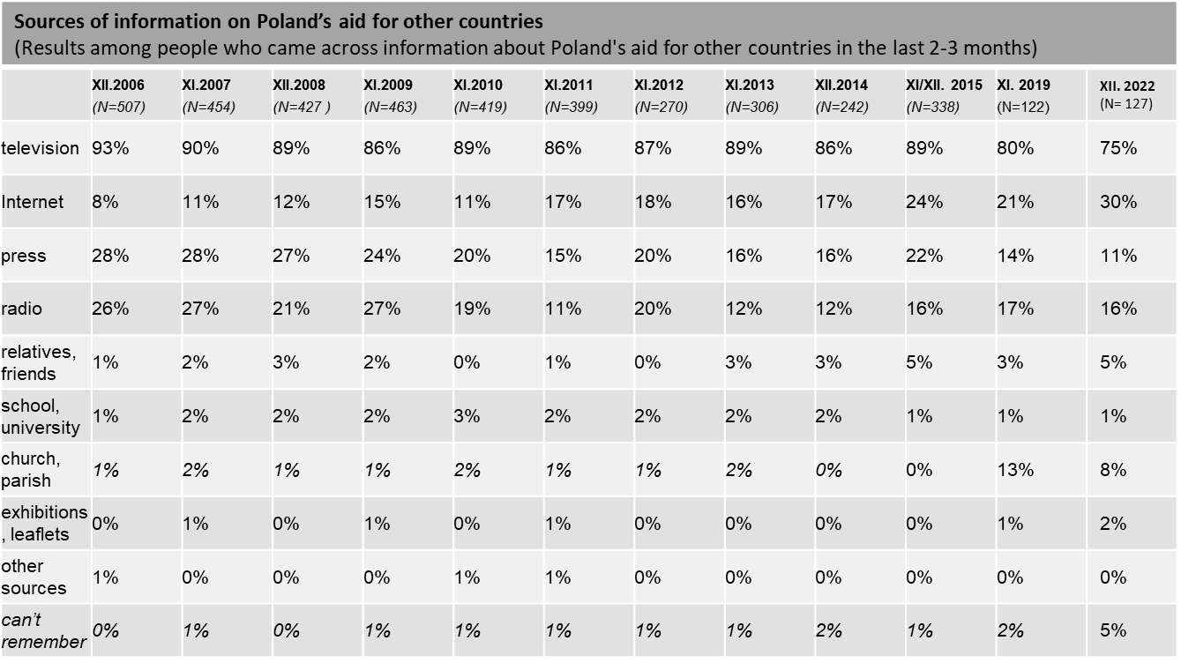

Percentages do not add up to 100% – multiple answers were allowed
Answers given in italics were not read out to the respondents

Information on Poland’s assistance to other countries, that encountered respondents, were most often concerned humanitarian aid (specifically in relation to combating poverty) (31%), as well as assistance to Ukraine (overall indications) (31%). The respondents’ connotations also focused on various forms of assistance: food collection, financial assistance (help by sending an SMS, donating money to help other countries), medical assistance, education, construction of wells (in the context of aid to Africa), as well as support for missionaries and support during war conflicts (referring primarily to Ukraine, but also to Syria and the aid in general). The places that Poles link with such information include mostly Ukraine, as well as Africa and Syria, and the reasons why such countries need support include war, lack of drinking water, famine and natural disasters.
Due to the war situation in Ukraine, the information that the respondents encountered concerned mainly Ukraine, and less often Africa or other countries that appeared in the earlier waves of the survey.

IF SO, WHAT WAS THE INFORMATION ABOUT?
(FOR CODING RULES, SEE THE QUESTIONNAIRE SECTION)
Results sorted in the order of coding frame items;  Data in % | 2006  (N=504) | 2007  (N=453) | 2008  (N=427 ) | 2009  (N=463) |  | 2010  (N=419) |  | 2011  (N=399) | 2012  (N=270) | 2013  (N=306) | 2014  (N=242) | 2015  (N=338) | 2019  (N=122) | 2022  (N=105)
Overall: humanitarian aid - aid for the poor, the needy, fighting poverty, wherever problems occur | 26 | 18 | 9 | 17 |  | 22 |  | 16 | 16 | 12 | 14 | 7 | 22 | 31
Economic assistance; | 1 | 0 | 1 | 1 |  | 1 |  | 2 | 3 | 0 | - | 0 | - | 2
Construction and assistance in re/construction of infrastructure – medical centres, schools | 1 | 3 | 2 | 3 |  | 4 |  | 4 | 10 | 3 | - | 0 | 2 | 1
Food assistance, combating starvation, problem of starvation | 23 | 23 | 13 | 9 |  | 12 |  | 10 | 9 | 5 | 5 | 3 | 14 | 9
Unavailability of drinking water | 3 | 2 | 1 |  | 4 |  | 8 | 6 | 9 | 4 | 2 | 1 | 7 | 4
Collections of clothing, footwear, blankets, tents; | 4 | 6 | 2 |  | 2 |  | 1 | 1 | 1 | 1 | 2 | 1 | 2 | 2
Cash collections, money collection via bank transfers; financial assistance, payments via text messages | 6 | 9 | 1 |  | 5 |  | 4 | 7 | 4 | 4 | 2 | 4 | 11 | 13
Medical assistance, collection of medicines, vaccines, assistance from Polish doctors, assistance for those suffering from AIDS, infectious diseases | 17 | 12 | 7 |  | 31 |  | 13 | 4 | 6 | 3 | 4 | 1 | 10 | 8
Other assistance and, generally, material assistance, tangible assistance (e.g. hygiene products) | 8 | 9 | 2 |  | 5 |  | 3 | 3 | 12 | 4 | - | 2 | 2
Assistance for Polish diaspora abroad – assistance for Poles (living in countries to the east of Poland) | 3 | 1 | 1 |  | 1 |  | 1 | 2 | 1 | 1 | - | - | - | 1
Military assistance – sending troops (to Iraq, Afghanistan), peace-keeping missions, stabilising missions, sending aid in connection with armed conflicts | 7 | 6 | 3 |  | 5 |  | 4 | 3 | 5 | 4 | 2 | 2 | 5 | 3
Assistance in reinforcing democratisation processes – assistance to democratic opposition in totalitarian regimes | 1 | 2 | 1 |  | 1 |  | 0 | 1 | 0 | 0 | - | - | - | -
Assistance for victims of natural disasters, earthquakes, tsunami, floods, draughts, landslides | 19 | 20 | 14 |  | 12 |  | 26 | 22 | 7 | 34 | 2 | 5 | 2
Assistance to children, ‘distance adoptions’ | 10 | 12 | 7 |  | 4 |  | 6 | 5 | 5 | 1 | - | 1 | 8 | 6
Assistance to victims of war and violence – invalids, war victims | 0 | 3 | 3 |  | 0 |  | 1 | 0 | 1 | 0 | 1 | - | - | -
Assistance to refugees | 0 | 0 | 1 |  | 0 |  | 0 | 0 | 0 | 0 | 1 | 56 | 2 | 4
Overall: assistance to third world countries, assistance to least developed countries | 2 | 13 | 7 |  | 5 |  | 3 | 2 | 2 | 5 | 2 | 1 | 9 | 2
Assistance to Africa, African countries, including: | 15 | 14 | 16 |  | 14 |  | 15 | 23 | 17 | 8 | 1 | 7 | 14 | 9
Chad | - | 0 | 1 |  | 0 |  | 0 | 0 | 1 | 0 | - | - | - | -
Ethiopia | 2 | 2 | 1 |  | 1 |  | 1 | 1 | 1 | 1 | - | 0 | 2
Congo | 1 | 0 | 0 |  | 0 |  | 0 | 0 | 0 | 0 | - |  | - | -
Somalia | - | 0 | 1 |  | 1 |  | 0 | 1 | 1 | 0 | 1 | - | - | -
Sudan, Darfur | - | 1 | 0 |  | 2 |  | 4 | 2 | 2 | 1 | - | - | 1
Libya | - | - | - |  | - |  | - | 3 | 0 | 0 | - | - | 1
Assistance to Latin American countries – South America, Central America, incl.: | 0 | 1 | 1 |  | 0 |  | 16 | 0 | 0 | 3 | - | - | - | -
Chile | - | - | - |  | - |  | 1 | 0 | 0 | 0 | - | - | - | -
Haiti | - | - | - |  | - |  | 14 | 0 | 0 | 3 | - | - | - | -
Assistance to former USSR countries and its area of influence, in the east, incl.: | 11 | 5 | 32 |  | 36 |  | 6 | 3 | 4 | 4 | 58 | 24 | 1 | 31
Belarus | 3 | 2 | 1 |  | 2 |  | 1 | 1 | 1 | 0 | - | 1 | - | -
Chechnya | 2 | 1 | 0 |  | 1 |  | 1 | 0 | 0 | 0 | - | - | - | -
Georgia | 0 | 0 | 21 |  | 1 |  | 0 | 0 | 1 | 0 | - | - | - | -
Kazakhstan | 1 | 0 | 0 |  | 1 |  | 0 | 0 | 0 | 0 | - | 0 | - | -
Lithuania | 1 | 0 | 0 |  | 1 |  | 0 | 2 | 1 | 0 | - | 0 | - | -
Russia | - | - | - |  | - |  | 1 | 0 | 0 | 0 | - | - | - | -
Ukraine | 2 | 1 | 3 |  | 34 |  | 2 | 0 | 1 | 0 | 58 | 22 | 1 | 31
Latvia | - | - | - |  | - |  | - | - | - | 1 | - | - | - | -
Assistance to Asian countries, incl.: | 12 | 8 | 9 |  | 4 |  | 7 | 12 | 5 | 34 | 2 | 12 | 8 | 2
Afghanistan | 2 | 2 | 5 |  | 2 |  | 4 | 1 | 4 | 1 | - | - | 1
Bangladesh | 0 | 2 | 0 |  | 0 |  | 0 | 0 | 0 | 0 | - | - | - | -
India | 0 | 1 | 1 |  | 0 |  | 0 | 0 | 0 | 0 | - | - | 1
Iraq | 7 | 2 | 3 |  | 1 |  | 2 | 0 | 0 | 0 | - | - | 1
Thailand | 1 | 0 | 0 |  | 0 |  | 0 | 0 | 0 | 2 | - | - | - | -
Japan | - | - | - |  | - |  | - | 2 | 0 | 0 | - | - | - | -
Turkey | - | - | - |  | - |  | - | 9 | 0 | 0 | - | 0 | - | -
Philippines | - | - | - |  | - |  | - | - | - | 28 | - | 0 | - | -
Indonesia | - | - | - |  | - |  | - | - | - | 2 | - | - | - | -
Syria | - | - | - |  | - |  | - | - | - | 2 | 2 | 7 | 5 | 2
Nepal | - | - | - |  | - |  | - | - | - | - | - | 2 | - | -
Assistance for European countries – in connection with the financial crisis, incl.: | - | - | 3 |  | 0 |  | 3 | 11 | 10 | 1 | - | 1 | - | -
Iceland | - | - | 3 |  | 0 |  | 0 | 0 | 0 | 0 | - | - | - | -
Ireland | - | - | 1 |  | 0 |  | 1 | 0 | 0 | 0 | - | - | - | -
Greece | - | - | - |  | - |  | - | 11 | 9 | 1 | - | 1 | - | -
Spain | - | - | - |  | - |  | - | - | 1 | 0 | - | - | - | -
Assistance from church institutions, the (Roman Catholic) church, CARITAS, catholic missions | 6 | 1 | 2 |  | 1 |  | 4 | 2 | 1 | 3 | - | - | 1
Assistance organised by Polish Humanitarian Organisation (PAH) headed by Janina Ochojska, ‘PAJACYK’ campaign | 7 | 4 | 4 |  | 1 |  | 6 | 2 | 3 | 3 | - | - | 3
Assistance organised by the Polish Red Cross, PCK, | 0 | 1 | 0 |  | 1 |  | 0 | 0 | 1 | 1 | - | 0 | - | -
Assistance organised by other institutions | 2 | 2 | 3 |  | 1 |  | 1 | 1 | 2 | 1 | - | - | - | 2
Assistance organised by other people or with participation of other people | 1 | 1 | 1 |  | 0 |  | 3 | 0 | 0 | 1 | - | - | - | -
General statements – rich/richer countries have an obligation to help the poor, generally: global assistance | 3 | 0 | 2 |  | 1 |  | 0 | 3 | 2 | 0 | 3 | 4 | - | -
Other | 4 | 0 | 2 |  | 2 |  | 7 | 3 | 4 | 2 | - | 2 | 2
not sure, can’t remember | 7 | 11 | 11 |  | 9 |  | 9 | 12 | 17 | 10 | 12 | 6 | 13 | 14

Results for the respondents who had heard about Poland’s assistance to other countries during the preceding 2–3 months.
Answers which were mentioned by under 1% of respondents in all of the surveys are not included in the tables

Awareness of international development problems

3.1. Countries which are poorer and less developed than Poland

In the respondents’ opinion, 83 countries on average are thought to be less developed than Poland among 195 countries in the world. 15% of those surveyed indicated under 100 countries, and 13% mentioned more than 100. However, as many as 68% of the respondents were unable to estimate the number of countries in the world which were in an inferior situation versus Poland.

Figure 6 How many of the 195 countries in the world do you think are poorer and less developed than Poland?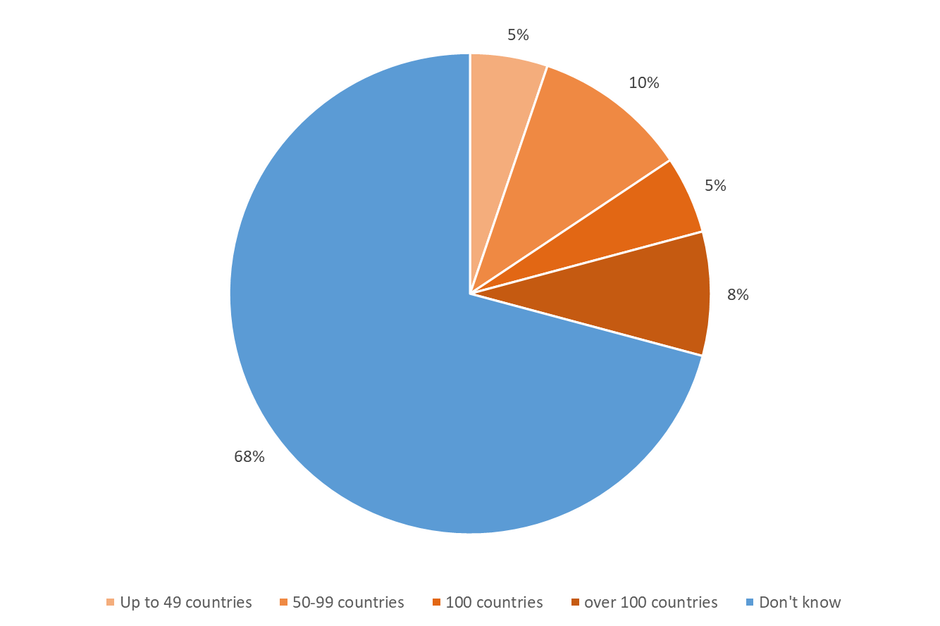

The perception of Poland’s situation in comparison with other countries is connected with the respondents’ social and material status. The higher the respondents’ education, the higher the position of Poland in the classification (on average, 79 countries were mentioned by people with primary education, 81 countries by those with secondary education and 92 by the respondents with tertiary education). More countries were also indicated by residents of the largest cities. Poland is perceived less favourably by the respondents in their thirties (average: 78 countries) and those aged over 70 (average: 75 countries).

Although the number of poorer and less developed countries stated by the respondents has not changed significantly since 2019, the distribution of answers to this question is significantly different in 2022. The greatest change is the increase in the percentage of people who were unable to answer this question (up by 8 percentage points): this percentage was never so high in the previous waves. The percentage of responses “up to 49 countries” and “over 100 countries” decreased significantly. The position of Poland in the minds of Poles has been more or less similar since 2014.

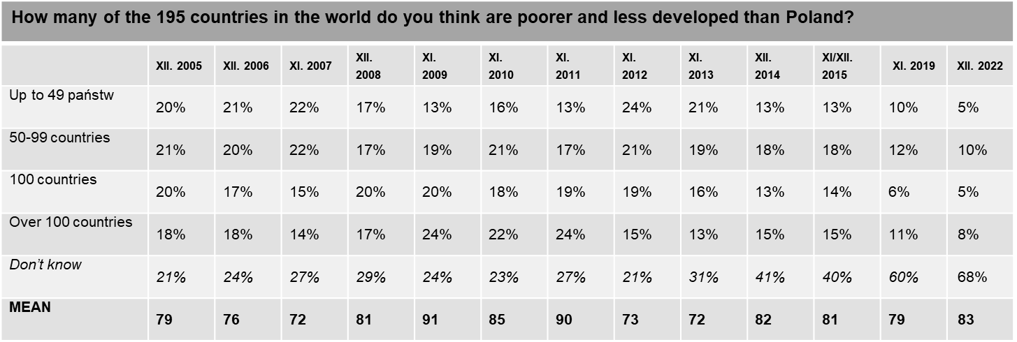

Answers in italics were not read out to the respondents

3.2. Sustainable Development Goals

Overall, 6% of Poles have heard of the Sustainable Development Goals that should be achieved by 2030. 94% of those surveyed have never heard of them. People who heard about them indicated that they had received information on combating disproportions in development of countries and actions taken to ensure that countries develop equally, climate and environmental protection, renewable energy sources, responsible consumption, equal access to education, health care, eradication of hunger, and also helping Africa, access to drinking water, moving away from coal and gas, sustainable agriculture and distribution of resources. Some of the respondents (19 people), however, did not remember what the Sustainable Development Goals were about or knew only the name.

Figure 7 Have you heard about the United Nations Sustainable Development Goals to be achieved in the world by 2030?
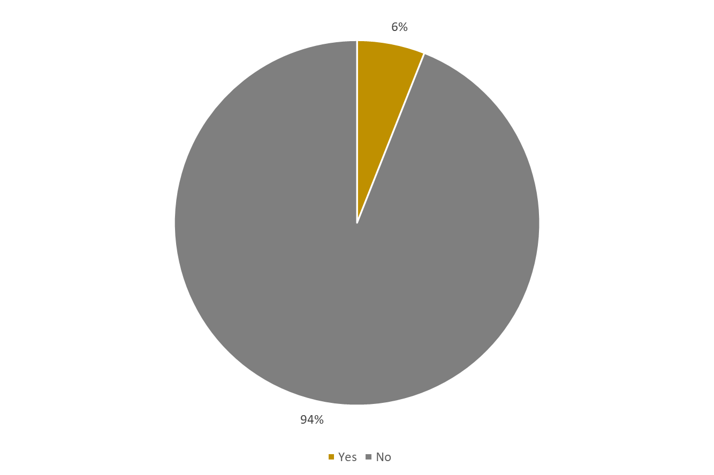

The higher the respondents’ education, the higher the awareness of Sustainable Development Goals (4% among people with primary education, 6% for secondary education, and as much as 10% for those with tertiary education). In general, higher awareness was demonstrated by the respondents from major cities (9% in cities over 500,000 inhabitants) than in rural areas (6%). In addition, the awareness is higher among the respondents in their forties (9%).
On the other hand, a high level of ignorance was recorded among people with primary education (96%), basic vocational education (97%), and inhabitants of the smallest towns (97%).

In subsequent editions until 2014, we asked Poles about their exposure to information on the UN Millennium Development Goals related to reduction of poverty in the world by 2015. At that time, the highest awareness was recorded in 2006 and 2007 (22% each), while the lowest awareness was recorded in in 2014. In 2015, those who declared they had heard of Sustainable Development Goals after 2015 accounted for 7% of the sample. This means that Poles’ awareness of the existence of Sustainable Development Goals after 2015 is lower than the awareness of the existence of UN Millennium Development Goals related to the reduction of poverty in the world by 2015 during the final period of that project. In 2019, when we asked about the Sustainable Development Goals, the awareness increased slightly to 10%, but it dropped again in 2022 (to 6%) - the lowest value since 2005.

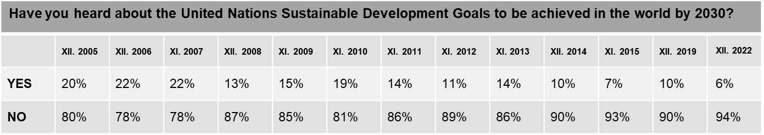
3.3. Greatest challenges faced by less developed countries

According to the respondents, the three major obstacles preventing the development of less developed countries are: problems with access to drinking water (41%), no health care (39%), as well as infectious diseases, including HIV and AIDS (25%). In the context of these issues, the respondents further mentioned military conflicts and other domestic conflicts (24%), the inability to produce sufficient amounts of food (21%), illiteracy (19%) and, mentioned as somewhat less significant by the respondents, non-democratic governments and human rights violations (14%), terrorism (13%), lack of jobs (13%), emigration of residents (12%) as well as environmental pollution and exploitation of natural resources (8%).

Figure 8 Which issues do you think represent the greatest challenges for less developed countries on their path to development?
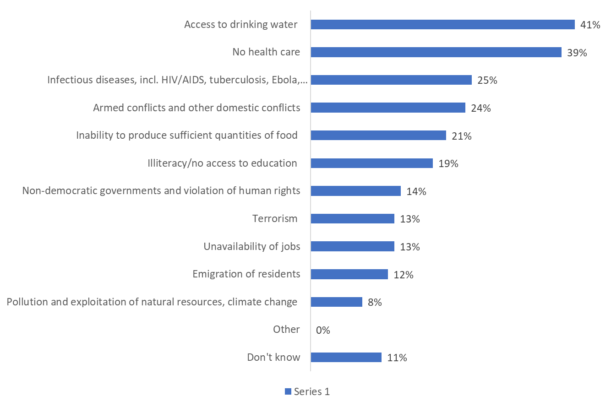

Until this edition, depending on the survey, the respondents tended to see a major challenge for less developed countries in the unavailability of drinking water or in infectious diseases. In the subsequent eleven editions of the survey, in the first editions in 2006–2009, but also in 2014, the problem of infectious diseases was ranked first, while in the subsequent editions in 2010–2013 and the latest edition in 2015, the respondents saw access to drinking water as the major problem. In 2019, lack of health care was indicated most commonly, although the other two problems were also noted as important. The major challenges in 2022 followed a similar pattern, with lack of drinking water was on the leading position.

In comparison with the most recent survey, the percentage of the respondents pointing to barriers related to access to drinking water has now increased by 3 percentage points. Since 2010, this issue has topped the ranking of major challenges facing the less developed countries. Opinions on that subject varies, ranging from 37% to 43% between 2006 and 2009. A significant change occurred in 2010 (when the United Nations General Assembly adopted a resolution recognising “access to clean drinking water and sanitation” as a fundamental human right;, and, following the devastating earthquake in Haiti, much media coverage was focused on the problems of Haiti’s population after the disaster), when as many as 57% of the respondents recognised the importance of access to drinking water. In the following years, the percentage of this response decreased gradually, to reach its five-year low in 2014 (43%). After returning to 50% in 2015, this percentage fell to the 2008 level in 2019 (38%), it is now the most frequently cited challenge in the development path of less developed countries, however, the percentage of indications is one of the lowest in the history of the study.

Infectious diseases are now indicated slightly less frequently than in 2019 (a decrease by 2 percentage points), and they still rank very high in the hierarchy of problems in 2022. Infectious diseases have so far been first (2006–2009, 2014) or second (2010–2013, 2015) in the ranking. In 2022, much as three years ago, they rank third.

In 2022, armed and internal conflicts are outside the top challenges, ranking fourth. Compared to the previous survey, the percentage of mentions has also dropped significantly (by 6 percentage points). A similar decline in mentions terrorism (down by 7 percentage points). In contrast, indications of an inability to produce enough food increased (up by 7 percentage points).
In contrast, respondents’ views have not changed substantially when it comes to the lack of medical care, illiteracy, lack of jobs, emigration of residents, as well as the challenges posed by undemocratic governments and human rights violations, and environmental pollution and exploitation of natural resources (which rank last in the ranking).

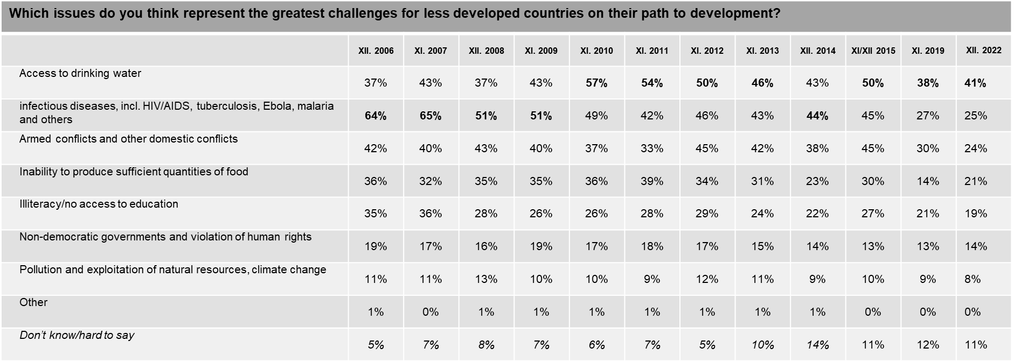
Percentages do not add up to 100% – up to 3 responses were allowed
In this case, categories which ranked first in a particular measurement are given in bold type

Areas, forms and directions for assistance

4.1. Areas of assistance

When asked about areas where Poland has most to offer to less developed countries, Poles, in 2022, most often mentioned improvements in health care (43%) and education (37%).
Other areas that Poland could support in less fortunate countries were identified less frequently. 28% of the respondents indicated assistance in infrastructure development, 21% mentioned agricultural development. 18% mentioned support for economic growth and local entrepreneurship, while 16% indicated crisis prevention and post-conflict reconstruction. Poles were less likely to mention Poland’s support to less developed countries in the field of environmental protection (13%), and democratic reforms, such as the development of local governance (10%).
There were 7% of the respondents who decided that there were no areas where Poland had something to offer to less developed countries, while 9% were unable to indicate any such areas.

Figure 9 In your opinion, in which areas does Poland have most to offer to less developed countries?

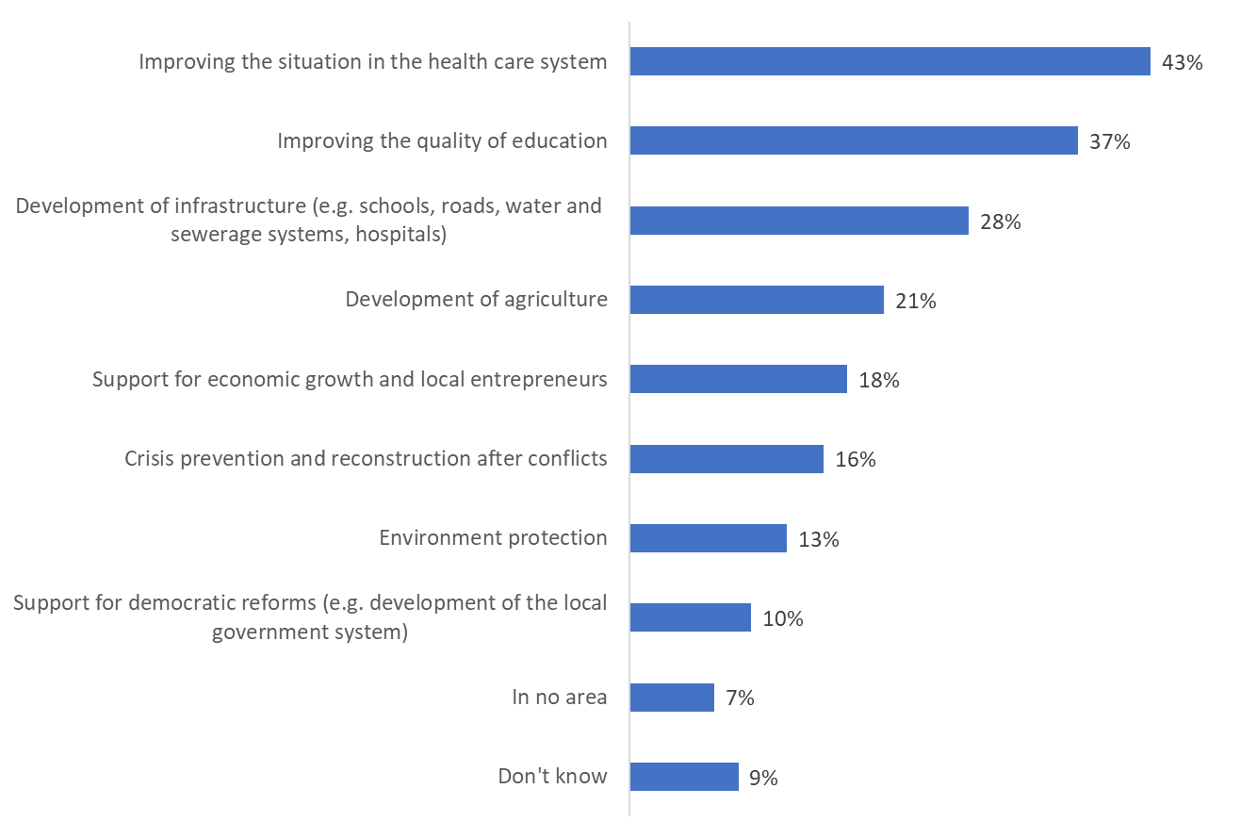
‘Don’t know’ was not read out to the respondents as an answer option

Compared to the situation in 2019, there has been little change in Poles’ opinions on the support Poland should offer to less developed countries. In particular, it is important to note the decreased percentage of people who believe that Poland should help other countries develop agriculture (by 5 percentage points, from 26% in 2019 to 21% in 2022). In this year’s wave of the survey, there was also a decrease in the percentage of people who felt that crisis prevention and post-conflict reconstruction were the areas where Poles could support other countries (by 4 percentage points, from 20% in 2019 to 16% in 2022). Smaller declines were also recorded with regard to the improvement of the level of education (down by 3 percentage points, from 40% in 2019 to 37% in 2022), and fewer respondents felt that Poland could support democratic reforms (by 3 percentage points, from 13% in 2019 to 10% in 2022) and environmental protection (by 2 percentage points, from 15% in 2019 to 13% in 2022). After the recorded increase in 2019 (from 19% in 2015 to 29% in 2019), meaning of infrastructure in the context of what Poland can offer to less developed countries is important for Poles at a slightly lower level in 2022 (28%).

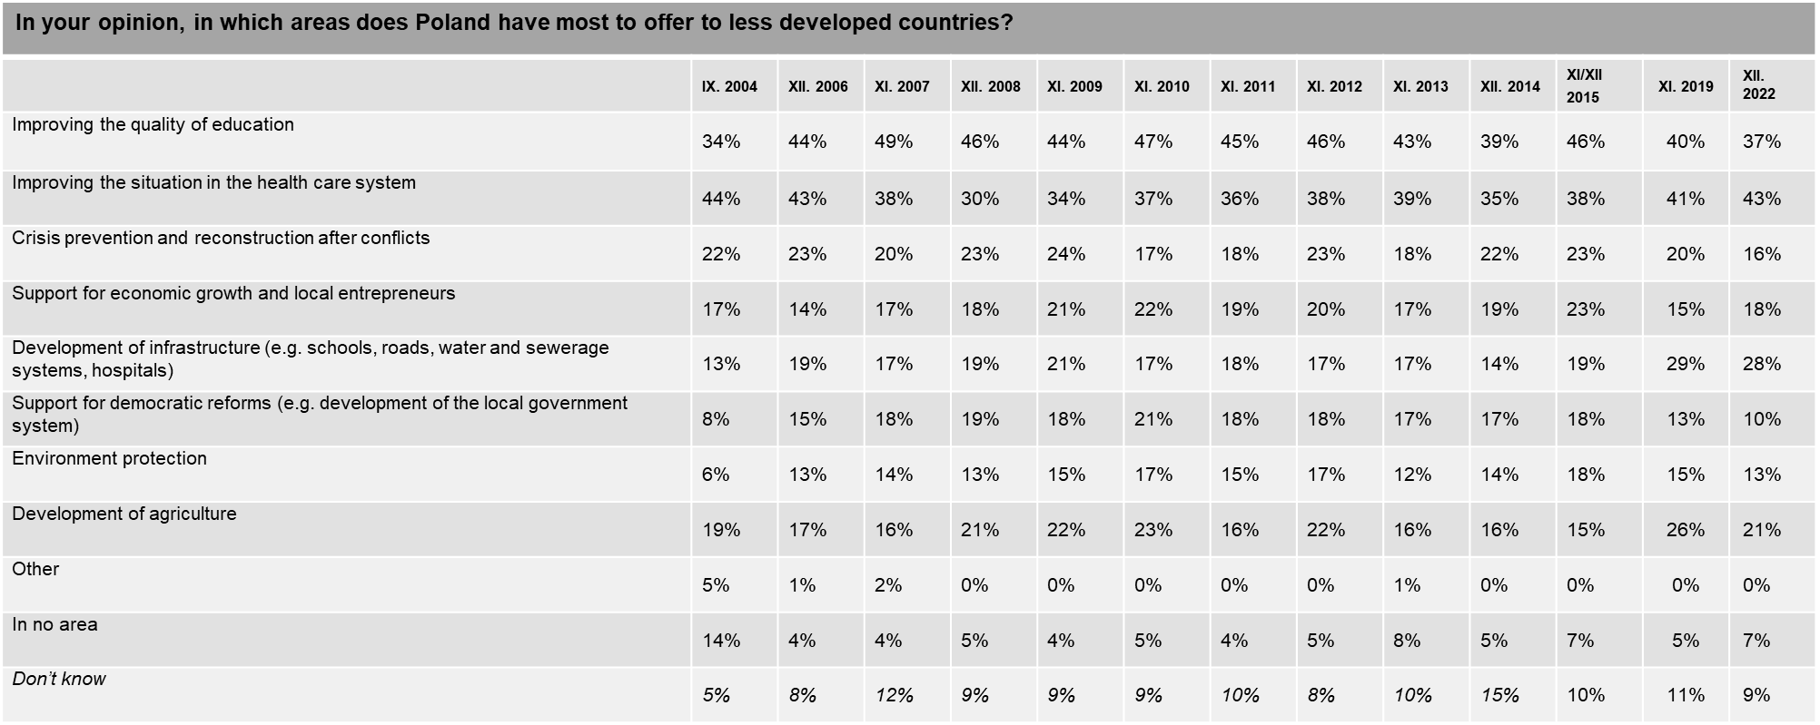Answers given in italics were not read out to the respondents
^{*)} The wording of this question in 2004 was: “In your opinion, in which areas should Poland provide development assistance to poorer countries?”
In 2019 and 2022, the question was worded as follows: “In your opinion, in which areas does Poland have most to offer to less developed countries?”

4.2. Forms and channels of assistance

In 2022, when asked how Poland could contribute to supporting the development of less developed countries, Poles most often indicated support for health care in these countries (37%) as well as sending volunteers there (30%). Other activities were mentioned less commonly, e.g. providing funds for children education (24%), Polish companies’ investments in these countries (19%) and enabling students from less developed countries to study in Poland (18%). Overall, 16% of Poles claim that Poland could support less developed countries also by opening the Polish market to products from these countries, and 15% – by financing or co-financing infrastructure development. Only slightly fewer respondents (14%) believe that Poles could support democratisation processes, and 12% also mention support for environmental protection. One in nine Poles (11%) believes that an appropriate activity for Poland to get involved in is working to resolve internal conflicts, as well as supporting local entrepreneurs. 9% of Poles believe that Poland could be involved in the training of administrative staff and public institutions to help less developed countries.

Supporting medical care in these countries was more often indicated by the youngest people (15-19 years old, 54%) and those in their fifties (41%), those with higher education (43%). Sending volunteers was more often indicated by people with higher education (36%) and residents of the largest cities (42%). The youngest (15-19 years old, 25%, 20-29 years old, 27%), people with secondary and higher education (28% each), residents of rural areas (25%) and the largest cities (25%) mentioned the transfer of funds for children's education more often. Investments of Polish companies in these countries were more often indicated by people aged 30-39 (23%) and 40-49 (22%), with secondary education (23%) and inhabitants of rural areas (22%). Women (20%), 40-year-olds (22%), people with higher education (24%) and residents of cities with a population of up to 100,000 (20%) spoke more often about enabling students from these countries to study in Poland. Opening of the Polish market to products from these countries is indicated to greater extent by men (18%), people aged 15-19 (20%), with higher education (18%). Financing or co-financing the construction of infrastructure was most often indicated by people aged 40-49 (19%), with higher education (21%) and residents of cities with 100-499 thousand inhabitants (18%). Supporting democratization processes was chosen more often by men (15%), people aged 20-29 (24%) and residents of cities with a population of 100,000 to 499,000 (16%). Supporting activities for environmental protection is a possible way for Poland to contribute to supporting less developed countries more often according to men (14%), people aged 15-19 (24%). Work to resolve internal conflicts was more often indicated by 50-year-olds (15%), people with basic vocational education (14%) and in cities with more than 100,000 inhabitants (14% each). Supporting small local entrepreneurs is more often indicated by people in their 20s, 40s and 60s (13% each), people with secondary education (13%) and inhabitants of rural areas (13%). Training of employees of administration and state institutions was chosen mainly by people aged 60-69 (13%).

Compared to the survey conducted in 2019, significant changes of percentage of indications of particular forms of support have been observed. In this year’s measurement the respondents were less likely to indicate that Poland could send volunteers (down by 4 percentage points) and support democratisation processes (down by 3 percentage points). Training of employees in public administration and public institutions was also mentioned less frequently (down by 4 percentage points). On the other hand, more frequent mentions were recorded for Polish companies’ investments in these countries (up 5 by percentage points) and opening the Polish market to products from less developed countries (up by 5 percentage points).

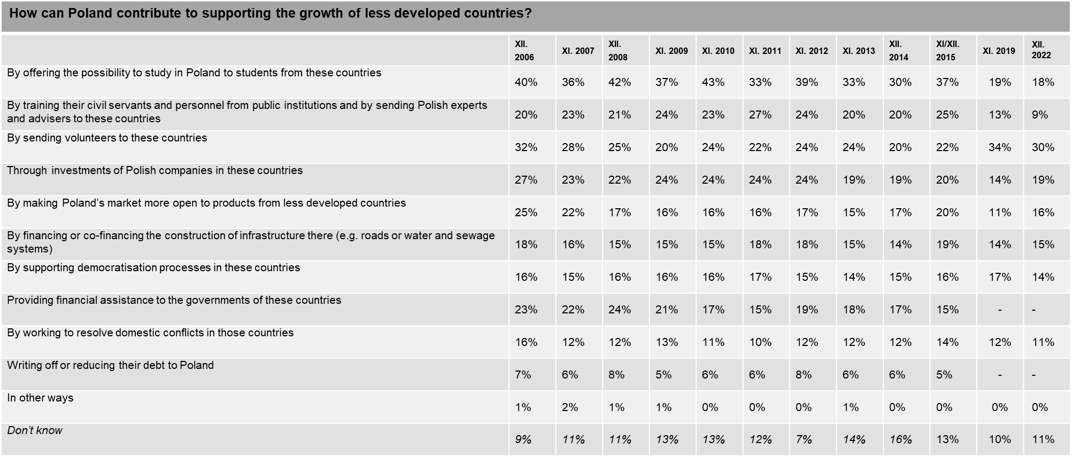
Percentages do not add up to 100% – up to 3 responses were allowed
Answers given in italics were not read out to the respondents.

According to the prevailing opinion, Poland should transfer funds to less developed countries through specialised international organisations (42%) as well as, more commonly, Polish NGOs and companies (47%). More than a quarter of Poles (27%) believe that funds should be channelled through specific Polish investments in these countries. More than one fifth (23%) of the respondents indicate that the transfer of funds should be the responsibility of local organisations.

Polish non-governmental organizations were more often chosen by the youngest people (15-19 years old, 65%), people with secondary education (50%) and residents of cities with 100-499 thousand inhabitants (49%). Specialized international organizations were indicated more often by women (44%), people aged 15-19 and 40-49 (51% each), with higher education (50%) and residents of cities with 100-499 thousand inhabitants (50%) . Polish investments in these countries are a good way to transfer aid more often according to 20-year-olds (35%) and people with higher education (33%). Local organizations were more often chosen by 60-year-olds (28%) and people with secondary education (28%).

Figure 10 In your opinion, how should Poland send aid funds for less developed countries?
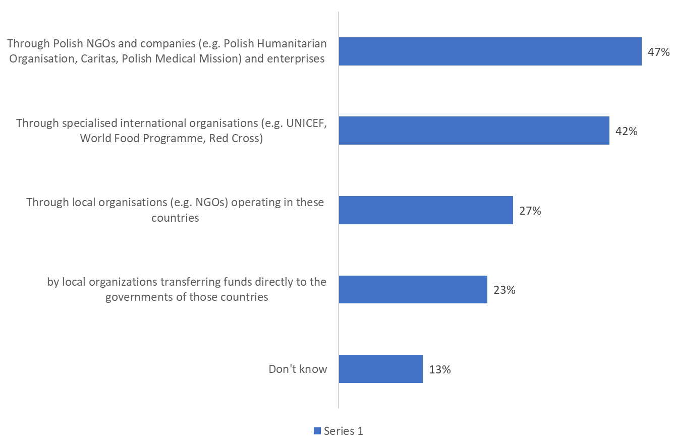

Compared to the previous survey conducted in 2019, the importance of Polish NGOs and companies in transferring funds to less developed countries has increased: the percentage of respondents indicating such organisations as a channel has risen by 5 percentage points reaching the level of 2015. These changes are due to the fact that Poles provided support to Ukrainians in 2022 mainly through local non-governmental organizations and companies, often in a bottom-up manner - international organizations were not of great importance in this process from the perspective of an average Pole.

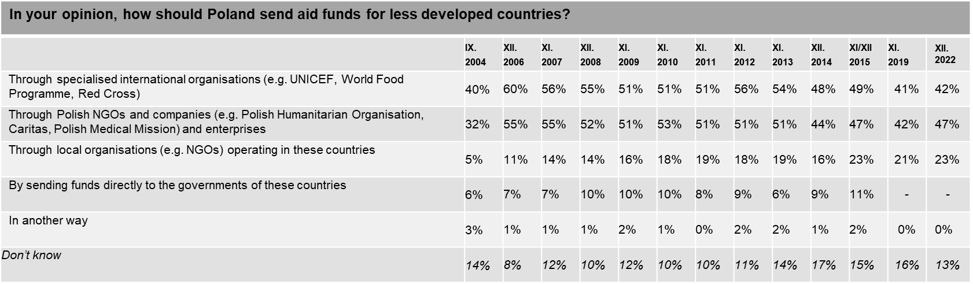
Answers given in italics were not read out to the respondents
^{*)} In 2004, the question was worded as follows: “In your opinion, how should Poland send development assistance funds to less developed countries? This was a single-response question.

4.3. Geographic targets of assistance

According to the respondents’ preferences, African countries (50%) should be the main destination of assistance provided by our country. Poles are far less likely to believe that Polish assistance should be sent to our eastern neighbours (26%), with nearly everyone mentioning Ukraine (99%), and merely 8% indicating Belarus. One in eight respondents indicated: Middle East countries (12%), other countries in the East (12%) and Asian countries (13%) while 7% of the respondents said that Polish assistance should not be sent to any country, while 15% were unable to provide an answer to this question.

African countries were more often indicated by people aged 15-19 (62%), 20-29 (57%) and 60-69 (58%), people with higher education (56%), residents of the largest cities (56%) and the Łódzkie (65%) and Świętokrzyskie (61%) voivodeships. According to men, Poland should help our eastern neighbours more often (27%), older people (60-69 years old - 27%, 70 years old and over - 29%), people with higher education (28%), residents of cities up to 100,000 inhabitants ( 28%) and Lubuskie (49%), Podkarpackie (46%) and Podlaskie (56%). Asian countries were more often chosen by 50-year-olds (16%), people with basic vocational (13%) and secondary (14%) education, residents of cities with up to 100,000 inhabitants (16%) and over 500,000 inhabitants (15%) and the Łódź Voivodeship (25%) and Opole (29%). Other countries in the East were more often indicated by 50-year-olds (16%), people with secondary (15%) and higher education (16%), and residents of the Podlaskie (26%) and Świętokrzyskie (23%) voivodeships. Middle Eastern countries are more often chosen by women (13%), 20-year-olds (16%) and 30-year-olds (15%), inhabitants of cities with up to 100,000 inhabitants (14%) and the Dolnośląskie (17%), Lubelskie (20%), Opolskie (20%) 34%) and Zachodniopomorskie (30%).

Figure 11 In your opinion, countries from which region should Poland provide assistance to, first of all?
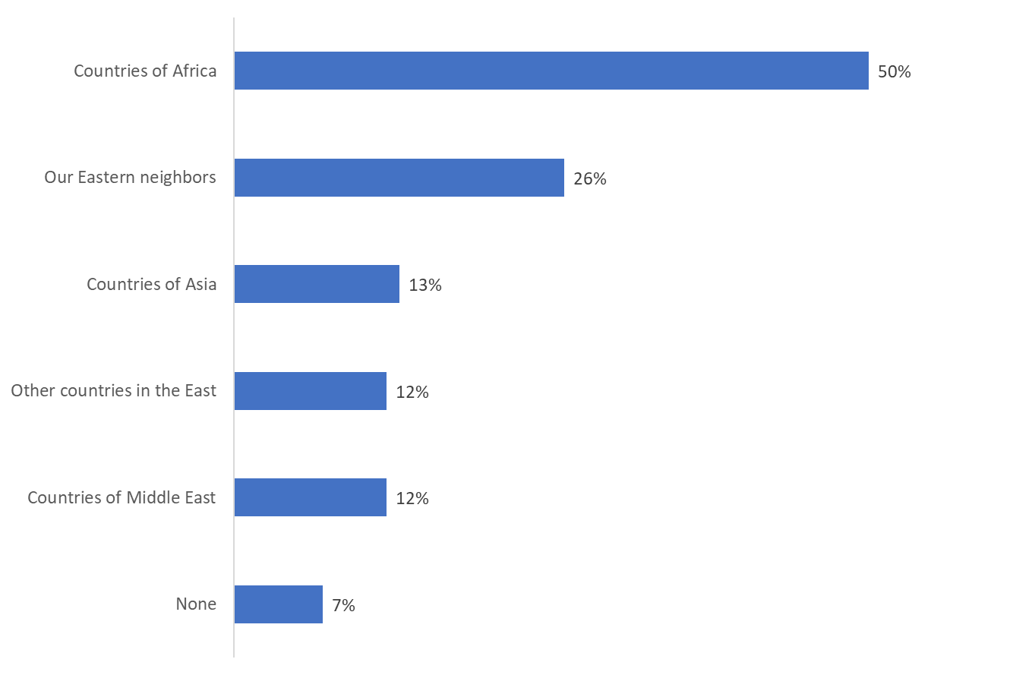
Percentages do not add up to 100% – up to 2 responses were allowed
‘Don’t know’ was not read out to the respondents as an answer option

The results obtained this year have changed. There has been a decrease in mentions for African countries (by 5 percentage points). On the other hand, an increase was recorded for Poland’s eastern neighbours, especially in the context of the situation in Ukraine (by 5 percentage points) and Asian countries (by 3 percentage points). These changes are caused by the war situation in Ukraine.

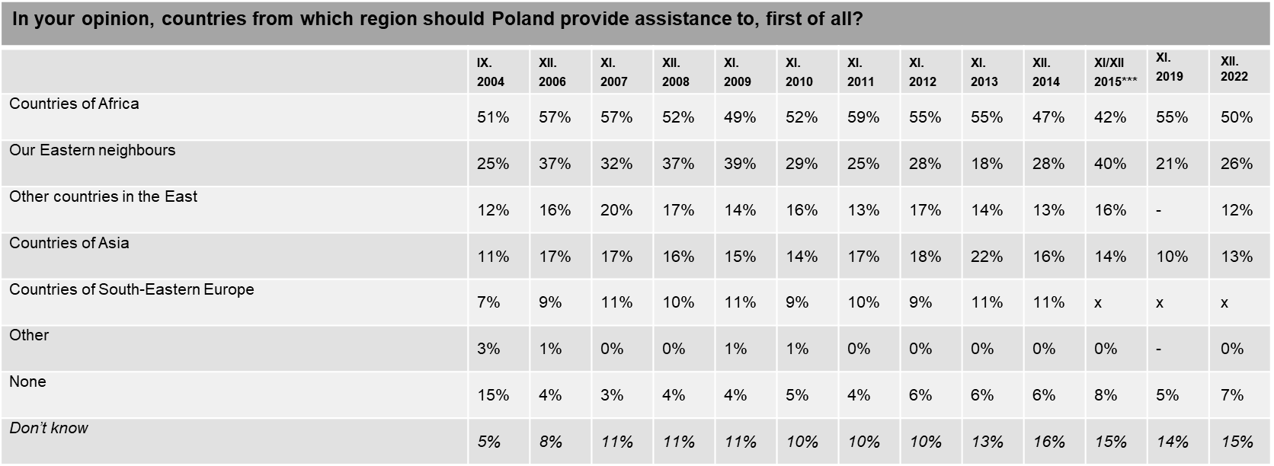
Percentages do not add up to 100% – up to 2 responses were allowed
Answers given in italics were not read out to the respondents.
^{*)} In 2004, Russia was mentioned alongside Ukraine and Belarus.
^{**)} In 2004, the following countries were mentioned as examples in brackets: “(e.g. Moldova, Albania, Serbia and Montenegro)”
***) The 2015 results are provided for information purposes only because the category “countries of South-Eastern Europe” was removed, and the countries given as examples were changed. As a result, the findings are not fully comparable (in the case of African countries the respondents were asked about Angola and Ethiopia until 2014, without mentioning the Middle East countries; in the case of other former Soviet republics in the Caucasus and Central Asia, the question mentioned Georgia, Armenia and Kazakhstan).

Volume of Poland’s aid

Two in five respondents (40%) believe that Poland spends just enough money on development assistance to less developed countries in relation to its potential. Among those who voice some reservations, 17% are of the opinion that Poland spends too much, whereas 13% believe that we do not spend enough.

People aged 20-29 (16%), 40-49 (15%), 60-69 (15%), people with higher education (20%) are more likely to believe that Poland allocates too little money , inhabitants of the largest cities (17%) and villages (15%). People who claim that these expenses are too high are more often in their twenties (22%), in their thirties (18%) and in their fifties (18%), people with secondary education (18%), inhabitants of rural areas (21%) and the largest cities (twenty%). People who believe that expenses are what they should be are more often men (41%), 50-year-olds (48%), educated at the basic vocational level (41%) and secondary (42%) and residents of cities (up to 100,000 inhabitants – 43%, 100-499 thousand inhabitants – 41%, cities over 500 thousand inhabitants – 42%).

Poles’ opinions regarding the amounts to be allocated by Poland on development assistance less developed countries, in relation to our economic potential, have changed significantly since 2019. The percentage of respondents claiming that Poland allocates an adequate amount of aid has dropped by 11 percentage points, and the share of those who think that Poland allocates too little has dropped by 3 percentage points. In contrast, the belief that Polish spending on assistance is too high has risen by 11 percentage points - the percentage of such people reached the highest level in the history of the survey (since 2005).
The increased percentage of those claiming that these expenses are too high may be due to the amount of aid that Poles and Poland provided to Ukrainians in 2022. This fact, in combination with the persistently high inflation, makes some Poles feel that there is too much help.

Figure 12 Do you find the Polish spending on development assistance and humanitarian aid:
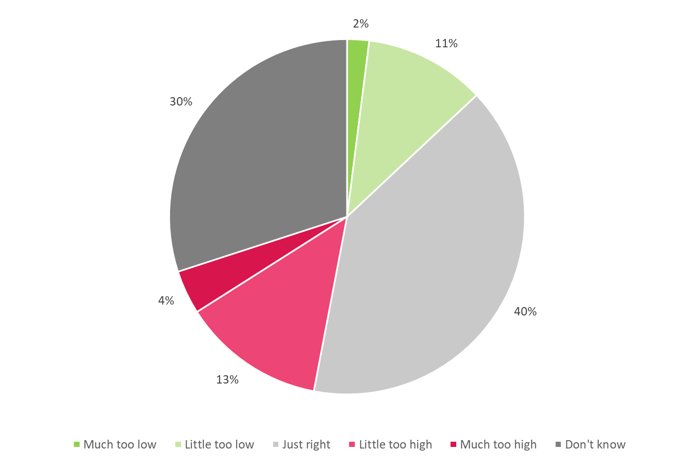
‘Don’t know’ was not read out to the respondents as an answer option
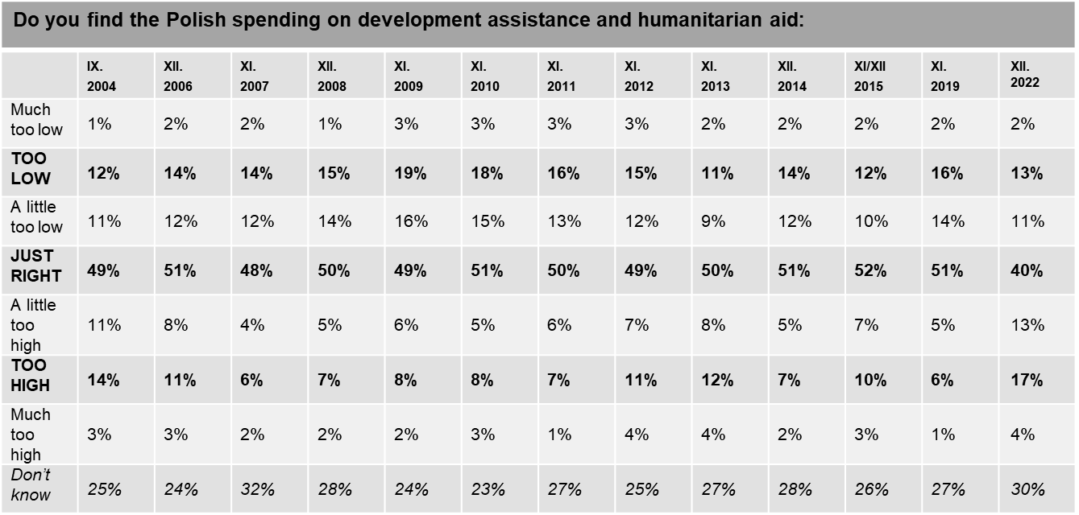
Answers given in italics were not read out to the respondents.

Recognisability of the development cooperation logo

74% of the respondents openly admit that they have no associations with the logo presented to them. The most common substantive answer is that the logo belongs to the Polish Humanitarian Organisation (9%). In total, 93% of the respondents are not familiar with the logo.
7% of Poles associate the presented logo with the Polish Assistance Programme. However, it should be mentioned that 5% of the respondents indicated aid actions for Africa, which may indicate that the logo is associated with the context of the aid itself, and not with a specific brand.

Figure 14 What does this logo make you think of?
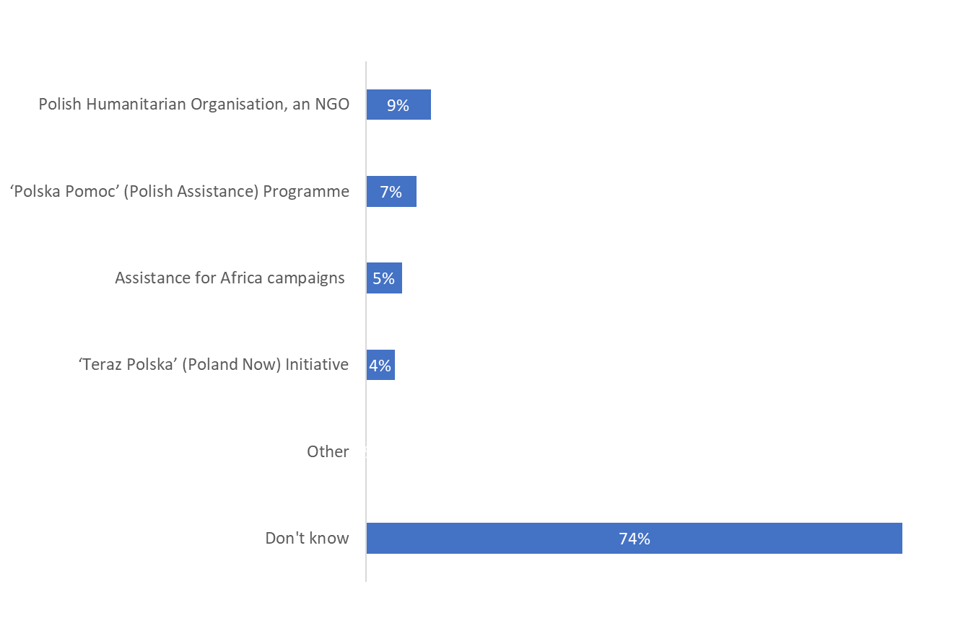
Awareness of the logo of Poland’s Assistance Programme was more common among the respondents aged 70+, those with primary education, inhabitants of the largest cities (12% in cities with a population over 500,000) as well as the Podkarpackie and Warmińsko-Mazurskie provinces (17% each). The logo was less commonly recognised by the inhabitants of large cities (with 100–500 thousand inhabitants).

Compared to the situation three years ago, the familiarity with the logo of the Polish Assistance Programme has dropped by 3 percentage points. It is now the lowest since 2014.

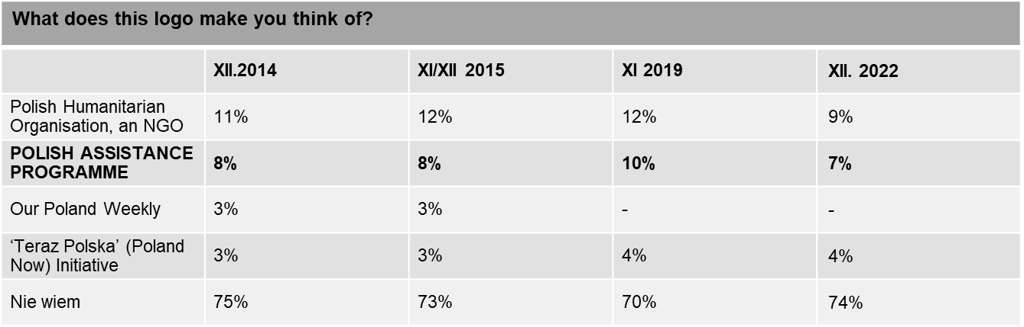

Pole’s involvement in assisting less developed countries

Only eight out of every hundred Poles (8%) have been involved in any way in helping less developed countries. 92% of the respondents admit that they have not participated in such activities so far, while 13% consider doing so in the future. Nearly one in eight respondents (12%) does not see any need to get involved.

Those who do get involved are more likely to be aged 50+, with secondary and tertiary education, living in rural areas. On the other hand, people who do not see the need for help are more often in their thirties (16%), in their forties (14%) and the oldest people (70+, 15%), people with primary (15%) and basic vocational education (16%) and inhabitants of rural areas (14%).

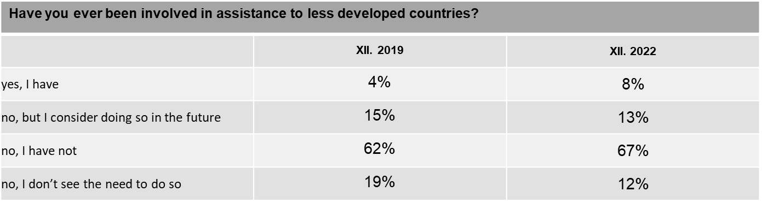

Compared to 2019, the involvement in helping less developed countries has increased (by 4 percentage points). At the same time, the percentage of people who do not see the need to engage in help decreased (by 7 percentage points).

The most popular form of support for less developed countries among those Poles who are involved in it includes transferring money for a specific project or fund-raising activity (63%). Money is slightly less likely to be transferred occasionally to support specific international organisations (24%). One in seven regularly helping respondents (15%) selects projects implemented in less developed countries. Poles are much less likely to get involved in educational or information projects focused on the situation and problems of these countries (8%), to participate in the implementation of assistance programmes (9%) or to make ethical choices when shopping (6%).

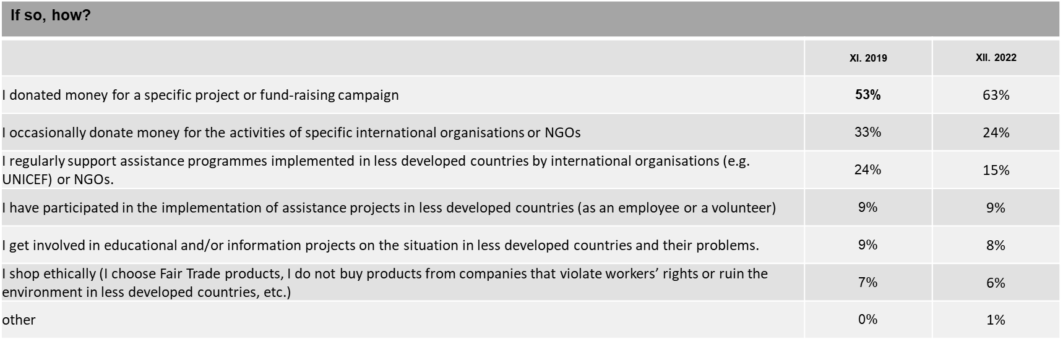

In 2022, Poles were more often (than in 2019) involved in a specific project or collection (by 10 percentage points), and less often donated money to international organizations (by 9 percentage points) and supported through regular aid programs (by 9 percentage points).
Greater mobilization of aid focused around programs and collections may be caused by the bottom-up form of aid that was provided to Ukraine, as well as the great popularity of online collections for specific purposes - e.g. siepomaga.pl.

Assistance to Ukraine

After the outbreak of war in Ukraine on February 24, many Poles became involved in providing support to their eastern neighbour in a situation of war - both by engaging in aid provided in Ukraine, on the Polish-Ukrainian borders, and by supporting refugees who sought refuge in Poland. These events have made the need to help other countries more visible, and international solidarity even necessary.

71% of Poles believe that Poland should support Ukraine in a situation of war in that country, with 19% of them saying so definitely, and 53% - rather. 18% of respondents are of the opposite opinion, with 13% of Poles being less sure and 5% definitely. Every tenth Pole (10%) does not know whether Poland should or should not currently support Ukraine. Young people (81% aged 20-29) and those with higher education (76%) are more likely to believe that they should help. People who disagree are more often people rather young – aged 30-39 (24%) and seniors (70+, 22%), as well as people with education below higher (primary - 21%, basic vocational - 21%, secondary - 19%), as well as residents of the largest cities (24%).

Figure 15. Do you think Poland should or should not support Ukraine in a situation of war in that country?
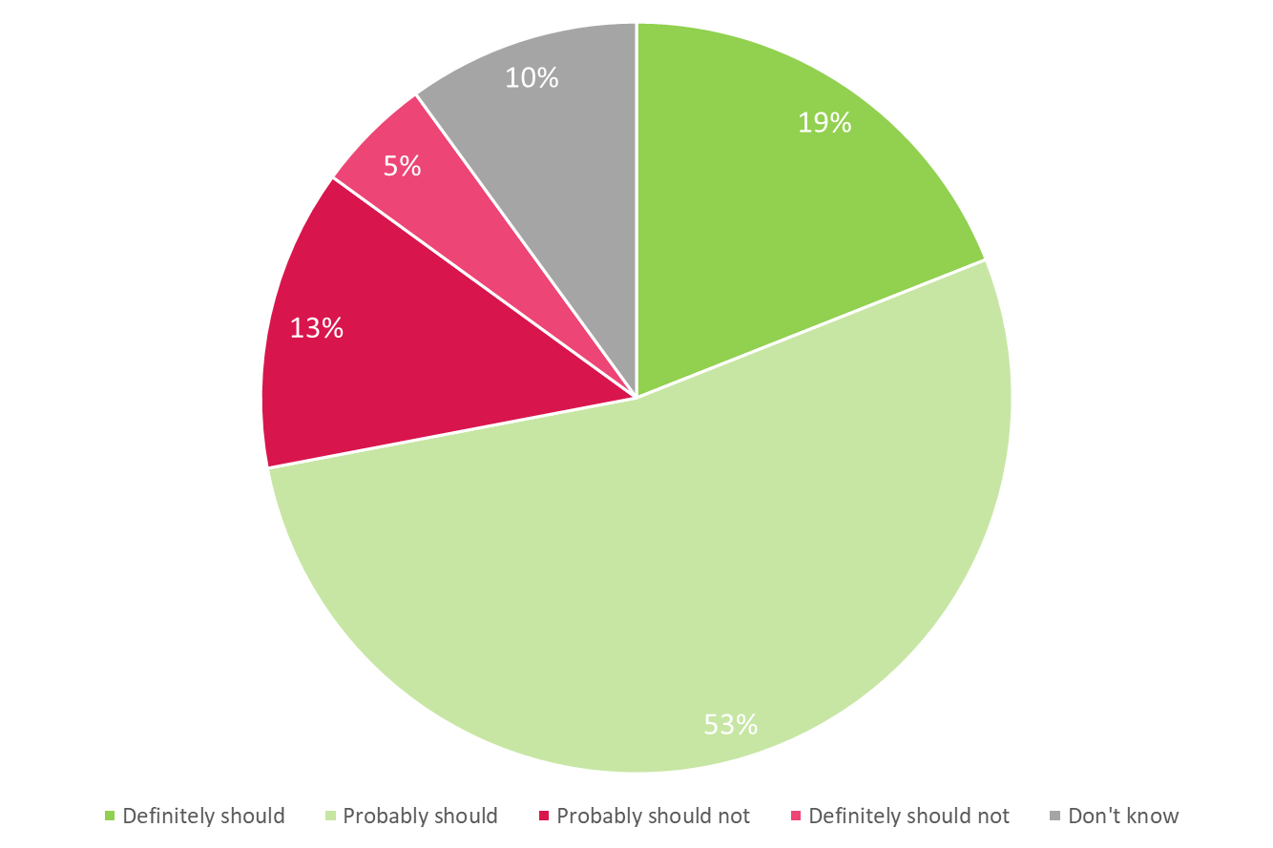
Poles who believe that Poland should support Ukraine say so because they believe that by helping Ukraine Poland increases its own security (56%), that Poles have a moral duty to help our neighbour (44%). One in three supporters of helping Ukraine said that by helping Ukraine on the ground Poland will reduce the inflow of refugees (34%), and also that helping Ukraine can benefit Poland (30%). One in five (21%) respondents believes that helping is a necessity resulting from international obligations assumed by Poland.
Women (57%), people aged 20-29 (62%), 30-39 (61%) and 50-59 (59%), with secondary (60%) or higher (66%) education and residents of the largest towns (62%) are more likely to believe about increasing safety. The moral obligation to help is an argument mentioned more often by men (45%), people aged 15-19 (58%), 30-39 (50%), people with higher education (52%) and residents of towns from 100 to 499 thousands of inhabitants (53%). Women (38%), 60-year-olds (43%), people with higher education (43%) and residents of the largest cities (41%) spoke about limiting the flow of refugees to Poland. Men (31%), 40-year-olds (34%), 50-year-olds (31%) and seniors (32%) are more convinced of the benefits for Poland, as well as people with secondary education (35%) and residents of cities with 100-499 thousand inhabitants (32%) and over 500,000 inhabitants (34%). International commitments, on the other hand, were mentioned more often by people aged 40-49 (28%) and from the largest cities (28%).

Figure 16. If so, why?
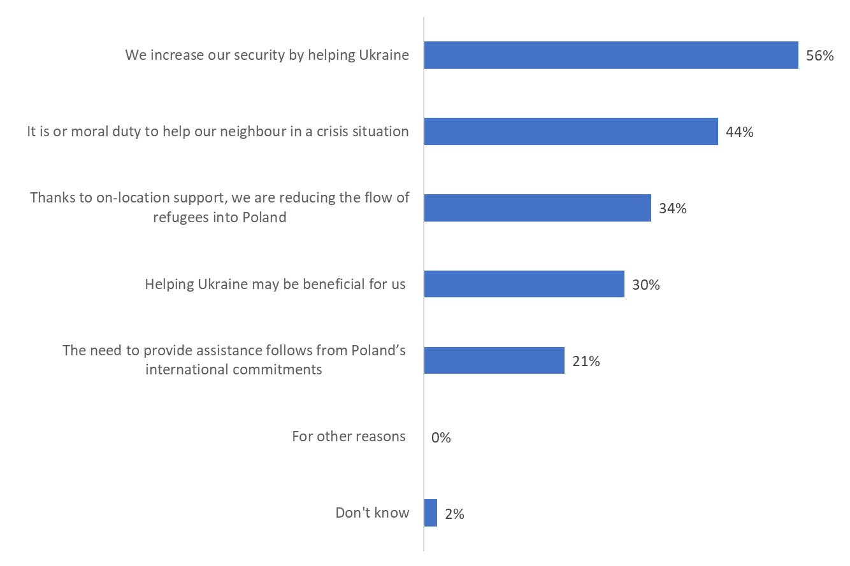
Opponents motivate their answer by saying that Poland should first solve own problems before helping others (43%), or that Poland is too poor to help others (41%). Less frequently, the respondents claim that the assistance received by Ukraine is not used properly (27%), Poland does not receive any help with its problems (22%) or that each country should take care of its own problems (21%).
People who argue that Poland should take care of its own problems first are more often women (47%), people aged 30-39 (49%), 40-49 (50%) and 70 and older ( 50%), as well as people with higher education (60%) and from the largest cities (56%). Poland is too poor to help others more often according to women (44%), people aged 20-29 (55%) and 70 or more (52%) and people with primary education (50%). Aid is misused, however, more often in the opinion of women (29%), 40-year-olds (44%), people with primary (34%) and higher education (33%) and residents of cities with 100-499 thousand inhabitants. No one helps Poland, so Poland has no such obligation was mentioned more often by 20-year-olds (34%), people with basic vocational (28%) and secondary education (26%) and residents of the largest cities (28%). The answer "each country should take care of itself" was more often indicated by women (23%), 60-year-olds (33%), people with higher education (31%) and residents of cities with up to 100,000 inhabitants (24%).

Figure 17. If not, why not?
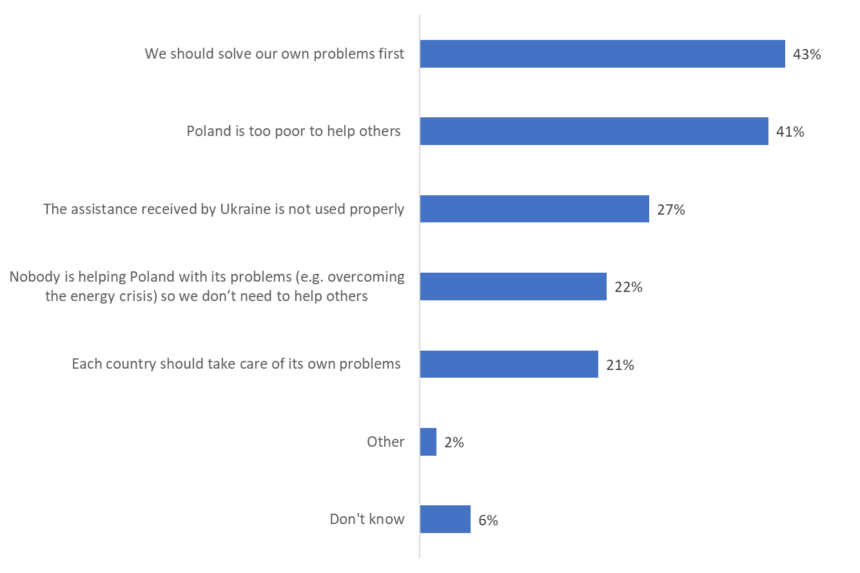

More than a half of Poles (54%) believe that Poland’s help for Ukraine and Ukrainian refugees will be beneficial for our country in the long term. The opposite view is held by 26% respondents. Those who are convinced of the benefits for Poland are mainly the youngest people (aged 15–19), with secondary (57%) and tertiary education (58%), living in towns with up to 100,000 inhabitants. These people believe that the next things that should be done for Ukraine are to increase humanitarian aid within Ukraine (55%), medical assistance within Ukraine (46%), and food assistance within Ukraine (46%). Less frequent mentions include increased economic assistance (28%) and support for refugees within Poland (28%).
People who believe that helping Ukraine may be unfavourable for Poland are more often men (27%), thirty-year-olds (29%) and fifty-year-olds (31%), people with vocational (28%) and secondary education (28%), and residents of the largest cities (41%). Those who believe that assistance to Ukraine could be detrimental to Poland say that support for refugees in our country should be reduced (51%). Less frequently, they mention the need to reduce economic assistance (31%), food assistance (22%), humanitarian aid (17%) and medical assistance (17%).

Figure 18. What do you think, is Poland’s assistance to Ukraine and Ukrainian refugees going to benefit our country in the long term?

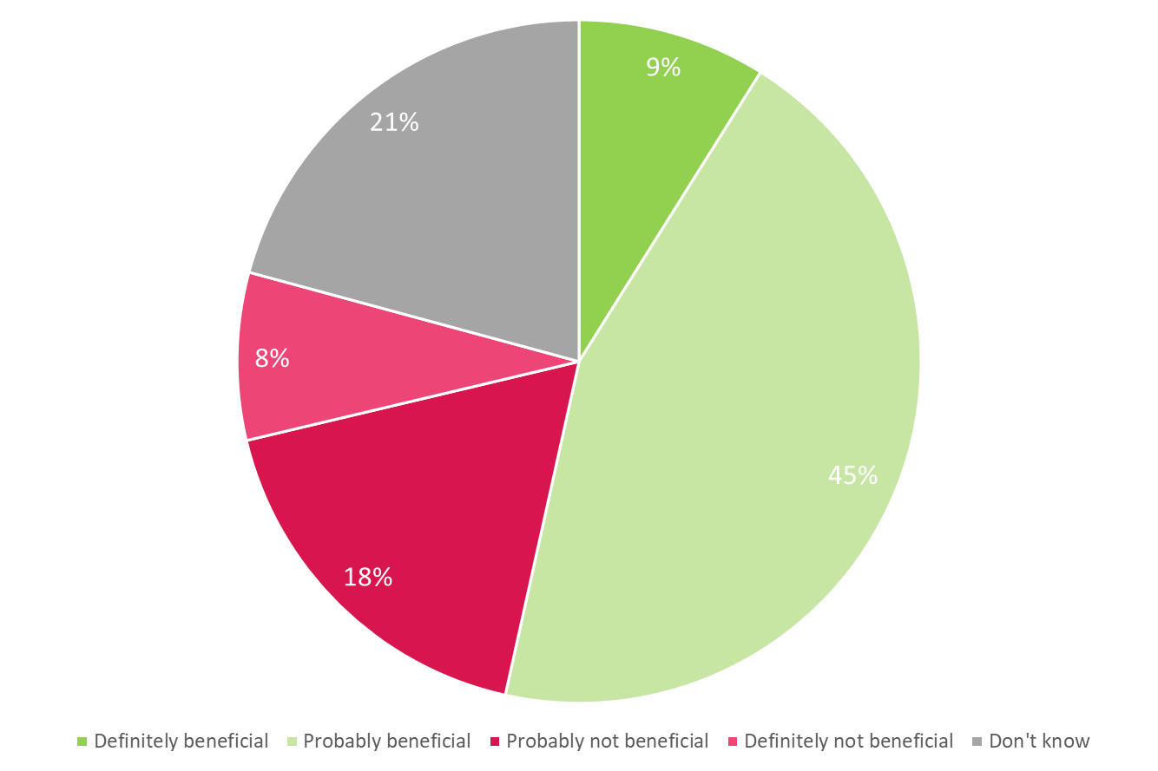

One third of Poles (32%) would not want to allocate additional funds to help Ukraine and Ukrainian refugees. However, 54% would allocate such an additional amount: 11% would allocate less than PLN 5 per month, one in four respondents (26%) would allocate PLN 5 per month, and 16% of Poles would allocate PLN 10 or more.
People who would spend money for this purpose are more often women, 60-year-olds, people with higher education and residents of smaller towns (up to 100,000 inhabitants).
Those reluctant to provide financial assistance are more likely to be male, aged 20–29, educated to primary and basic vocational level, and living in the largest cities.

Figure 19. Would you voluntarily agree to donate the following amount extra per month to help Ukraine and Ukrainian refugees?

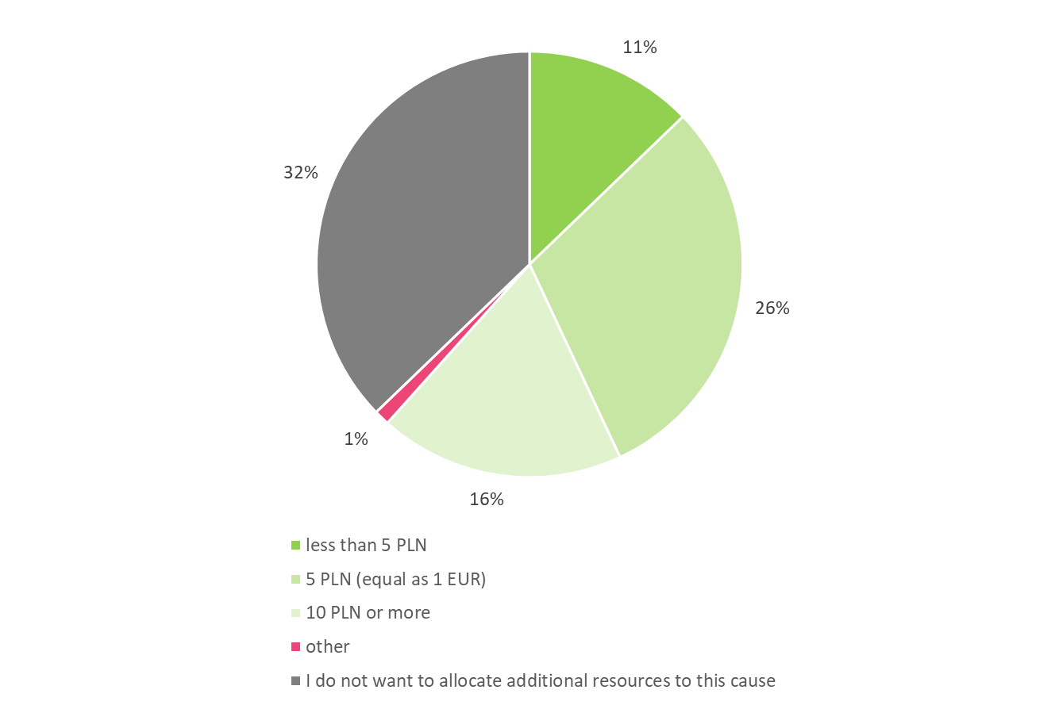

‘Development Assistance 2022’ – Framework Questionnaire

O1 | How many of the 195 countries in the world do you think are poorer and less developed than Poland?  Allow thinking time. Probe. Write in the number provided by the respondent. |  |  | .....................................  (write in number)  Don’t know
O2 | Have you heard about the United Nations Sustainable Development Goals to be achieved in the world by 2030?  (if “no”, skip to O4) |  |  | - Yes  - No
O3 | If so, please name at least one of those goals. |  |  | .....................................  (write in)
O4 | In 2021, Poland spent PLN 3.797 billion on development assistance and humanitarian aid. This accounts for approx. 0.7% of the country’s budget (the total Polish budget is approx. PLN 521 billion). Do you find the Polish spending on development assistance and humanitarian aid:  Single code only. |  |  | - Much too low  - A little too low  - Just right  - A little too high  - Much too high  - Not sure
O5 | Over the past two or three months, have you come across information on Poland’s aid for less developed countries?  (if “not”, skip to O6) |  |  | - Yes
 |  |  |  | - No
O5a | Where did the information come from?  Code all that apply |  |  | - press,  - radio,  - television,  - Internet (Facebook, YouTube, Twitter, news websites etc.),  - school, university,  - church, parish,  - relatives, friends,  - exhibitions, leaflets,  - books,  - other sources (specify).............................. write in  - can’t remember
O5b | If so, what was the information about?  Write in verbatim! Probe.  ......................................................................................................................................................................................  ......................................................................................................................................................................................  ......................................................................................................................................................................................  ......................................................................................................................................................................................
O6 | Which issues do you think represent the greatest challenges for less developed countries on their path to development?  Hand in Showcard O6  Indicate no more than 3 main challenges |  |  | - illiteracy/no access to education  - no health care  - infectious diseases, incl. HIV/AIDS, tuberculosis, Ebola, malaria and others  - access to drinking water  - inability to produce sufficient quantities of food  - pollution and exploitation of natural resources, climate change  - armed conflicts and other domestic conflicts  - terrorism  - non-democratic governments and violation of human rights  - emigration of residents  - unavailability of jobs  - other (specify).............................. write in  - don’t know
Read out:
Many countries and international organisations support the development of less developed countries. They help them financially and materially, and send specialists. The aim of that aid is primarily to support economic growth, reduce poverty, support democratic reforms, rule of law, self-governance, prevent domestic conflicts and improve global safety. Development assistance is supposed to provide sustainable support for those countries. Development assistance is not the humanitarian aid which is provided ad hoc in the case of humanitarian crises, natural disasters, military conflicts, etc.
O7 | In your opinion, should Poland support the development of less developed countries or not?  One answer only  (if “not”, skip to Q7b, if “don’t know”, skip to Q8) |  |  |  | - definitely should  - probably should
- probably should not
- definitely should not
 |  |  |  |  | - don’t know
O7a | If so, why?  Multiple answers allowed  (skip to O8) |  | - it is our moral duty to help less developed countries  - richer countries helped us in the past so now we should help those which are poorer  - Poland is affluent enough to help others  - helping others may be beneficial for us, e.g. improve Poland’s international security and prestige  - the situation in Poland also depends on what is happening in other countries, even in remote corners of the world (e.g. due to climate change)  - through on-location support, we counteract illegal migration of people from less developed countries  - the need to provide assistance follows from Poland’s international commitments  - for other reasons (specify)..............................................write in  - don’t know
O7b | If not, why not?  Multiple answers allowed. |  | - nobody helped Poland so we don’t need to help others  - Poland is too poor to help others  - we should solve our own problems first  - each country should take care of its own problems  - assistance received by less developed countries is not used properly  - other (specify)...........................................................write in  - don’t know
O8 | How can Poland contribute to supporting the growth of less developed countries?  Hand in Showcard O10  Maximum 3 responses allowed |  | - by working to resolve domestic conflicts in those countries  - by supporting democratisation processes in these countries  - by training their civil servants and personnel from public institutions and by sending Polish experts and advisers to these countries  - by sending volunteers to these countries  - by offering the possibility to study in Poland to students from these countries  - by providing funds to educate children (schools, preschools) and adults (university students, teachers)  - by supporting health care in those countries  - by financing or co-financing the construction of infrastructure there (e.g. roads or water and sewage systems)  - by supporting activities for environment protection and climate in less developed countries  - by supporting small local entrepreneurs, including entrepreneurial women  - through investments of Polish companies in these countries  - by making Poland’s market more open to products from less developed countries  - in other ways (specify)..................................... write in  - don’t know
O9 | In your opinion, countries from which region should Poland provide assistance to, first of all?  Two answers are allowed. |  | - our Eastern neighbours  a) Ukraine  b) Belarus  - other countries in the East (e.g. Moldova, Georgia, Armenia)  - countries of Africa (e.g. Ethiopia, Kenya, Senegal, Uganda, Tanzania)  - countries of the Middle East (Palestine, Lebanon)  - countries of Asia (e.g. Burma/Myanmar, Laos)  - other (specify)............................................write in  - none  - don’t know
O10 | In your opinion, in which areas does Poland have most to offer to less developed countries?  Multiple answers allowed. |  | - crisis prevention and reconstruction after conflicts  - improving the situation in the health care system  - improving the quality of education  - environment protection  - development of agriculture  - support for democratic reforms (e.g. development of the local government system)  - support for economic growth and local entrepreneurs  - development of infrastructure (e.g. schools, roads, water and sewerage systems, hospitals)  - other (specify) ...............................................write in  - in no area  - don’t know
O11 | In your opinion, how should Poland send aid funds for less developed countries?  Multiple answers allowed. |  | - through Polish NGOs and companies (e.g. Polish Humanitarian Organisation, Caritas, Polish Medical Mission) and enterprises  - through Polish investments in those countries  - through specialised international organisations (e.g. UNICEF, World Food Programme, Red Cross)  - through local organisations (e.g. NGOs) operating in these countries  - by sending funds directly to the governments of these countries  - in another way (specify) …….…  - don’t know
O12 | What does this logo make you think of?  Show the logo of Polish assistance | - ‘Teraz Polska’ (Poland Now) Initiative  - ‘Polska Pomoc’ (Polish Assistance) Programme  - Polish Humanitarian Organisation, an NGO  - assistance for Africa campaigns  - other (specify)...............................................write in  - don’t know
O13 | Have you ever been involved in assistance to less developed countries? | - yes, I have  - no, but I consider doing so in the future  - no, I have not  - no, I don’t see the need to do so
O13a | If so, how? | - I donated money for a specific project or fund-raising campaign  - I occasionally donate money for the activities of specific international organisations or NGOs  - I regularly support assistance programmes implemented in less developed countries by international organisations (e.g. UNICEF) or NGOs.  - I have participated in the implementation of assistance projects in less developed countries (as an employee or a volunteer)  - I get involved in educational and/or information projects on the situation in less developed countries and their problems.  - I shop ethically (I choose Fair Trade products, I do not buy products from companies that violate workers’ rights or ruin the environment in less developed countries, etc.)  - other (specify)...............................................write in

Read out:
In 2022, Russia’s aggression against Ukraine triggered an unprecedented migration and development crisis. The resulting damage to infrastructure and loss of human and economic potential poses a significant threat to the future of that country. Therefore, in 2023, Poland will continue to provide humanitarian aid to Ukraine. At the same time, the priority of Polish development assistance will be the recovery of Ukraine and support for Ukrainian institutions and society in response to the conflict.
O14 | Do you think Poland should or should not support Ukraine in a situation of war in that country?  Single code only  (if “no”, skip to O14b, if “don't know”, skip to O15) | - yes, it definitely should  - yes, it probably should
- no, it probably should not
- no, it definitely should not
 |  | - don’t know
O14a | If so, why?  Multiple codes possible.  (go to O15) | - it is or moral duty to help our neighbour in a crisis situation  - we increase our security by helping Ukraine  - helping Ukraine may be beneficial for us (e.g. increase Poland’s prestige in the world, bring Polish companies to the Ukrainian market)  - thanks to on-location support, we are reducing the flow of refugees into Poland  - the need to provide assistance follows from Poland’s international commitments  - for other reasons (specify)..............................................write in  - don't know
O14b | If not, why not?  Multiple codes possible. | - nobody is helping Poland with its problems (e.g. overcoming the energy crisis) so we don’t need to help others  - Poland is too poor to help others  - we should solve our own problems first  - each country should take care of its own problems  - the assistance received by Ukraine is not used properly  - other (specify)...........................................................write in  - don't know
O15 | What do you think, is Poland’s assistance to Ukraine and Ukrainian refugees going to benefit our country in the long term?  Single code only  (if “no”, skip to O15b, if “don't know”, skip to O16) | - yes, it will definitely be beneficial  - yes, it will probably be beneficial
- no, it will probably not be beneficial
- no, it will definitely not be beneficial
 |  | - not sure
O15a | If so, what else should be done to help Ukraine?  (skip to O16) | - increase support for refugees within our country  - increase humanitarian aid in Ukraine  - increase food aid in Ukraine  - increase medical assistance in Ukraine  - increase economic aid  - other specific actions (specify).............................................. write in  - not sure
O15b | If not, what kind of assistance to Ukraine should be reduced in the first place? | - reduce support for refugees within our country  - reduce humanitarian aid in Ukraine  - reduce food aid in Ukraine  - reduce medical assistance in Ukraine  - reduce economic aid  - other specific actions (specify).............................................. write in  - not sure
O16 | Would you voluntarily agree to donate the following amount extra per month to help Ukraine and Ukrainian refugees? | - less than PLN 5  - PLN 5 (equivalent to EUR 1)  - PLN 10 or more  - other amount (specify) ........................................... write in  - I do not want to allocate additional resources to this cause  - not sure

Key to question O4a
Information on Poland’s assistance to other countries
Multiple coding e.g.: “construction of wells with drinking water” (3. construction of infrastructure and 5. unavailability of drinking water).
If '97. not sure”, no other code can be present
In the case of continents, if the name of a country is mentioned, we provide the code for both the continent and the country mentioned (e.g. “food parcels for Poles in Kazakhstan” is coded with: 4, 10, 32 and 39).

- overall: humanitarian aid – aid for the poor, the needy, fighting poverty, wherever problems occur
- economic aid;
- construction and assistance in re/construction of infrastructure – medical centres, schools

- food assistance, combating starvation, the problem of starvation,
- unavailability of drinking water
- collections of clothing, footwear, blankets, tents;
- cash collections, money collection via bank transfers; financial assistance, payments via text messages
- medical assistance, collection of medicines, vaccines, assistance from Polish doctors, assistance for those suffering from AIDS, infectious diseases
- other, and overall – material assistance, in kind assistance (e.g. cleaning products)
- assistance for Polish diaspora abroad – assistance for Poles (living in countries to the East of Poland)

- military assistance – sending troops (to Iraq, Afghanistan), peace-keeping missions, stabilising missions, sending aid in connection with armed conflicts
- assistance in reinforcing democratisation processes – assistance to democratic opposition in totalitarian regimes
- assistance for victims of natural disasters, earthquakes, tsunami, floods, droughts, landslides
- assistance to children, ‘distance adoptions’
- assistance to victims of war, violence – invalids, war victims
- assistance to refugees;

- overall: assistance to third world countries, assistance to least developed countries

- assistance to Africa, African countries

- Chad
- Ethiopia
- Ghana
- Kenya
- Congo (Zaire)
- Madagascar
- Somalia
- Sudan, Darfur
- Uganda
72 Libya

- assistance to Latin American countries – South America, Central America

- Mexico
- Nicaragua
- Peru
67. Haiti
68. Chile
77. Dominican Republic

- assistance to former USSR countries and its area of influence (the countries of the former “people’s democracies”), in the East

- Armenia
- Belarus
- Croatia
- Chechnya
- Georgia
- Countries of the former Yugoslavia (in general)
- Kazakhstan
- Lithuania
- Russia
- Romania
- Slovakia
- Ukraine
76. Latvia

- assistance to Asian countries, assistance to Middle East countries

- Afghanistan
- Bangladesh
- China
- Philippines
- India
- Indonesia
- Iraq
- Iran
- Cambodia
- Lebanon

- Thailand
- Sri Lanka

71. Turkey
70. Japan
72. Libya
73. Syria
75. Vietnam

- assistance from church institutions, the (Roman Catholic) Church, CARITAS, Catholic missions
- assistance organised by the Polish Humanitarian Organisation (PAH) headed by Janina Ochojska, ‘PAJACYK’ campaign
- assistance organised by the Polish Red Cross, PCK
- assistance organised by other institutions
- assistance organised by other people or with participation of other people

- assistance to European countries – in connection with the financial crisis
- Iceland
- Ireland
69. Greece

90. general statements – rich/richer countries have an obligation to help the poor, generally: global assistance
96. other
97. not sure, can’t remember

TNS OBOP for the Canadian Embassy in Poland, a survey of 2–5 September 2004; a nation-wide representative random sample of 1,004 Polish citizens aged 15+.
TNS OBOP for the United Nations Development Programme; a survey of 1–5 December 2005; a nation-wide representative random sample of 1,004 Polish citizens aged 15+; and TNS OBOP for the Ministry of Foreign Affairs, a survey of 7–11 December 2006; a nation-wide representative random sample of 1,005 Polish citizens aged 15+, a survey of 22–26 November 2007; a nation-wide representative random sample of 1,004 Polish citizens aged 15+, a survey of 4–8 December 2008; a nation-wide representative random sample of 1,001 Polish citizens aged 15+, a survey of 26–29 November 2009; a nation-wide representative random sample of 1,004 Polish citizens aged 15+; a survey of 25–28 November 2010; a nation-wide representative random sample of 1,003 Polish citizens aged 15+; a survey of 17–25 November 2011; a nation-wide representative random sample of 1,000 Polish citizens aged 15+; (already as TNS Polska) a survey of 23–27 November 2012; a nation-wide representative random sample of 1,000 Polish citizens aged 15+; (already as TNS Polska) a survey of 22-27 November 2013; a nation-wide representative random sample of 1,000 Polish citizens aged 15+; ***( already as TNS Polska) a survey of 5-10 December 2014; a nation-wide representative random sample of 1,000 Polish citizens aged 15+; TNS Polska for the Ministry of Foreign Affairs, a survey of 27 November - 2 December 2015; a nation-wide representative random sample of 1,014 Polish citizens aged 15+.
The resolution called upon UN member states and international organisations to provide financial and technological support to poorer countries and to make joint efforts to ensure clean water for all people.

