[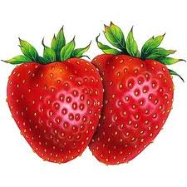](http://www.google.pl/imgres?q=owoce&um=1&hl=pl&biw=1024&bih=695&tbm=isch&tbnid=jFD4WevF0kZMiM:&imgrefurl=http://maria-51.bloog.pl/id,4868656,title,owoce-napoje-desery,index.html&docid=BJMIg4ru6jFtzM&imgurl=http://4.bp.blogspot.com/_lddFFu6s4yQ/SfLzOYf6OXI/AAAAAAAASkY/IHuLSZe_ojM/s400/owoce18.jpg&w=300&h=300&ei=ssmoT6PEH7LO4QScgImFCQ&zoom=1&iact=hc&vpx=357&vpy=179&dur=1974&hovh=225&hovw=225&tx=111&ty=124&sig=105733949763196923014&page=4&tbnh=158&tbnw=158&start=44&ndsp=16&ved=1t:429,r:1,s:44,i:241)[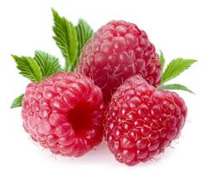](http://www.google.pl/imgres?q=owoce&um=1&hl=pl&biw=1024&bih=695&tbm=isch&tbnid=K3OPhlnZB-f7yM:&imgrefurl=http://strony.liceum-zwolen.pl/1a/gr5/index.php/polskie-owoce&docid=-CyipeWAkngscM&imgurl=http://strony.liceum-zwolen.pl/1a/gr5/images/malina.jpg&w=377&h=318&ei=ssmoT6PEH7LO4QScgImFCQ&zoom=1&iact=hc&vpx=737&vpy=155&dur=273&hovh=206&hovw=244&tx=128&ty=139&sig=105733949763196923014&page=4&tbnh=158&tbnw=187&start=44&ndsp=16&ved=1t:429,r:3,s:44,i:245)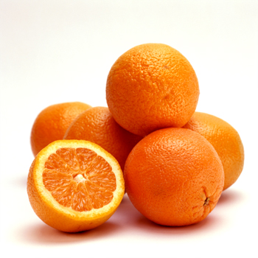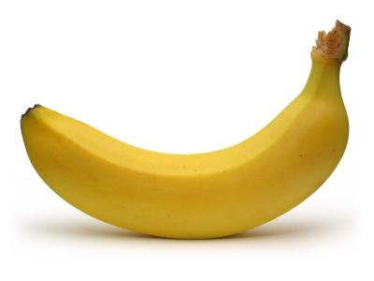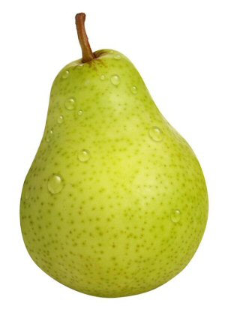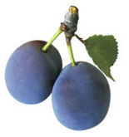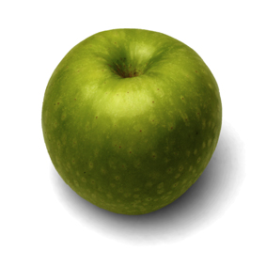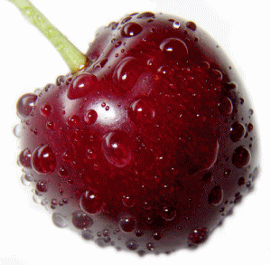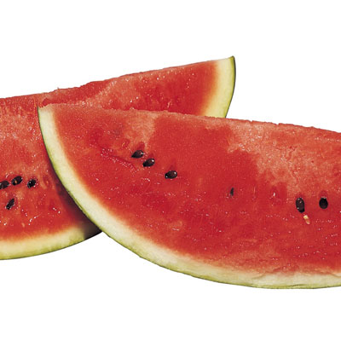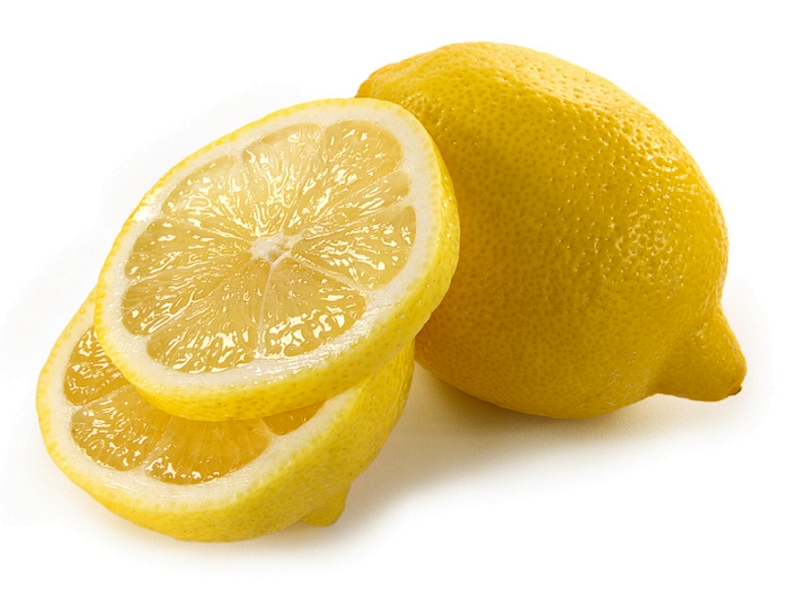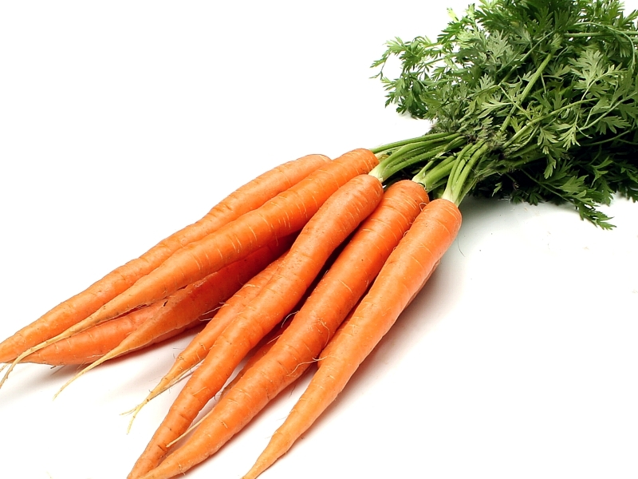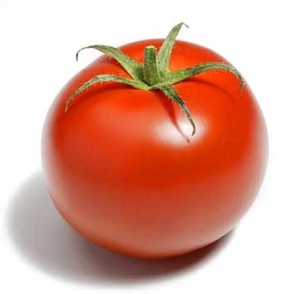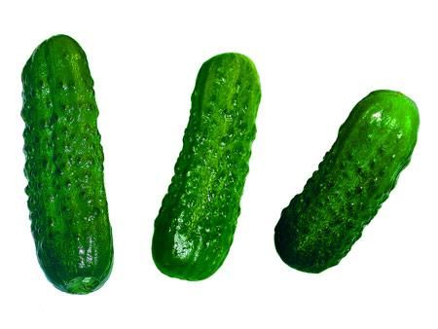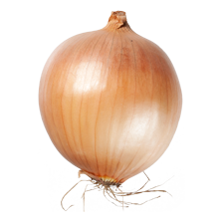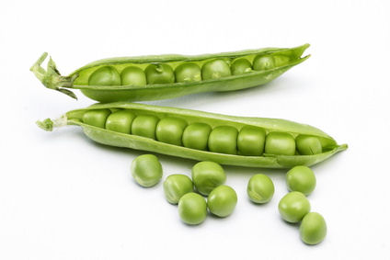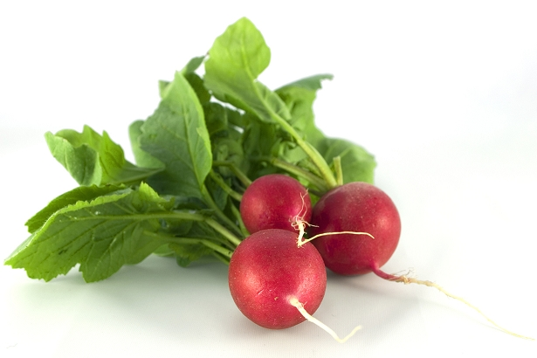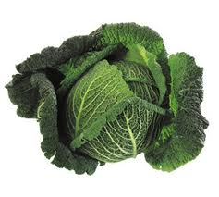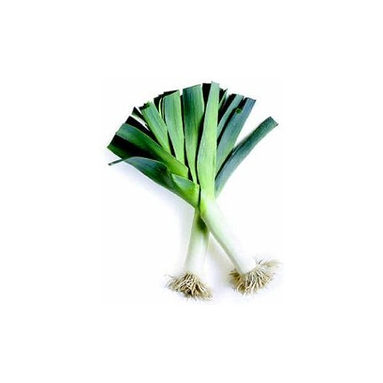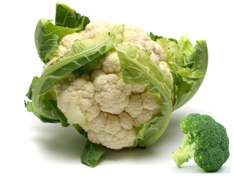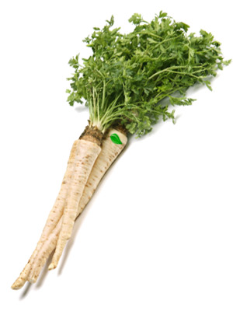

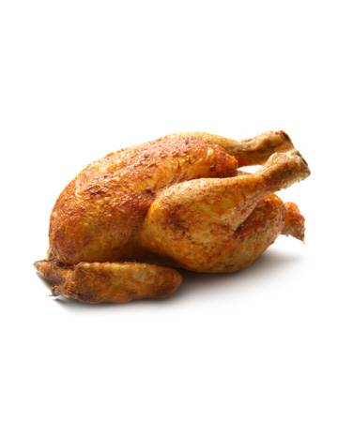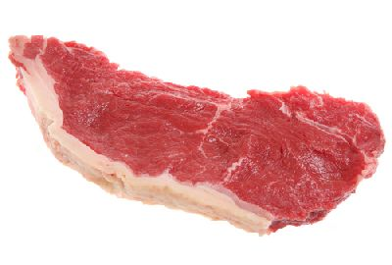

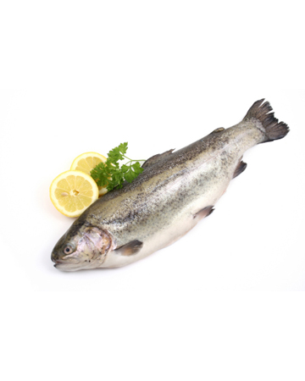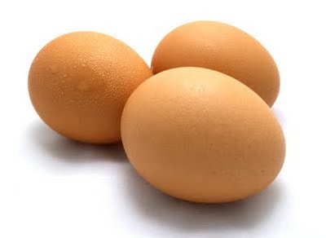

[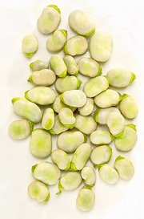](http://www.edziecko.pl/jedzenie/55,79377,3972430,,,,3941605.html)