Andranik Abajyan
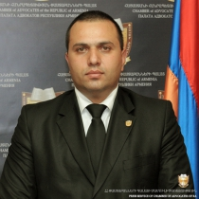
Specialization
Crimes against a person
Crimes against human freedom, honor and dignity
Crimes against sexual immunity and sexual freedom of a person
Contact information
Tel: 091 245456, 093 245456
Main address: Ararat, Ararat
License number: 983
Lusine Abajyan
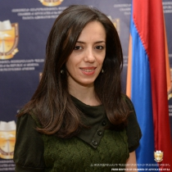
Specialization
Banking activity
Other civil relations
Labor relations
Contact information
Tel: , 093 22 01 80
Main address: Yerevan
License number: 1636
Anzhela Abelyan
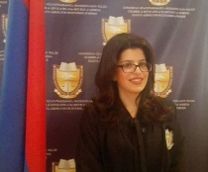
Specialization
Labor relations
Contractual relations
Heritage
Contact information
Tel: 010 54 52 84, 098 876617
Main address: Yerevan
License number: 2008
Ernest Abelyan
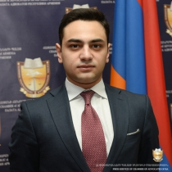
Specialization
Other civil relations
Other administrative relations
Contact information
Tel: , 091 22 88 39
Main address: Yerevan
License number: 2028

Vardan Abelyan
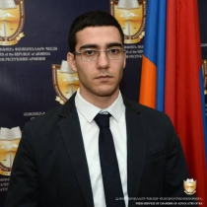
Specialization
Other civil relations
Contact information
Tel: , 091 713933
Main address: Yerevan
License number: 1965
Davit Abgaryan
Specialization
Contractual relations
Corporate relations
Contact information
Tel: 56 87 88 54 01 99,
Main address: Yerevan
License number: 337
Amalya Abovyan
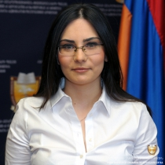
Specialization
Other civil relations
Contact information
Tel: , 077 238887
Main address: Yerevan
License number: 1359
Armen Abovyan
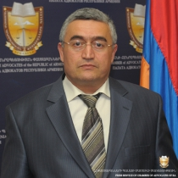
Specialization
Other civil relations
Electoral relations
Other administrative relations
Contact information
Tel: 010 442199, 094 473459
Main address: Yerevan
License number: 442

Artur Abovyan
Specialization
Other civil relations
Other administrative relations
Labor relations
Contact information
Tel: , 094 99 77 84
Main address: Yerevan
License number: 2567
Ashot Abovyan
Specialization
Other civil relations
Other administrative relations
Contact information
Tel: , 091 40 72 90։ 098 40 72 90
Main address: Yerevan
License number: 2566
Nelson Abovyan
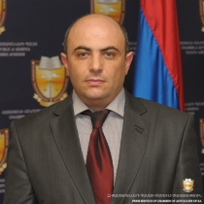
Specialization
Administrative claims
Other administrative relations
Corporate relations
Contact information
Tel: (010) 263708, 055812163 093812163
Main address: Yerevan
License number: 1629
Tatevik Abovyan
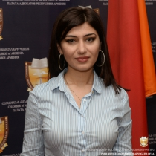
Specialization
Other civil relations
Labor relations
Family relations
Contact information
Tel: 011444444, 094-09-77-17
Main address: Yerevan
License number: 1824

Aida Abrahamyan
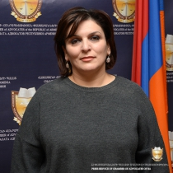
Specialization
Other civil relations
Contact information
Tel: , 093 66 93 35
Main address: Kotayq, Hrazdan
License number: 2480
Alisa Abrahamyan
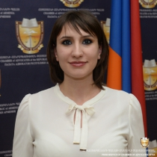
Specialization
Other civil relations
Contact information
Tel: , 055 228925 091 296815
Main address: Yerevan
License number: 1760
Arayik Abrahamyan
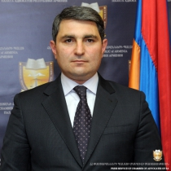
Specialization
Other civil relations
Contact information
Tel: 51 47 83, 094 909211
Main address: Yerevan
License number: 791
Ashot Abrahamyan
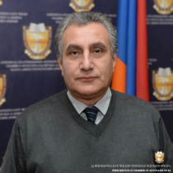
Specialization
Other civil relations
Other administrative relations
Contact information
Tel: , 091 209340
Main address: Yerevan
License number: 695

Hrachya Abrahamyan
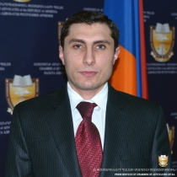
Specialization
Labor relations
Other civil relations
Other administrative relations
Contact information
Tel: 096-30-30-02, 096-30-30-02
Main address: Yerevan
License number: 1361
Klimenti Abrahamyan
Specialization
Other civil relations
Other criminal relations
Contact information
Tel: 0262 4 43 20, 093 62 75 71
Main address: Yerevan
License number: 79
Lusine Abrahamyan
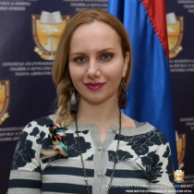
Specialization
Other civil relations
Contact information
Tel: , 091 41 27 17
Main address: Yerevan
License number: 1602
Mariam Abrahamyan
Specialization
Other civil relations
Contact information
Tel: , 091 23 72 06
Main address: Syuniq, Meghri
License number: 490

Hrachya Abrahamyan
Specialization
Labor relations
Other civil relations
Other administrative relations
Contact information
Tel: 096-30-30-02, 096-30-30-02
Main address: Yerevan
License number: 1361
Klimenti Abrahamyan
Specialization
Other civil relations
Other criminal relations
Contact information
Tel: 0262 4 43 20, 093 62 75 71
Main address: Yerevan
License number: 79
Lusine Abrahamyan
Specialization
Other civil relations
Contact information
Tel: , 091 41 27 17
Main address: Yerevan
License number: 1602

Mariam Abrahamyan
Specialization
Other civil relations
Contact information
Tel: , 091 23 72 06
Main address: Syuniq, Meghri
License number: 490

Roza Abrahamyan
Specialization
Other civil relations
Contact information
Tel: 48-84-02, 094-48-65-34
Main address: Yerevan
License number: 1362
Tatevik Abrahamyan
Specialization
Other civil relations
Crimes against a person
Crimes against human freedom, honor and dignity
Main address: Ararat, Ararat
License number: 1625
Tigran Abrahamyan
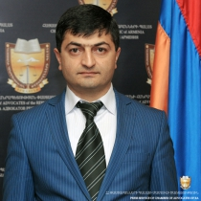
Specialization
Crimes against a person
Crimes against human freedom, honor and dignity
Crimes against constitutional human rights and freedoms of citizens
Contact information
Tel: 077 02 88 77, 077 028877
Main address: Gegharquniq, Gavar
License number: 1347

Vagharshak Abrahamyan
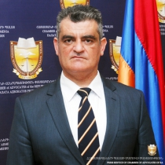
Specialization
Other civil relations
Other administrative relations
Contact information
Tel: 0237 216 40, 091-17-32-71
Main address: Armavir, Armavir
License number: 1363

Armen Adamyan
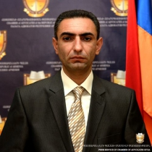
Specialization
Other civil relations
Crimes against a person
Crimes against human freedom, honor and dignity
Contact information
Tel: 077 76 40 76, 077 04 04 74
Main address: Tavush, Ijevan
License number: 1573
Shushanik Adamyan
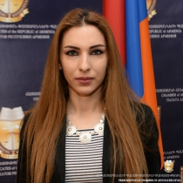
Specialization
Other civil relations
Other administrative relations
Contact information
Tel: , 055 800856
Main address: Yerevan
License number: 1890
Ashot Adibekyan
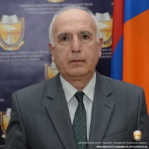
Specialization
Crimes against military service
Crimes against a person
Crimes against human freedom, honor and dignity
Contact information
Tel: 010 52 10 44, 091 94 22 32
Main address: Yerevan
License number: 299
Segey Adibekyan
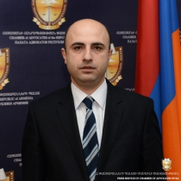
Specialization
Other civil relations
Family relations
Property
Contact information
Tel: , 099 30 99 30
Main address: Yerevan
License number: 1891

Lavrenti Adulyan
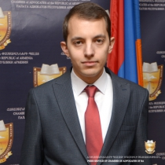
Specialization
Migration issues
Contractual relations
Heritage
Contact information
Tel: 044 24 00 24, 077 44 89 44
Main address: Yerevan
License number: 2481
Siran Afyan
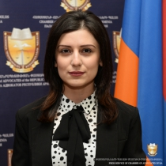
Specialization
Other civil relations
Contact information
Tel: .........,
Main address: Kotayq, Charentsavan
License number: 1994
George Agadjanyan
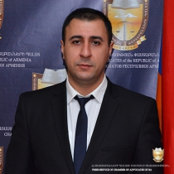
Specialization
Other criminal relations
Contact information
Tel: , 093 36 22 60; 099 36 22 60
Main address: Yerevan
License number: 2308
Mihran Aghababyan
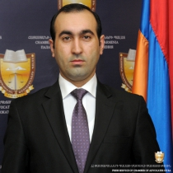
Specialization
Corporate relations
Contractual relations
Tax relations
Contact information
Tel: (+374 55) 530 531,
Main address: Yerevan
License number: 1695

Nerses Aghababyan
Specialization
Other civil relations
Other administrative relations
Contact information
Tel: , 094 44 51 59
Main address: Yerevan
License number: 2152
Lyova Aghabalyan
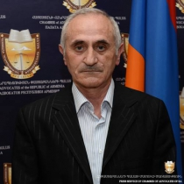
Specialization
Other civil relations
Contact information
Tel: , 093 865834
Main address: Yerevan
License number: 411
Lusine Aghabekyan
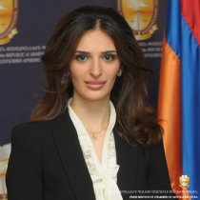
Specialization
Other civil relations
Other administrative relations
Contact information
Tel: , 077 140303
Main address: Yerevan
License number: 1696
Eduard Aghajanyan
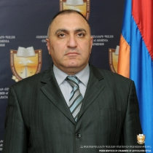
Specialization
Crimes against human freedom, honor and dignity
Crimes against sexual immunity and sexual freedom of a person
Crimes against constitutional human rights and freedoms of citizens
Contact information
Tel: 010 600714, 091 494602
Main address: Yerevan
License number: 134

Eduard Aghajanyan
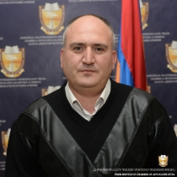
Specialization
Other civil relations
Other administrative relations
Crimes against a person
Contact information
Tel: , 091 32 96 42
Main address: Yerevan
License number: 989
Karapet Aghajanyan
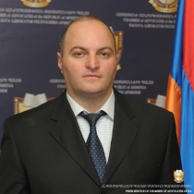
Specialization
Other civil relations
Crimes against a person
Crimes against human freedom, honor and dignity
Contact information
Tel: , 091 100878 094 100878
Main address: Yerevan
License number: 35
Karen Aghajanyan
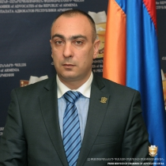
Specialization
Family relations
Heritage
Property
Contact information
Tel: 010 531 531, 077 022 221
Main address: Yerevan
License number: 11
Mher Aghajanyan Aghajanyan
Specialization
Other civil relations
Contact information
Tel: , 077 766448
Main address: Syuniq, Goris
License number: 699
Samvel Aghakhanyan
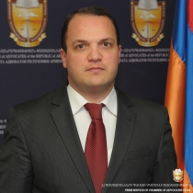
Specialization
Insurance
Contractual relations
Property
Contact information
Tel: 000000000,
Main address: Yerevan
License number: 1165
Melsik Aghaloyan
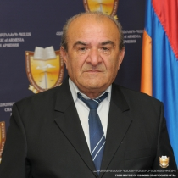
Specialization
Other civil relations
Crimes against a person
Contact information
Tel: , 093 447736
Main address: Yerevan
License number: 123
Volodya Aghamyan
Specialization
Other civil relations
Contact information
Tel: 34 26 16,
Main address: Yerevan
License number: 332
Ala Aghasyan
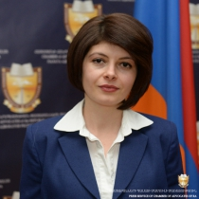
Specialization
Other civil relations
Contact information
Tel: 53 34 60, 093 55 55 99
Main address: Yerevan
License number: 1166
Sargis Aghasyan
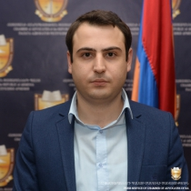
Specialization
Labor relations
Contractual relations
Heritage
Contact information
Tel: 010749972, 094-81-11-89
Main address: Yerevan
License number: 1367
Ashot Aghayan
Specialization
Other criminal relations
Contact information
Tel: , 093 770701
Main address: Yerevan
License number: 2132
Armine Aghramanyan
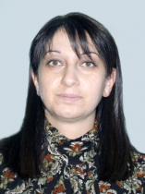
Specialization
Other civil relations
Crimes against a person
Crimes against constitutional human rights and freedoms of citizens
Contact information
Tel: 0244 5 65 33, 093 82 40 66
Main address: Shirak, Artik
License number: 991

Sirush Aghvanyan
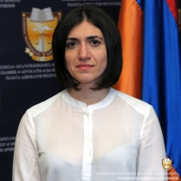
Specialization
Crimes against a person
Crimes against human freedom, honor and dignity
Crimes against sexual immunity and sexual freedom of a person
Contact information
Tel: , 093 762624
Main address: Yerevan
License number: 1368

Roman Aharonyan
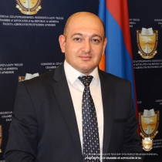
Specialization
Other criminal relations
Contact information
Tel: 099 109924, 093 535390
Main address: Yerevan
License number: 1289
Romen Aharonyan
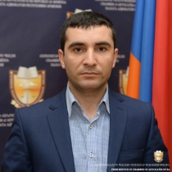
Specialization
Other civil relations
Other administrative relations
Tax relations
Contact information
Tel: 010 50 11 44, 055 34 84 05
Main address: Yerevan
License number: 1164
Harut Aklunts
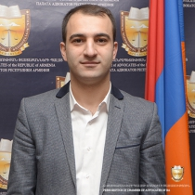
Specialization
Other criminal relations
Main address: Yerevan
License number: 2468

Lilit Akopova
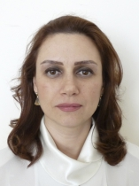
Specialization
Other civil relations
Contact information
Tel: 44 97 14, 091 81 21 83
Main address: Yerevan
License number: 798

Syuzanna Akritova
Specialization
Other civil relations
Crimes against a person
Crimes against human freedom, honor and dignity
Contact information
Tel: , 091 400197
Main address: Yerevan
License number: 495

Ani Alaverdyan
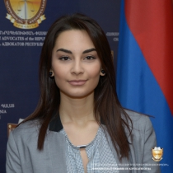
Specialization
Other civil relations
Contact information
Tel: , 098084036
Main address: Yerevan
License number: 2155
Hermine Alaverdyan
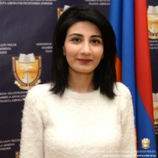
Specialization
Other civil relations
Contact information
Tel: 055-25-69-55, 055-25-69-55
Main address: Yerevan
License number: 1365
Meri Alaverdyan
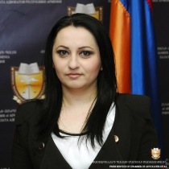
Specialization
Crimes against human freedom, honor and dignity
Crimes against sexual immunity and sexual freedom of a person
Crimes against constitutional human rights and freedoms of citizens
Contact information
Tel: 010 600714, 094 034 114
Main address: Yerevan
License number: 1297

Naira Alaverdyan
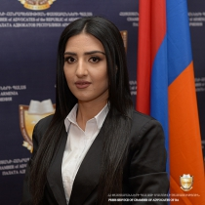
Specialization
Other civil relations
Other administrative relations
Family relations
Contact information
Tel: , 093 055 790; 091 615 516
Main address: Yerevan
License number: 2571
Gohar Aleksanyan
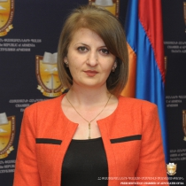
Specialization
Other civil relations
Contact information
Tel: , 094-32-30-10
Main address: Ararat, Ararat
License number: 1594
Lilit Aleksanyan
Specialization
Other civil relations
Contact information
Tel: , 093 793 797
Main address: Shirak, Gyumri
License number: 2387
Manvel Aleksanyan
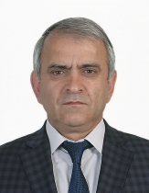
Specialization
Other criminal relations
Other civil relations
Contact information
Tel: , +374 91 20 59 60
Main address: Yerevan
License number: 2135

Samvel Aleksanyan
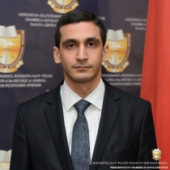
Specialization
Other civil relations
Contractual relations
Intellectual Property
Contact information
Tel: 077-460-121, 077-460-121
Main address: Yerevan
License number: 1825
Tadevos Aleksanyan
Specialization
Other criminal relations
Crimes against a person
Contact information
Tel: 010 568080, 094 581858
Main address: Yerevan
License number: 87
Veronika Aleksanyan
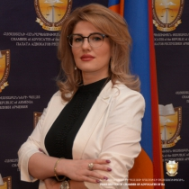
Specialization
Other civil relations
Contact information
Tel: , 043 011 340
Main address: Yerevan
License number: 2396
Viktorya Aleksanyan
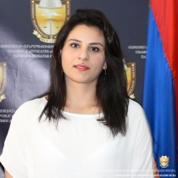
Specialization
Other civil relations
Other administrative relations
Contact information
Tel: 0255 2 37 11,0255 2 25 91, 091 47 67 77
Main address: Lori, Spitak
License number: 988

Hrach Alezyan
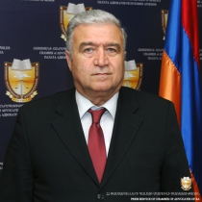
Specialization
Other civil relations
Other administrative relations
Crimes against a person
Contact information
Tel: 010 562343, 091 379335
Main address: Yerevan
License number: 403
Erik Alieksanyan
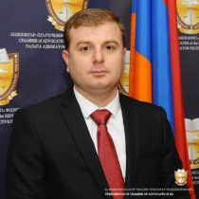
Specialization
Other criminal relations
Contact information
Tel: , 096 70 70 27; 077 51 63 51
Main address: Yerevan
License number: 2231
Artur Alikhanyan
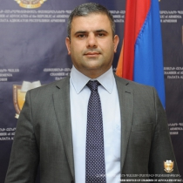
Specialization
Crimes against human freedom, honor and dignity
Crimes against constitutional human rights and freedoms of citizens
Crimes against the interests of family and child
Contact information
Tel: 010 600714, 091 536619
Main address: Yerevan
License number: 404
Gayane Alikhanyan
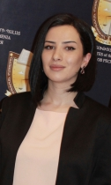
Specialization
Other civil relations
Contact information
Tel: , 055 777 294
Main address: Tavush, Dilijan
License number: 2535

Robert Alikhanyan
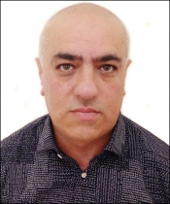
Specialization
Crimes against a person
Crimes against human freedom, honor and dignity
Contact information
Tel: , 91347134
Main address: Tavush, Dilijan
License number: 1606
Anahit Aloyan
Specialization
Other civil relations
Other administrative relations
Contact information
Tel: 0322 42545, 094 340350
Main address: Lori, Vanadzor
License number: 207
Artak Aloyan
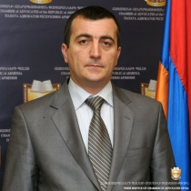
Specialization
Other civil relations
Other administrative relations
Contact information
Tel: 010 282090, 093 534483 055 534483
Main address: Yerevan
License number: 494
Narek Aloyan
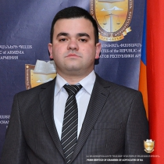
Specialization
Other criminal relations
Contact information
Tel: , 044 44 44 08
Main address: Yerevan
License number: 2310
Vardan Aloyan
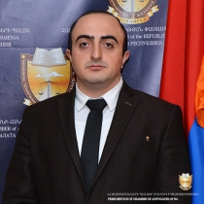
Specialization
Bankruptcy
Other civil relations
Other administrative relations
Contact information
Tel: +374 55 88 94 01,
Main address: Yerevan
License number: 2311
Yurik Aloyan
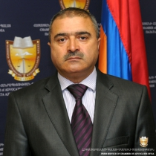
Specialization
Other civil relations
Crimes against a person
Crimes against human freedom, honor and dignity
Contact information
Tel: , 091 482240
Main address: Yerevan
License number: 697
Hayk Alumyan
Specialization
Other civil relations
Crimes against a person
Crimes against human freedom, honor and dignity
Contact information
Tel: 010 583130, 093 164040
Main address: Yerevan
License number: 284
Arayik Alvandyan
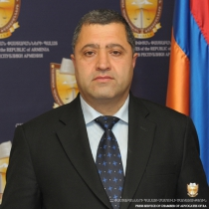
Specialization
Other civil relations
Crimes against a person
Crimes against human freedom, honor and dignity
Contact information
Tel: 091207277, 077207277
Main address: Yerevan
License number: 443

Artur Amiraghyan
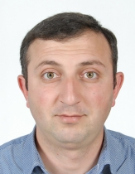
Specialization
Customs Relations
Insurance
Property
Contact information
Tel: 093 419 429 , 093 111 828
Main address: Tavush, Noyemberyan
License number: 992
Arpine Amirjanyan
Specialization
Other civil relations
Other administrative relations
Contact information
Tel: , 077 78 82 85
Main address: Yerevan
License number: 2536
Vahe Amirjanyan
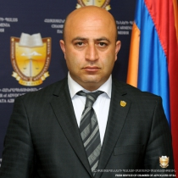
Specialization
Other civil relations
Contact information
Tel: 0231 608 81, 094 57 00 04
Main address: Armavir, Vagharshapat
License number: 1167
Emil Amirkhanyan
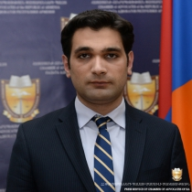
Specialization
Other civil relations
Administrative claims
Other administrative relations
Contact information
Tel: , 091 512148
Main address: Yerevan
License number: 993
Rafayel Amirkhanyan
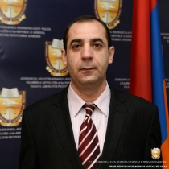
Specialization
Crimes against a person
Crimes against human freedom, honor and dignity
Crimes against sexual immunity and sexual freedom of a person
Contact information
Tel: 010265707, 093 300733
Main address: Yerevan
License number: 1917
Sergey Amirkhanyan
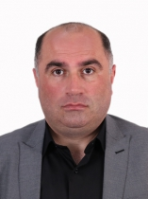
Specialization
Labor relations
Contractual relations
Corporate relations
Contact information
Tel: (374 94) 80 33 00,
Main address: Yerevan
License number: 874
Simon Amirkhanyan
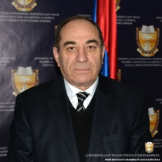
Specialization
Other administrative relations
Crimes against military service
Contact information
Tel: , (099) 094 26 57 07;
Main address: Yerevan
License number: 1132
Davit Amiryan
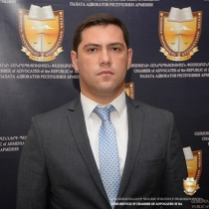
Specialization
Other civil relations
Contact information
Tel: , 094 17 00 11
Main address: Yerevan
License number: 2459

Minas Amiryan
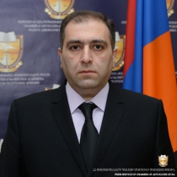
Specialization
Labor relations
Contractual relations
Heritage
Contact information
Tel: 093 977700,
Main address: Yerevan
License number: 163
Suren Amiryan
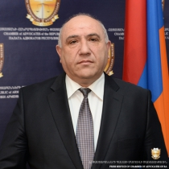
Specialization
Crimes against a person
Crimes against human freedom, honor and dignity
Crimes against constitutional human rights and freedoms of citizens
Contact information
Tel: , 093 540011
Main address: Tavush, Ijevan
License number: 1892
Samvel Amirzadyan
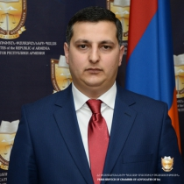
Specialization
Other civil relations
Other administrative relations
Contact information
Tel: 010470166, 055077733
Main address: Yerevan
License number: 2068
Elen Ananyan
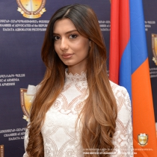
Specialization
Labor relations
Contractual relations
Heritage
Contact information
Tel: , 095 09 98 98
Main address: Yerevan
License number: 2572

Hrant Ananyan
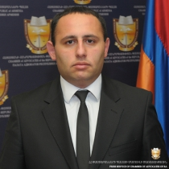
Specialization
Crimes against a person
Crimes against property
Crimes against economic activity
Contact information
Tel: 091356067,
Main address: Yerevan
License number: 1156
Naira Ananyan
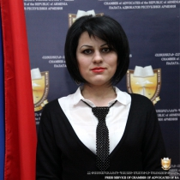
Specialization
Other civil relations
Contact information
Tel: , 093 552772
Main address: Yerevan
License number: 1887
Narine Ananyan
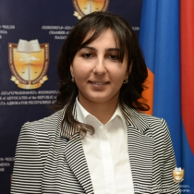
Specialization
Other civil relations
Contact information
Tel: , 055 922557
Main address: Yerevan
License number: 1976
Karen Andreasyan
Specialization
Other civil relations
Contact information
Tel: 51 91 10, 091 41 35 42
Main address: Yerevan
License number: 630

Karine Andreasyan
Specialization
Crimes against a person
Crimes against human freedom, honor and dignity
Crimes against constitutional human rights and freedoms of citizens
Main address: Yerevan
License number: 1893
Mikhеil Andreasyan
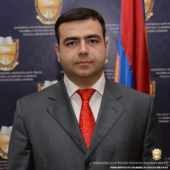
Specialization
Other civil relations
Administrative claims
Other administrative relations
Contact information
Tel: , 055 40 55 01
Main address: Yerevan
License number: 994
Gor Andriasyan
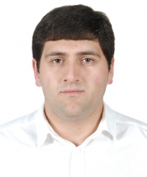
Specialization
Other civil relations
Other administrative relations
Contact information
Tel: , 091 554505
Main address: Yerevan
License number: 1707
Hakob Andriasyan
Specialization
Other civil relations
Contact information
Tel: , 091 500688
Main address: Lori, Stepanavan
License number: 311

Hasmik Andriasyan
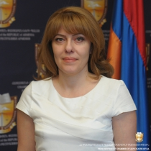
Specialization
Other civil relations
Labor relations
Contractual relations
Contact information
Tel: , 091 816100
Main address: Yerevan
License number: 640
Samvel Andriasyan
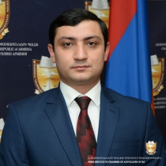
Specialization
Other criminal relations
Contact information
Tel: , 077 060703
Main address: Yerevan
License number: 2069
Armen Andrikyan
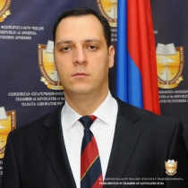
Specialization
Other criminal relations
Contact information
Tel: , 091 28 65 60; 093 28 65 60
Main address: Yerevan
License number: 2232
Diana Angliatsyan
Specialization
Other civil relations
Other administrative relations
Other international relations
Contact information
Tel: , 096 433043
Main address: Yerevan
License number: 1697

Ani Antonyan
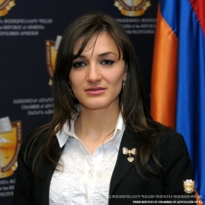
Specialization
Labor relations
Contractual relations
Heritage
Contact information
Tel: 091 543211,
Main address: Yerevan
License number: 1369
Ararat Antonyan
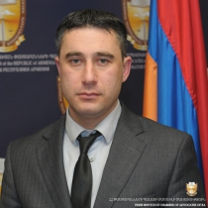
Specialization
Other civil relations
Other administrative relations
Contact information
Tel: , 091 555447
Main address: Yerevan
License number: 701
Armen Antonyan
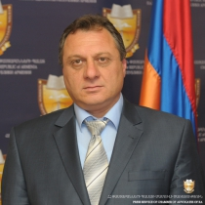
Specialization
Other civil relations
Administrative claims
Other administrative relations
Contact information
Tel: , 099-69-10-02
Main address: Yerevan
License number: 1370
Astghik Antonyan
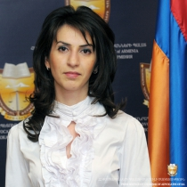
Specialization
Other civil relations
Other administrative relations
Labor relations
Contact information
Tel: 011321131, 093391503
Main address: Yerevan
License number: 1699

Diana Antonyan
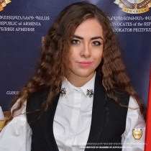
Specialization
Other civil relations
Other administrative relations
Contact information
Tel: , 098 81 99 81
Main address: Yerevan
License number: 2312
Gevorg Antonyan
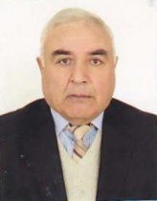
Specialization
Other civil relations
Other administrative relations
Labor relations
Contact information
Tel: 094621497, 094 62 14 97
Main address: Armavir, Armavir
License number: 875
Narek Antonyan
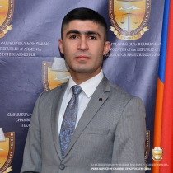
Specialization
Other civil relations
Other administrative relations
Contact information
Tel: , 055 290 555; 094 700 468
Main address: Yerevan
License number: 2313
Artur Apikyan
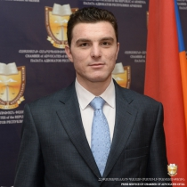
Specialization
Other civil relations
Main address: Yerevan
License number: 1854
Edvard Apoyan
Specialization
Other civil relations
Contact information
Tel: , 077-64-54-25
Main address: Yerevan
License number: 1389
Hayk Apresyan
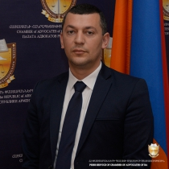
Specialization
Other criminal relations
Contact information
Tel: , 098 65 99 29; 041 441 411
Main address: Yerevan
License number: 2398
Zohrak Apresyan
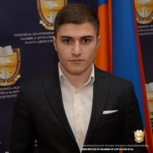
Specialization
Other civil relations
Other administrative relations
Contact information
Tel: , 093 41 05 93
Main address: Yerevan
License number: 2397
Ani Arabajyan
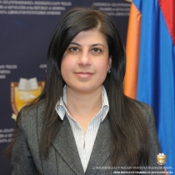
Specialization
Other civil relations
Crimes against a person
Crimes against human freedom, honor and dignity
Contact information
Tel: , 091 356993
Main address: Yerevan
License number: 402

Minas Arabyan
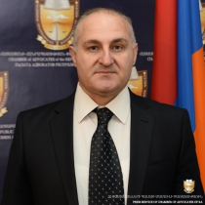
Specialization
Other civil relations
Contact information
Tel: , 099 80 40 11
Main address: Yerevan
License number: 1894
Ani Arakelyan
Specialization
Other civil relations
Other administrative relations
Contact information
Tel: , 077 70 99 80
Main address: Aragatsotn, Aparan
License number: 2392
Arman Arakelyan
Specialization
Other civil relations
Road accidents
Crimes against a person
Contact information
Tel: 093249127, 093 24 91 27
Main address: Yerevan,
License number: 1133
Armenuhi Arakelyan

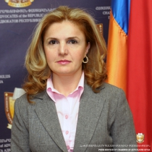
Specialization
Other civil relations
Contact information
Tel: 010 742491, 091 492580
Main address: Yerevan
License number: 306

Babken Arakelyan
Specialization
Other criminal relations
Labor relations
Family relations
Contact information
Tel: , 099 42 61 36
Main address: Yerevan
License number: 2560
Eva Arakelyan
Specialization
Other civil relations
Other administrative relations
Contact information
Tel: 51-91-10, 091-31-81-03
Main address: Yerevan
License number: 1372
Grigor Arakelyan
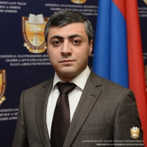
Specialization
Migration issues
Labor relations
Contractual relations
Contact information
Tel: , 099 959000
Main address: Yerevan
License number: 2029
Lusine Arakelyan
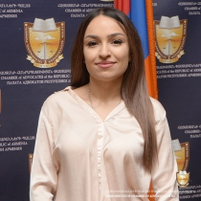
Specialization
Other civil relations
Contact information
Tel: , 095 08 09 08
Main address: Yerevan
License number: 2483

Musheg Arakelyan
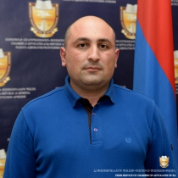
Specialization
Other civil relations
Other administrative relations
Contact information
Tel: , 096 659122 077 507681
Main address: Yerevan
License number: 1762
Sona Arakelyan
Specialization
Crimes against a person
Crimes against human freedom, honor and dignity
Crimes against constitutional human rights and freedoms of citizens
Contact information
Tel: , 099 999342
Main address: Yerevan
License number: 2009
Tigran Arakelyan
Specialization
Crimes against a person
Crimes against human freedom, honor and dignity
Crimes against sexual immunity and sexual freedom of a person
Contact information
Tel: , 098212125
Main address: Ararat, Masis
License number: 1763
Vardan Arakelyan
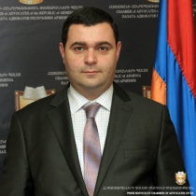
Specialization
Contractual relations
Labor relations
Property
Contact information
Tel: 010 58 88 98, 091 91 17 14
Main address: Yerevan
License number: 995

Ashot Aramyan
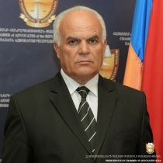
Specialization
Other civil relations
Crimes against a person
Crimes against human freedom, honor and dignity
Contact information
Tel: , 093 249324
Main address: Aragatsotn, Ashtarak
License number: 1003
Edgar Aramyan
Specialization
Crimes against public security
Contact information
Tel: 58 60 15, 094 51 20 29; 099 04 04 70
Main address: Yerevan
License number: 1004
Tatev Aramyan
Specialization
Other civil relations
Other administrative relations
Labor relations
Contact information
Tel: 055-82-96-96,
Main address: Yerevan
License number: 2237
Marianna Arevshatyan
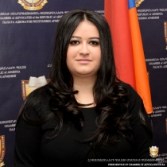
Specialization
Other civil relations
Contractual relations
Family relations
Contact information
Tel: +374 99 88 15 99,
Main address: Yerevan
License number: 1855

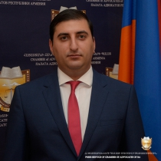
Specialization
Other criminal relations
Contact information
Tel: , 096 500 222
Main address: Yerevan
License number: 2402
Lusine Aristakesyan
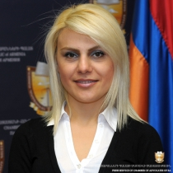
Specialization
Other civil relations
Contact information
Tel: , 091-22-39-33
Main address: Yerevan
License number: 1388
Vahe Armenakyan
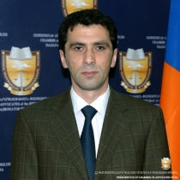
Specialization
Traffic fines
Other administrative relations
Crimes against a person
Contact information
Tel: , 091 424152
Main address: Yerevan
License number: 881
Eliza Aroyan
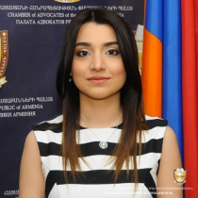
Specialization
Other civil relations
Other administrative relations
Contact information
Tel: , 098 23 53 88
Main address: Yerevan
License number: 2238

Lusine Aroyan
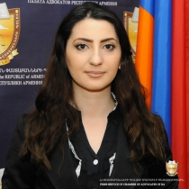
Specialization
Other civil relations
Other administrative relations
Contact information
Tel: , 093 57 35 17
Main address: Yerevan
License number: 2239
Hovik Arsenyan
Specialization
Other civil relations
Other criminal relations
Contact information
Tel: , 094 47 12 68
Main address: Yerevan
License number: 50
Nazeli Arsenyan
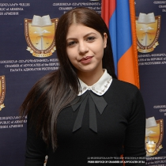
Specialization
Other criminal relations
Contact information
Tel: , 055 02 03 43
Main address: Yerevan
License number: 2488
Arusyak Artenyan
Specialization
Other civil relations
Contact information
Tel: , 091 386128
Main address: Yerevan
License number: 94

Artur Arushanyan
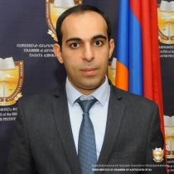
Specialization
Other civil relations
Other administrative relations
Contact information
Tel: , 099 06 44 08
Main address: Yerevan
License number: 2235
Elina Arustamova
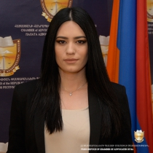
Specialization
Other civil relations
Contact information
Tel: , 055 17 79 79
Main address: Yerevan
License number: 2399
Lusine Arustamyan
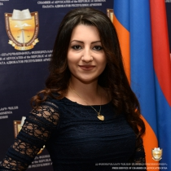
Specialization
Other civil relations
Family relations
Administrative claims
Contact information
Tel: , 041 544542
Main address: Yerevan
License number: 2010
Marianna Arustamyan
Specialization
Other civil relations
Contact information
Tel: , 091 472288
Main address: Yerevan
License number: 1971

Petros Arzakantsyan
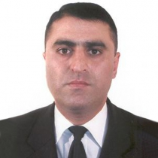
Specialization
Heritage
Family relations
Other civil relations
Contact information
Tel: , 093 42 27 82
Main address: Yerevan
License number: 452
Manushak Arzikyan
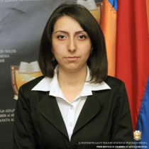
Specialization
Other civil relations
Other administrative relations
Crimes against a person
Contact information
Tel: , 096 027171 055 828587
Main address: Yerevan
License number: 1386
Arman Arzumanyan
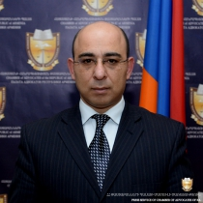
Specialization
Other administrative relations
Crimes against a person
Crimes against human freedom, honor and dignity
Main address: Yerevan
License number: 1850
Ashot Arzumanyan
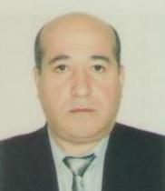
Specialization
Other civil relations
Contact information
Tel: , 093 562709
Main address: Yerevan
License number: 501

David Arzumanyan
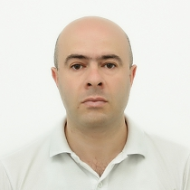
Specialization
Other civil relations
Other administrative relations
Crimes against a person
Contact information
Tel: 055 153 155,
Main address: Syuniq, Kapan
License number: 1172
Samvel Arzumanyan
Specialization
Other civil relations
Other administrative relations
Contact information
Tel: , 094-49-10-37
Main address: Yerevan
License number: 1387
Syuzanna Arzumanyan
Specialization
Other civil relations
Contact information
Tel: , 099 411 262
Main address: Yerevan
License number: 2401
Anahit Asatryan
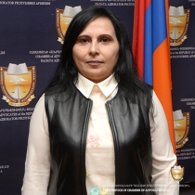
Specialization
Other civil relations
Other administrative relations
Contact information
Tel: , 099 50 86 67
Main address: Yerevan
License number: 2485
Anna Asatryan
Specialization
Other civil relations
Contact information
Tel: , 099-42-95-10
Main address: Yerevan
License number: 1373
Armen Asatryan
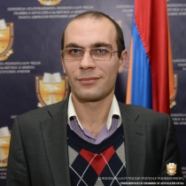
Specialization
Other civil relations
Contractual relations
Heritage
Contact information
Tel: +374 10 48 97 44, +374 93 07 82 83
Main address: Yerevan
License number: 996
Arsen Asatryan
Specialization
Other civil relations
Contact information
Tel: 59-14-57, 077-07-50-05
Main address: Yerevan
License number: 1375
Ashot Asatryan
Specialization
Contractual relations
Corporate relations
Establishment, reorganization and liquidation of entities
Contact information
Tel: 37493711460, 37493711460
Main address: Yerevan
License number: 525
Davit Asatryan
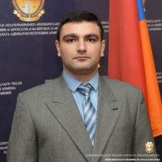
Specialization
Other civil relations
Other administrative relations
Tax relations
Contact information
Tel: 093 143 888,
Main address: Yerevan
License number: 1851
Gagik Asatryan
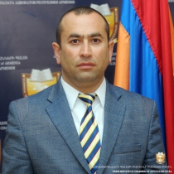
Specialization
Crimes against a person
Crimes against human freedom, honor and dignity
Contact information
Tel: 043 204 404, 094 340 100
Main address: Ararat, Masis
License number: 2055
Karo Asatryan
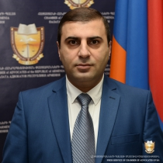
Specialization
Other civil relations
Contractual relations
Heritage
Contact information
Tel: , 099 473449
Main address: Yerevan
License number: 2031
Lusine Asatryan
Specialization
Other civil relations
Contact information
Tel: , 077 357433
Main address: Yerevan
License number: 72

Ruben Asatryan
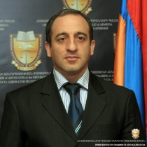
Specialization
Other civil relations
Other administrative relations
Other international relations
Contact information
Tel: 091 24 67 16, 077 24 67 16
Main address: Yerevan
License number: 1169
Sedrak Asatryan
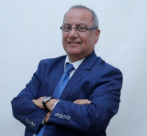
Specialization
Other civil relations
Other administrative relations
Contact information
Tel: 374 10 57 51 21, 374 77 26 22 26
Main address: Yerevan
License number: 799
Silva Asatryan
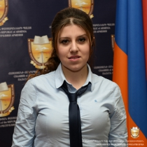
Specialization
Other civil relations
Contractual relations
Bankruptcy
Contact information
Tel: 093 873076, 093 873076
Main address: Yerevan
License number: 2030
Tatevik Asatryan
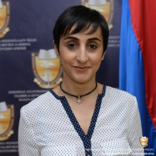
Specialization
Other civil relations
Contact information
Tel: , 091301177 095331177
Main address: Yerevan
License number: 1764

Varazdat Asatryan
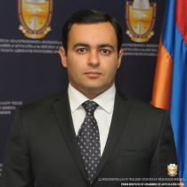
Specialization
Bankruptcy
Other civil relations
Administrative claims
Contact information
Tel: , 094-18-70-08
Main address: Yerevan
License number: 1376
Vardan Asatryan
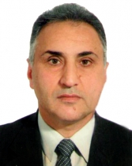
Specialization
Other criminal relations
Contact information
Tel: , 91498549
Main address: Yerevan
License number: 1683
Yeremia Asatryan
Ani Aslanyan
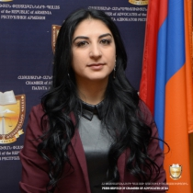
Specialization
Other civil relations
Other administrative relations
Contact information
Tel: , 077 24 06 73
Main address: Yerevan
License number: 2486
Aram Aslanyan
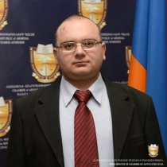
Specialization
Other civil relations
Contact information
Tel: , 077 396969
Main address: Kotayq, Charentsavan
License number: 2032
Eduard Aslanyan
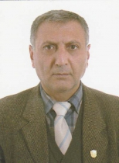
Specialization
Other civil relations
Other administrative relations
Crimes against a person
Contact information
Tel: 093394567, 094394567
Main address: Shirak, Gyumri
License number: 499
Hermine Aslanyan
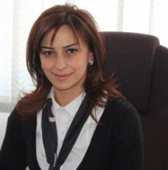
Specialization
Labor relations
Contractual relations
Heritage
Contact information
Tel: 010 570170 +106, 091 210191
Main address: Yerevan
License number: 638

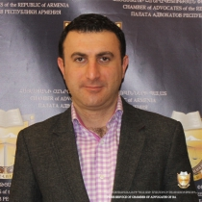
Specialization
Other civil relations
Administrative claims
Other administrative relations
Contact information
Tel: , 077 002 330; 095 022 330
Main address: Yerevan
License number: 2214
Gohar Aselesyan
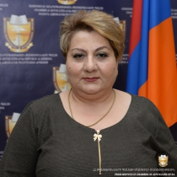
Specialization
Other civil relations
Contact information
Tel: , 099288800
Main address: Yerevan
License number: 1765

Lusine Aslanyan
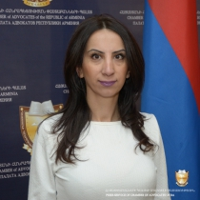
Specialization
Other criminal relations
Contact information
Tel: , 094 80 33 10; 096 80 33 10
Main address: Yerevan
License number: 2157
Mher Aslanyan
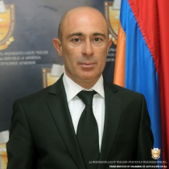
Specialization
Crimes against a person
Other international relations
Contact information
Tel: , 091 400116
Main address: Yerevan
License number: 1712
Sargis Aslanyan
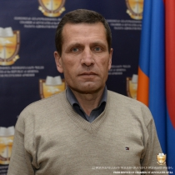
Specialization
Other civil relations
Other administrative relations
Crimes against a person
Contact information
Tel: , 093 26 49 72
Main address: Yerevan
License number: 801
Murad Asryan
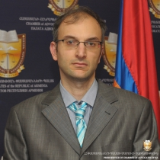
Specialization
Other civil relations
Contact information
Tel: , 091 533 803
Main address: Yerevan
License number: 877
Vahe Astvatsatryan
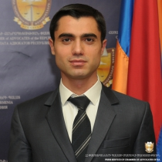
Specialization
Labor relations
Contractual relations
Bankruptcy
Contact information
Tel: 011321131, 055070977
Main address: Yerevan
License number: 1701
Aghasi Atabekyan
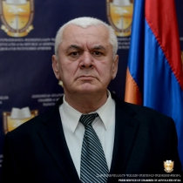
Specialization
Crimes against a person
Crimes against human freedom, honor and dignity
Crimes against constitutional human rights and freedoms of citizens
Contact information
Tel: , 091 529297
Main address: Yerevan
License number: 389
Eduard Atabekyan
Specialization
Other civil relations
Contact information
Tel: , 091 48 28 16
Main address: Kotayq, Eghvard
License number: 1151
Ani Atanesyan
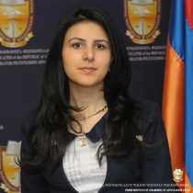
Specialization
Other civil relations
Labor relations
Contractual relations
Contact information
Tel: 010-54-45-97, 094-93-42-72
Main address: Yerevan
License number: 1364
Arusyak Atanesyan
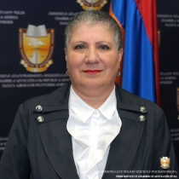
Specialization
Other civil relations
Administrative claims
Other administrative relations
Contact information
Tel: , 093 30 83 38
Main address: Aragatsotn, Talin
License number: 1163
Tigran Atanesyan
Specialization
Other civil relations
Other administrative relations
Contact information
Tel: 060 623264, 093 701071
Main address: Yerevan
License number: 78
Marat Atovmyan
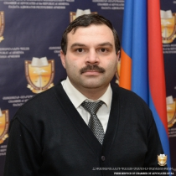
Specialization
Migration issues
Labor relations
Contractual relations
Contact information
Tel: 54 01 99, 091 49 66 46
Main address: Yerevan
License number: 1002
Anahit Atoyan
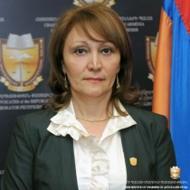
Specialization
Heritage
Other civil relations
Other administrative relations
Contact information
Tel: 091-21-04-43, 091 210443
Main address: Yerevan
License number: 326
Dianna Atoyan
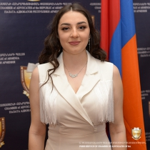
Specialization
Other civil relations
Other administrative relations
Contact information
Tel: , 091 61 03 16
Main address: Yerevan
License number: 2569
Emma Atoyan
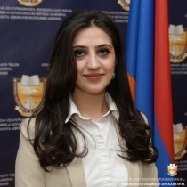
Specialization
Other civil relations
Contact information
Tel: , 094 393969
Main address: Yerevan
License number: 1694
Gevorg Atoyan
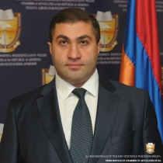
Specialization
Other civil relations
Contact information
Tel: 093035583,
Main address: Yerevan
License number: 985
Rudolf Atoyan
Specialization
Labor relations
Contractual relations
Heritage
Contact information
Tel: +374 95 39 09 00, 095 390 900
Main address: Yerevan
License number: 2458

Vaghinak Atoyan
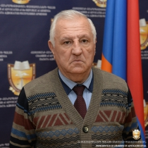
Specialization
Other civil relations
Crimes against a person
Crimes against human freedom, honor and dignity
Contact information
Tel: , 094 93 68 00
Main address: Yerevan
License number: 492
Nune Atshemyan
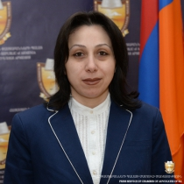
Specialization
Other civil relations
Crimes against a person
Crimes against human freedom, honor and dignity
Contact information
Tel: , 091 501917
Main address: Yerevan
License number: 497
Ruzanna Avagimyan
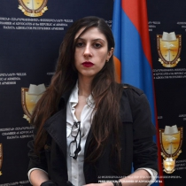
Specialization
Other civil relations
Other administrative relations
Contact information
Tel: 055 188 806,
Main address: Yerevan
License number: 2060
Amalya Avagyan
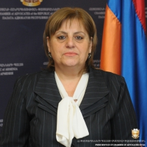
Specialization
Other criminal relations
Contact information
Tel: , 094 48 50 64
Main address: Yerevan
License number: 135
Anahit Avagyan
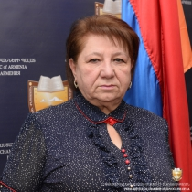
Specialization
Other civil relations
Contact information
Tel: , 091 349180
Main address: Ararat, Artashat
License number: 283
Arayik Avagyan
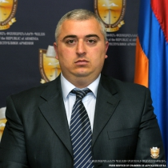
Specialization
Other civil relations
Other administrative relations
Labor relations
Contact information
Tel: 0322 21150, 055663335 077833391
Main address: Lori, Vanadzor
License number: 997
Davit Avagyan
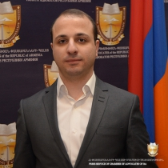
Specialization
Other criminal relations
Tax relations
Customs Relations
Contact information
Tel: , 098 15 15 99
Main address: Yerevan
License number: 2537
Emma Avagyan
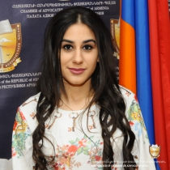
Specialization
Other civil relations
Contact information
Tel: , 096 00 30 30
Main address: Yerevan
License number: 2236
Gohar Avagyan
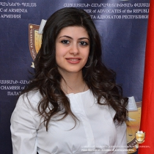
Specialization
Other civil relations
Contact information
Tel: , 091 26 20 09
Main address: Yerevan
License number: 2314
Inga Avagyan
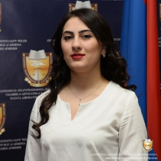
Specialization
Crimes against a person
Crimes against human freedom, honor and dignity
Crimes against constitutional human rights and freedoms of citizens
Contact information
Tel: , 043 252233
Main address: Yerevan
License number: 2011
Kaghtcrik Avagyan
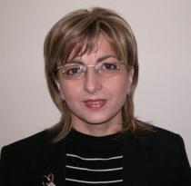
Specialization
Other civil relations
Other administrative relations
Contact information
Tel: 59-29-59, 091-36-96-53; 094 46 82 64
Main address: Yerevan
License number: 1379
Karlen Avagyan
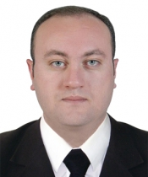
Specialization
Other criminal relations
Contact information
Tel: , 098 99 99 29
Main address: Yerevan
License number: 2206
Lilit Avagyan
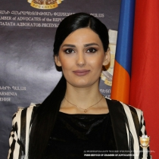
Specialization
Other civil relations
Contact information
Tel: , 043 43 22 21
Main address: Armavir, Vagharshapat
License number: 2373
Lusine Avagyan
Specialization
Other civil relations
Crimes against a person
Crimes against human freedom, honor and dignity
Contact information
Tel: 010 561944, 091 և 094 605533
Main address: Yerevan
License number: 413
Mikayel Avagyan
Specialization
Other civil relations
Contact information
Tel: 59 04 77, 091 48 65 20
Main address: Yerevan
License number: 878
Norayr Avagyan
Specialization
Other civil relations
Other administrative relations
Contact information
Tel: , 041 66 90 90
Main address: Yerevan
License number: 2573

Papaz Avagyan
Specialization
Other civil relations
Other criminal relations
Contact information
Tel: 0281-6-20-55, 077-19-82-87
Main address: Vayots Dzor, Yeghegnadzor
License number: 1378
Sergey Avagyan
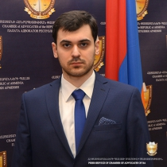
Specialization
Labor relations
Contractual relations
Heritage
Contact information
Tel: , 096 51 77 88
Main address: Yerevan
License number: 2538
Vahagn Avagyan
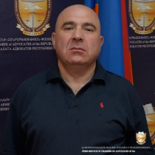
Specialization
Other criminal relations
Contact information
Tel: , 093 77 01 02
Main address: Yerevan
License number: 2400
Vahan Avagyan
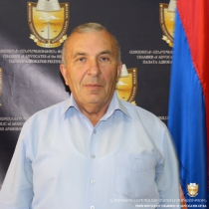
Specialization
Other civil relations
Other administrative relations
Contact information
Tel: , "093 86 34 32;"
Main address: Lori, Vanadzor
License number: 998
Anahit Aleksandr Avanesyan
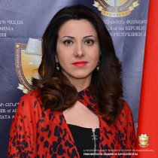
Specialization
Other civil relations
Other administrative relations
Contact information
Tel: , 094 799 779
Main address: Yerevan
License number: 2315
Artak Avanesyan
Specialization
Other civil relations
Other administrative relations
Other international relations
Contact information
Tel: , 096 227897
Main address: Yerevan
License number: 1702
Diana Avanesyan
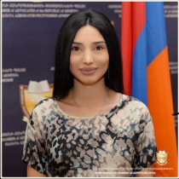
Specialization
Other civil relations
Contact information
Tel: , 077 88 77 62
Main address: Yerevan
License number: 2575
Kristine Avanesyan
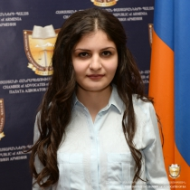
Specialization
Crimes against a person
Crimes against human freedom, honor and dignity
Crimes against constitutional human rights and freedoms of citizens
Contact information
Tel: , 077 15 16 14
Main address: Syuniq, Kapan
License number: 1977
Yura Avayan
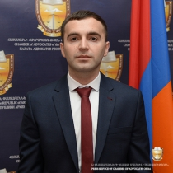
Specialization
Other criminal relations
Contact information
Tel: , 077 80 85 82; 093 99 60 11
Main address: Yerevan
License number: 2574
Varya Avchyan
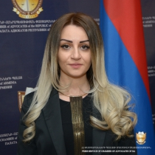
Specialization
Other civil relations
Contact information
Tel: , 099 333 003
Main address: Yerevan
License number: 2158
Naira Avdalyan
Specialization
Other civil relations
Contact information
Tel: , 094 156 999
Main address: Shirak, Gyumri
License number: 2460
Aghanik Avetisyan
Specialization
Other civil relations
Contact information
Tel: , 099 66 66 89; 098 07 23 45
Main address: Yerevan
License number: 2147
Alina Avetisyan
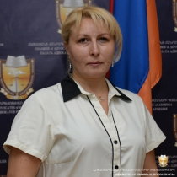
Specialization
Other civil relations
Contact information
Tel: , 098363942 091363942
Main address: Yerevan
License number: 1766
Anahit Avetisyan
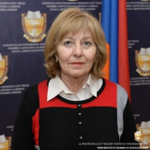
Specialization
Other civil relations
Contact information
Tel: , 096 792566
Main address: Yerevan
License number: 669
Ani Avetisyan
Specialization
Other civil relations
Արտոնագրված հաշտարարություն
Labor relations
Contact information
Tel: 091-27-11-77,
Main address: Yerevan
License number: 1380
Ani Armen Avetisyan
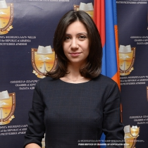
Specialization
Other civil relations
Contact information
Tel: , 077 25 35 60
Main address: Yerevan
License number: 2487

Anna Avetisyan
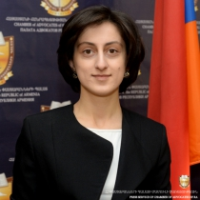
Specialization
Other civil relations
Main address: Yerevan
License number: 1826
Areg Avetisyan
Specialization
Other civil relations
Contact information
Tel: 28 70 03, 091 22 33 31
Main address: Yerevan
License number: 879
Arevik Avetisyan
Specialization
Other civil relations
Contact information
Tel: 44 97 14, 094-45-81-08
Main address: Yerevan
License number: 1381
Armine Avetisyan
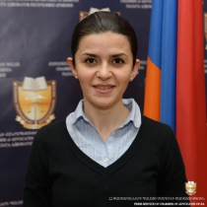
Specialization
Other civil relations
Contact information
Tel: +374 93 143103, +374 93 143103
Main address: Yerevan
License number: 1054
Ashot Avetisyan
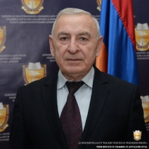
Specialization
Other civil relations
Other administrative relations
Other international relations
Contact information
Tel: 233877, 094 43 50 05
Main address: Yerevan
License number: 1171
Emma Avetisyan
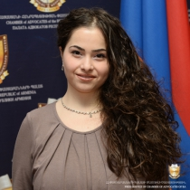
Specialization
Other civil relations
Contact information
Tel: , 099 090717
Main address: Yerevan
License number: 2012
Gagik Avetisyan
Specialization
Other civil relations
Other administrative relations
Other criminal relations
Contact information
Tel: , 091 43 68 98
Main address: Kotayq, Zovuni
License number: 1672
Hamlet Avetisyan
Specialization
Crimes against a person
Crimes against human freedom, honor and dignity
Crimes against constitutional human rights and freedoms of citizens
Contact information
Tel: , 093 161676
Main address: Yerevan
License number: 249
Hermine Avetisyan
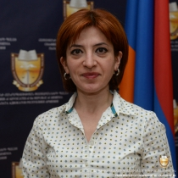
Specialization
Other civil relations
Contact information
Tel: 060 441434, 096 771772
Main address: Yerevan
License number: 803
Lyudvig Avetisyan
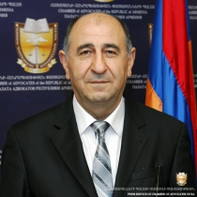
Specialization
Crimes against a person
Crimes against human freedom, honor and dignity
Crimes against constitutional human rights and freedoms of citizens
Contact information
Tel: 010 600714, 077 289028
Main address: Yerevan
License number: 685
Marusya Avetisyan
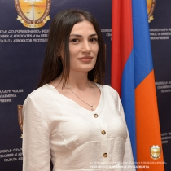
Specialization
Other civil relations
Other administrative relations
Contact information
Tel: , 094 566 330
Main address: Yerevan
License number: 2576
Mayis Avetisyan
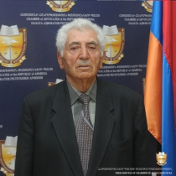
Specialization
Crimes against a person
Crimes against human freedom, honor and dignity
Contact information
Tel: , 091 624256
Main address: Yerevan
License number: 205
Mikayel Avetisyan
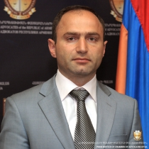
Specialization
Other civil relations
Administrative claims
Contact information
Tel: , 094 216992
Main address: Yerevan
License number: 641
Nelly Avetisyan
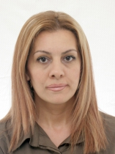
Specialization
Labor relations
Other civil relations
Other administrative relations
Contact information
Tel: , 091 382883
Main address: Yerevan
License number: 164
Nelly Lyudvig Avetisyan
Specialization
Other civil relations
Contact information
Tel: , 093 33 90 90
Main address: Yerevan
License number: 670
Tigran Hamlet Avetisyan
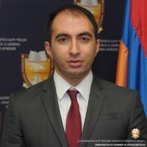
Specialization
Other civil relations
Other administrative relations
Representation in the Constitutional Court of RA
Contact information
Tel: 093 349764,
Main address: Yerevan
License number: 1383
Tsovinar Avetisyan
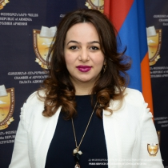
Specialization
Other civil relations
Contact information
Tel: , 093 405582
Main address: Yerevan
License number: 2071
Vahram Avetisyan
Specialization
Other civil relations
Contact information
Tel: , 095 777775
Main address: Yerevan
License number: 643
Vardan Avetisyan
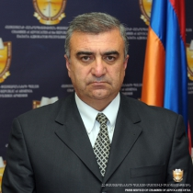
Specialization
Other civil relations
Administrative claims
Crimes against a person
Contact information
Tel: , 091-40-44-49
Main address: Yerevan
License number: 1382
Varsik Avetisyan
Specialization
Other civil relations
Other administrative relations
Crimes against a person
Contact information
Tel: , 099 694349
Main address: Yerevan
License number: 315
Varuzhan Avetisyan
Specialization
Other criminal relations
Other civil relations
Other administrative relations
Contact information
Tel: 28 54 25, 094 56 92 80
Main address: Yerevan
License number: 1339
Hrant Avetyan
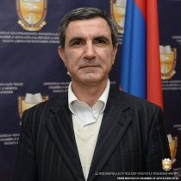
Specialization
Other civil relations
Other administrative relations
Contact information
Tel: 060-54-42-24, 077-23-23-02
Main address: Yerevan
License number: 1384
Rafik Avetyan
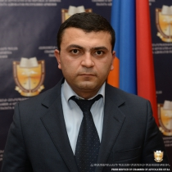
Specialization
Other civil relations
Contact information
Tel: , 093-06-43-95
Main address: Yerevan
License number: 1385
Ruzan Avetyan
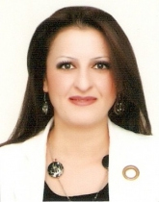
Specialization
Other civil relations
Crimes against a person
Crimes against human freedom, honor and dignity
Contact information
Tel: , 091116176 098190600
Main address: Yerevan
License number: 1767
Anahit Ayvazyan
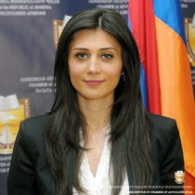
Specialization
Other civil relations
Main address: Yerevan
License number: 1743
Artavazd Ayvazyan
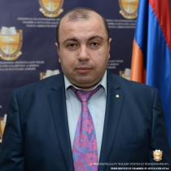
Specialization
Other civil relations
Crimes against a person
Crimes against public security
Contact information
Tel: , 094 303330
Main address: Yerevan
License number: 69
Artur Ayvazyan
Specialization
Corporate relations
Other civil relations
Contact information
Tel: 010 559501, 091 423213
Main address: Yerevan
License number: 156
Gegham Ayvazyan
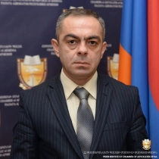
Specialization
Other civil relations
Other administrative relations
Crimes against a person
Contact information
Tel: 010 541504, 091 473009
Main address: Yerevan
License number: 498
Nvard Ayvazyan
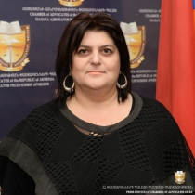
Specialization
Other civil relations
Crimes against a person
Crimes against human freedom, honor and dignity
Contact information
Tel: 010 524619, 094 616833
Main address: Yerevan
License number: 1852
Tatevik Ayvazyan
Specialization
Other civil relations
Other administrative relations
Labor relations
Contact information
Tel: , 099 41 31 33; 093 43 31 33
Main address: Yerevan
License number: 2156
Gagik Azaryan
Specialization
Other civil relations
Contact information
Tel: , 093 04 07 50
Main address: Yerevan
License number: 872
Petros Azaryan
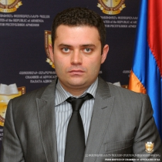
Specialization
Heritage
Other civil relations
Contact information
Tel: , 093 400504 093 400504
Main address: Yerevan
License number: 491

Harutyun Azatyan
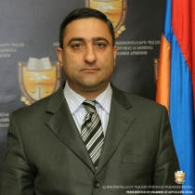
Specialization
Other civil relations
Other administrative relations
Contact information
Tel: 010 560117, 091 494770
Main address: Yerevan
License number: 420
Ararat Azibekyan
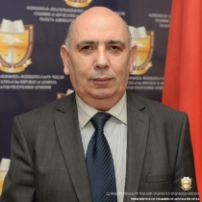
Specialization
Crimes against a person
Crimes against human freedom, honor and dignity
Crimes against constitutional human rights and freedoms of citizens
Main address: Tavush, Noyemberyan
License number: 1834
Tatev Azibekyan
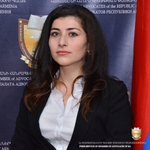
Specialization
Other civil relations
Contact information
Tel: , 077 91 35 02
Main address: Yerevan
License number: 2309
Davit Azizyan
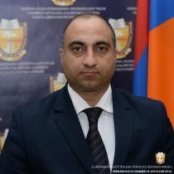
Specialization
Other civil relations
Contact information
Tel: , 095 818515
Main address: Ararat, Masis
License number: 1819
Seyran Azizyan
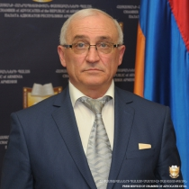
Specialization
Labor relations
Contractual relations
Heritage
Contact information
Tel: 0232 36077, 077 130218
Main address: Aragatsotn, Ashtarak
License number: 797
Soffi Azizyan
Specialization
Labor relations
Heritage
Insurance
Contact information
Tel: 077284403, 091871109
Main address: Aragatsotn, Ashtarak
License number: 873
Volodya Aznavuryan
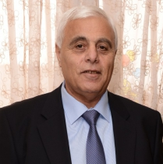
Specialization
Labor relations
Other civil relations
Crimes against a person
Contact information
Tel: 010 749692, 091 464136
Main address: Yerevan
License number: 331

