**Diplomatic Car For Sale**

**from Embassy of the Republic of Poland**

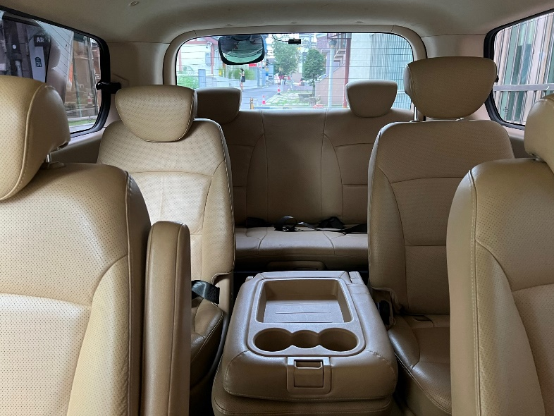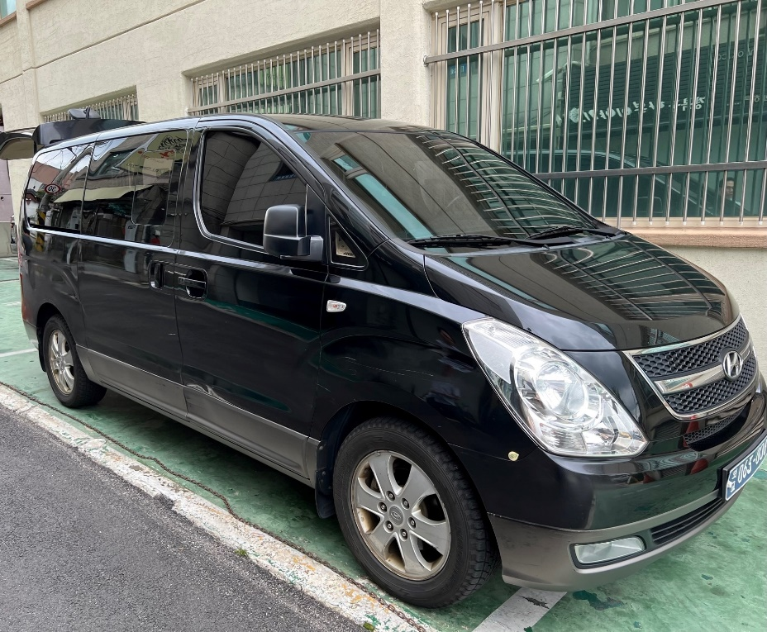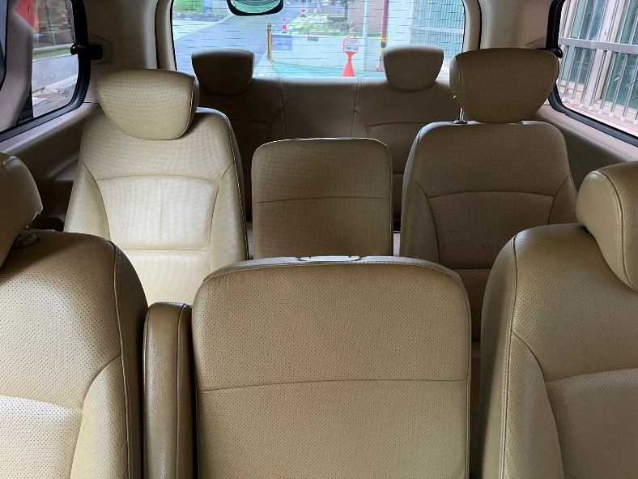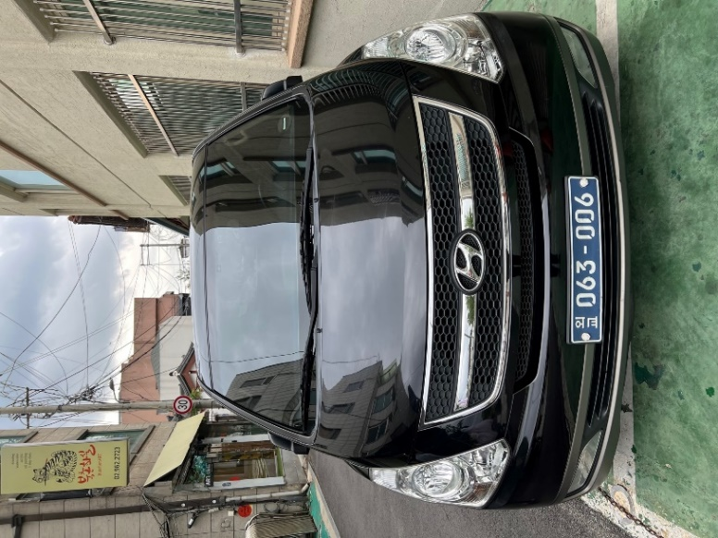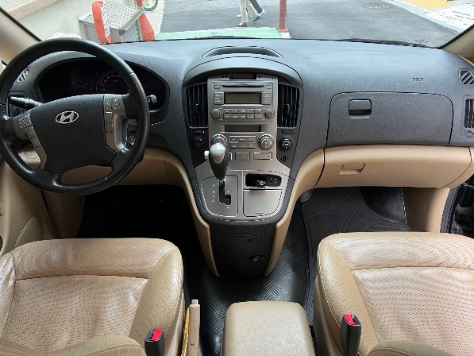**Hyundai Starex TQ**

**General information**:

First Registration: 2010 Colour: black

Gearbox: Automatic Engine : 2497 cm3

Seating capacity: 11

**starting price: 3.200,00 EURO**

Please contact us if you are interested!

e-mail: yoojung.lee@msz.gov.pl

telephone number : (02) 723-9681