The Consulate General of the Republic of Poland in Barcelona and the Polish-Spanish Chamber of Commerce in Warsaw
are pleased to invite you to the webinar:
URBAN GREEN TECHNOLOGIES: POLISH POTENTIAL – SMART OFFER FOR CATALUNYA?
INNOVATION ECO CITIES: GDAŃSK AND BARCELONA EXPERIENCES
which will be held on
Friday, 16th of April at 11.00 hrs. via MS Teams platform
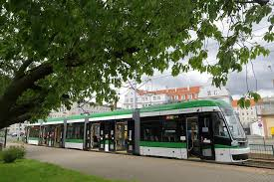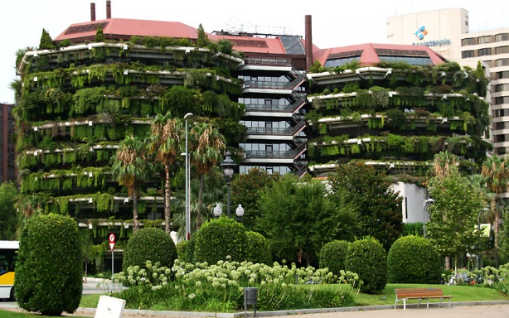
Agenda:
Opening words:
11.00 – 11.05 Ms. Karolina Cemka, Polish Consul General in Barcelona
11.05 – 11.10 Mr. Stefan Bekir Assanowicz, President of the Polish-Spanish Chamber of Commerce
11.10 – 11.20 Mr. Xavier Mayo, Head of International City Promotion, Barcelona City Council

Moderator: Ms. Renata Marciniak – President of the Polish-Catalan Chamber of Commerce in Manresa
Why to make green inno business with the Polish Cities?

11.20 – 11.35 Open data in preventing clime changes, Ms. Joanna Tobolewicz, Plenipotentiary of Mayor of Gdańsk for Energy
11.35 – 11.45 Urban Policies versus Climate Changes in Poland – main objectives, Ms. Marta Piszcz, GreenEvo Project Coordinator, Ministry of Climate and Environment of the Republic of Poland
11.45 – 12.00 Eco mobility, eco construction and waste management, Mr. Włodzimierz Ehrenhalt, Vice President of the Renewable Energy Association SEO, Poland
12.00 – 12.15 Green public procurement as a tool in green urban transformation, Ms. Katarzyna Kuźma, Partner at Domański Zakrzewski Palinka, Infrastructure and Energy Practice
12.15 – 12.30 Green Opportunities for Catalan and Polish Companies, Mr. Michał Chabasiewicz, Director of the Office of the Catalonia Trade & Investment Agency ACCIÓ in Warsaw
12.30 – 12.45 - Case study: Energy from waste a fast growing part of waste management system in Poland, Mr. Artur Pielech, President of the Management Board and CEO at FB Serwis SA, Poland
12.45 – 13.00 Questions and Answers

Closing remarks:
Ms. Zuzanna Gołębiewska, Director of the Polish-Spanish Chamber of Commerce in Warsaw Ms. Karolina Cemka, Polish Consul General in Barcelona

ABOUT
Urban centers in Poland and in the world are developing dynamically, which is also associated with pressure on the natural environment. Already today, the 75% of greenhouse gas emissions come from there. The conference will be an opportunity to reflect on how cities can continue their development, while reducing their negative impact on the environment and providing a decent and healthy living to their inhabitants. The participants of the event will look at challenges, such as: investments in infrastructure or the use of available financing models. They will also learn lessons that have worked succeeded Polish cities such as Gdańsk.
The Urban Agenda for the EU
With the establishment of the Urban Agenda for the EU Community in 2016, European cities have gained more ability, through their partnerships, to influence the shape of EU policy on issues directly related to the urban development. The priority topics of the agenda included, among others, air quality, adaptation to climate changes, changes in the energy model or mobility. One of the advanced urban adjustments represent cities of Gdansk and Barcelona (twinning cities).
FOR WHOM
The webinar is an opportunity to meet experts on sustainable development and innovative technologies, representatives of regional administration and Catalan institutions, business delegates and its environment, non-governmental organizations, research and academic institutes.
FORMULA
The event will be live streamed in real time and will be recorded (at the disposal of KG RP in Barcelona and PHIG) and can be distributed as required.
LANGUAGE
English (optionally Spanish)

In order to register, please fill in the online registration form or contact with k.tetych@phig.pl
The link to the webinar in MS Teams will be send to You one day prior to the meeting.

