Poland supports Bali and NTT communities with new technology to grow fish and plants
- New aquaponics technology allows for the growth of fish and plants while saving water
- Poland supported the project in Bali with a local NGO Kopernik
- Another Polish project was aimed at prevention of stunting by planting moringa trees in NTT
Aquaponics is a new technology that allows to grow plants and fish in one system. In simple terms, fish live in a basin. They pollute the water, but also fill it with valuable nutrients. Such water is pumped to fertilize plants. Plants use the nutrients from the water and clean it. Clean water flows back to the fish. Integrating plant and fish farming has many advantages. It allows for faster growth, makes it impossible to use artificial fertilizers, and most of all – saves water. As such it contributes to climate change adaptation. Poland through the governmental fund Polish Aid gave a grant of 10 000 EUR and decided to disseminate this technology in Bali.
An aquaponic facility was constructed in Selat village near Ubud, Bali. The project was implemented by a Balinese NGO Kopernik in cooperation with Warmadewa University. It was opened officially on December, 11, 2021, by Ambassador of Poland Ms. Beata Stoczyńska.
Why Bali? Nanda Riska from Kopernik, the project manager explains: - Balinese people have been particularly financially impacted by the Covid-19 pandemic. The project participants and their families experienced an income reduction of 60%. They had to adjust daily food consumption by limiting protein variety, consumption frequency and reducing meal portions, adds Riska. Thanks to the facility, local community will now grow valuable vegetables including pak choi, together with tilapia fish.
The local community embraced the project, with 73% participants being women. As the facility was constructed and the trainings started the interest began to grow. As the news on the new technology spread, also participants from other parts of Bali started attending training meetings. These interests indicate that there is high potential for further adoption and replication of the aquaponic system as an alternative food source and income. Soon a question on how to run the facility arose. It was agreed that the revenue from the harvest will be managed to cover the operational cost, labor cost, and land lease. Then the profit will be distributed to the participants once in six months during Galungan (a Balinese religious celebration day) when they need money the most.
The project in Bali was not the only effort of Poland to support the needy in Indonesia. In East Nusa Tenggara the Polish Aid sponsored a project of stunting prevention. The project in Kuotae (Timor Central-South regency) consisted of education activities on the importance of good nutrition and establishment of community garden. The garden serves young mothers to source healthy food, including leaves of the “miracle plant” – moringa. Ambassador of Poland explains: - As the government of Indonesia makes the food security and combating stunting its priority, Poland wishes to do its part. We will continue supporting Indonesia in this respect.
Both projects were part of #TeamEurope effort of the European Union and its member states to aid Indonesia in advancing sustainable Development Goals.

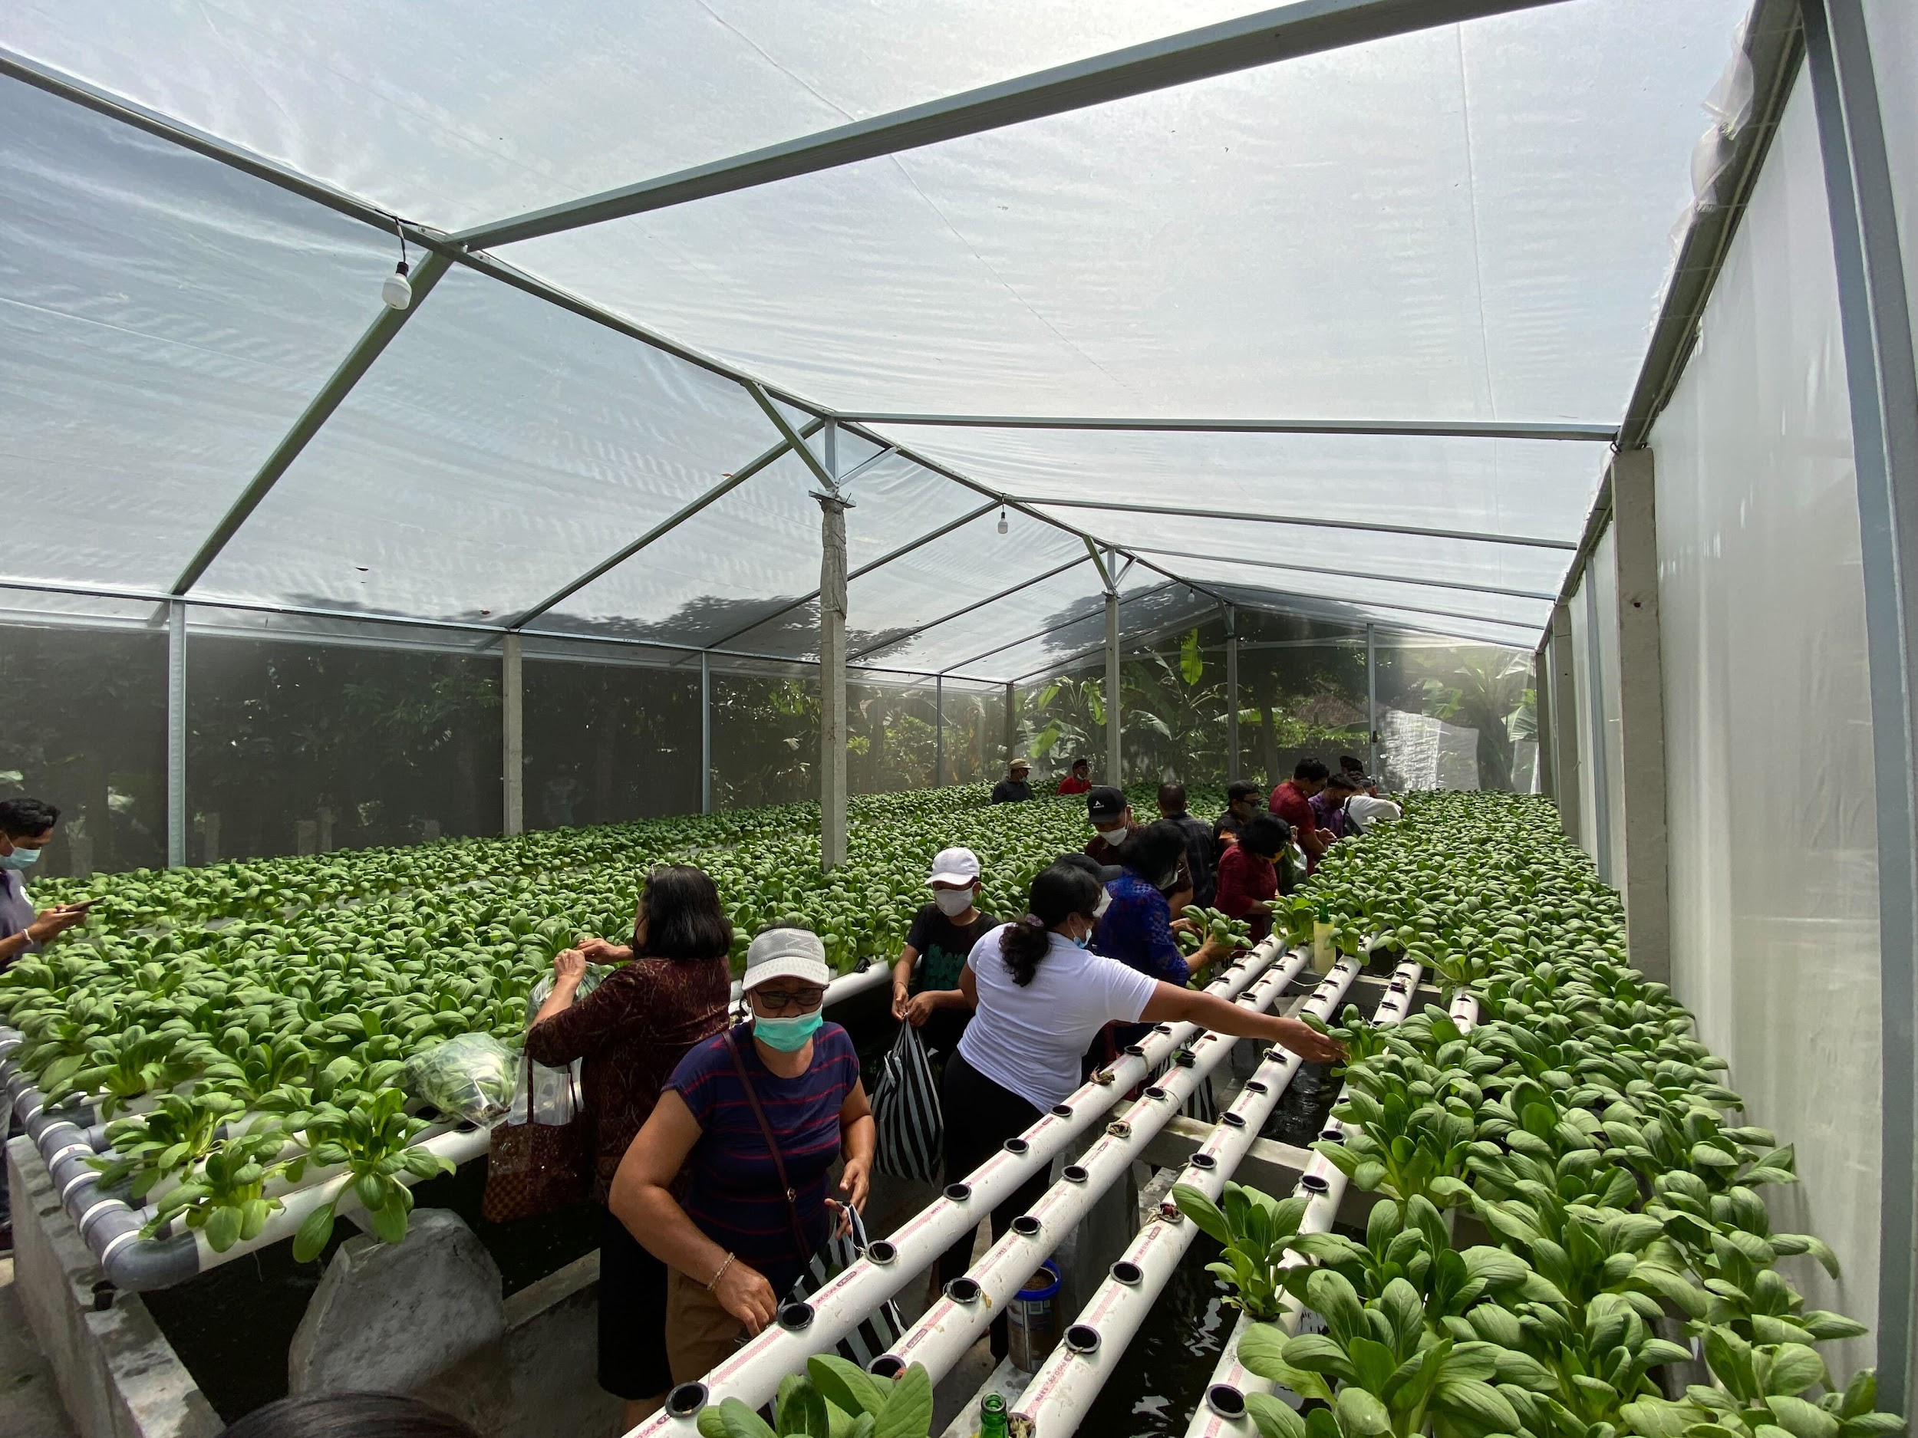
| 12 October 2021| Female participants harvest the vegetables in the first planting cycle.
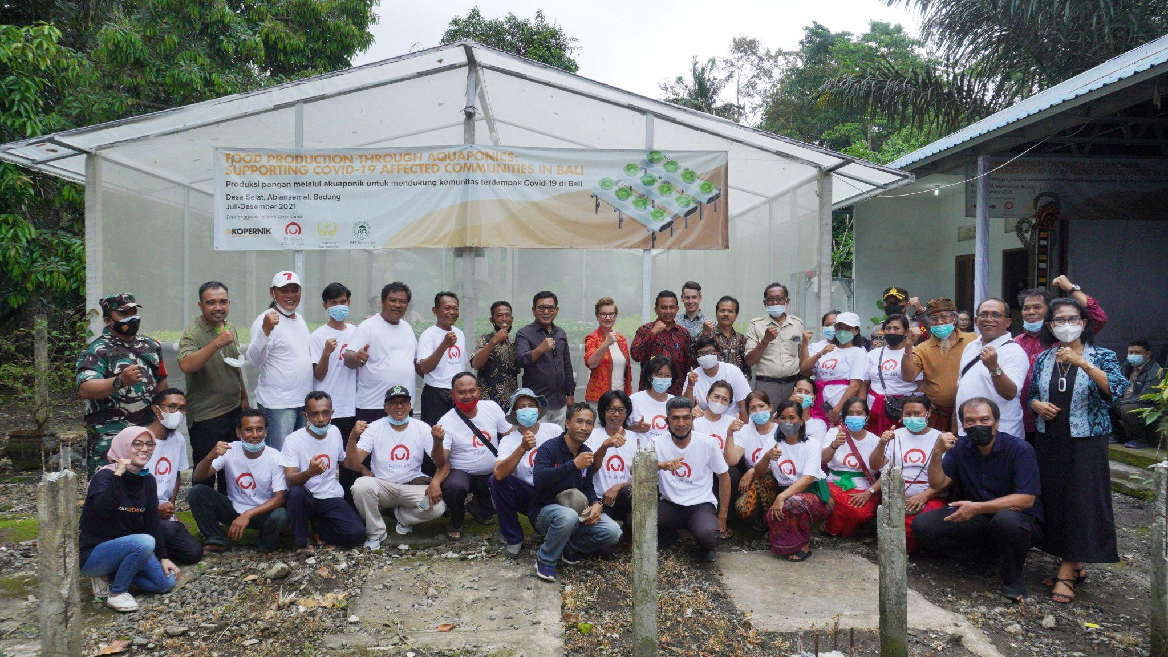
The whole team - training participants, Kopernik, Warmadewa University, and Polish Ambassador for Indonesia.
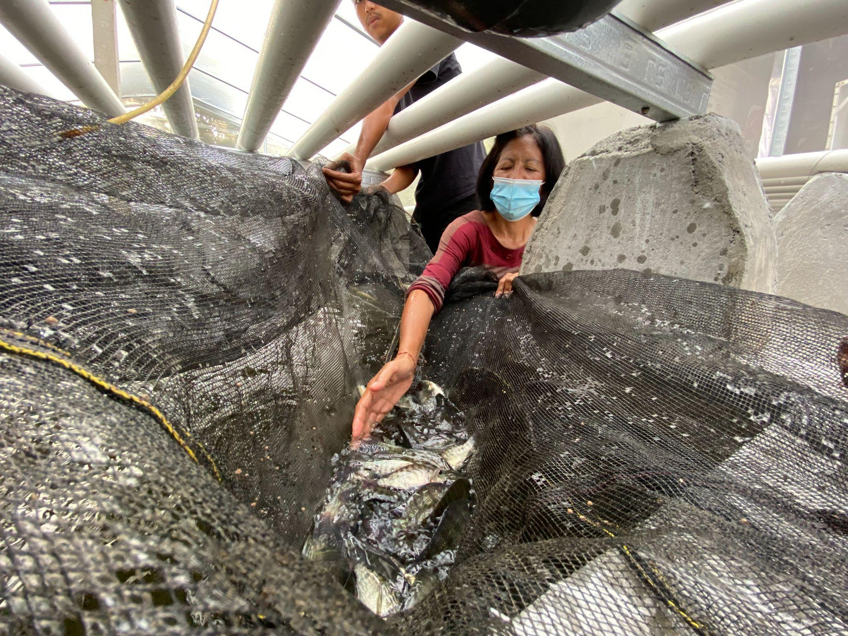
A female participant monitoring fish conditions at the facility.
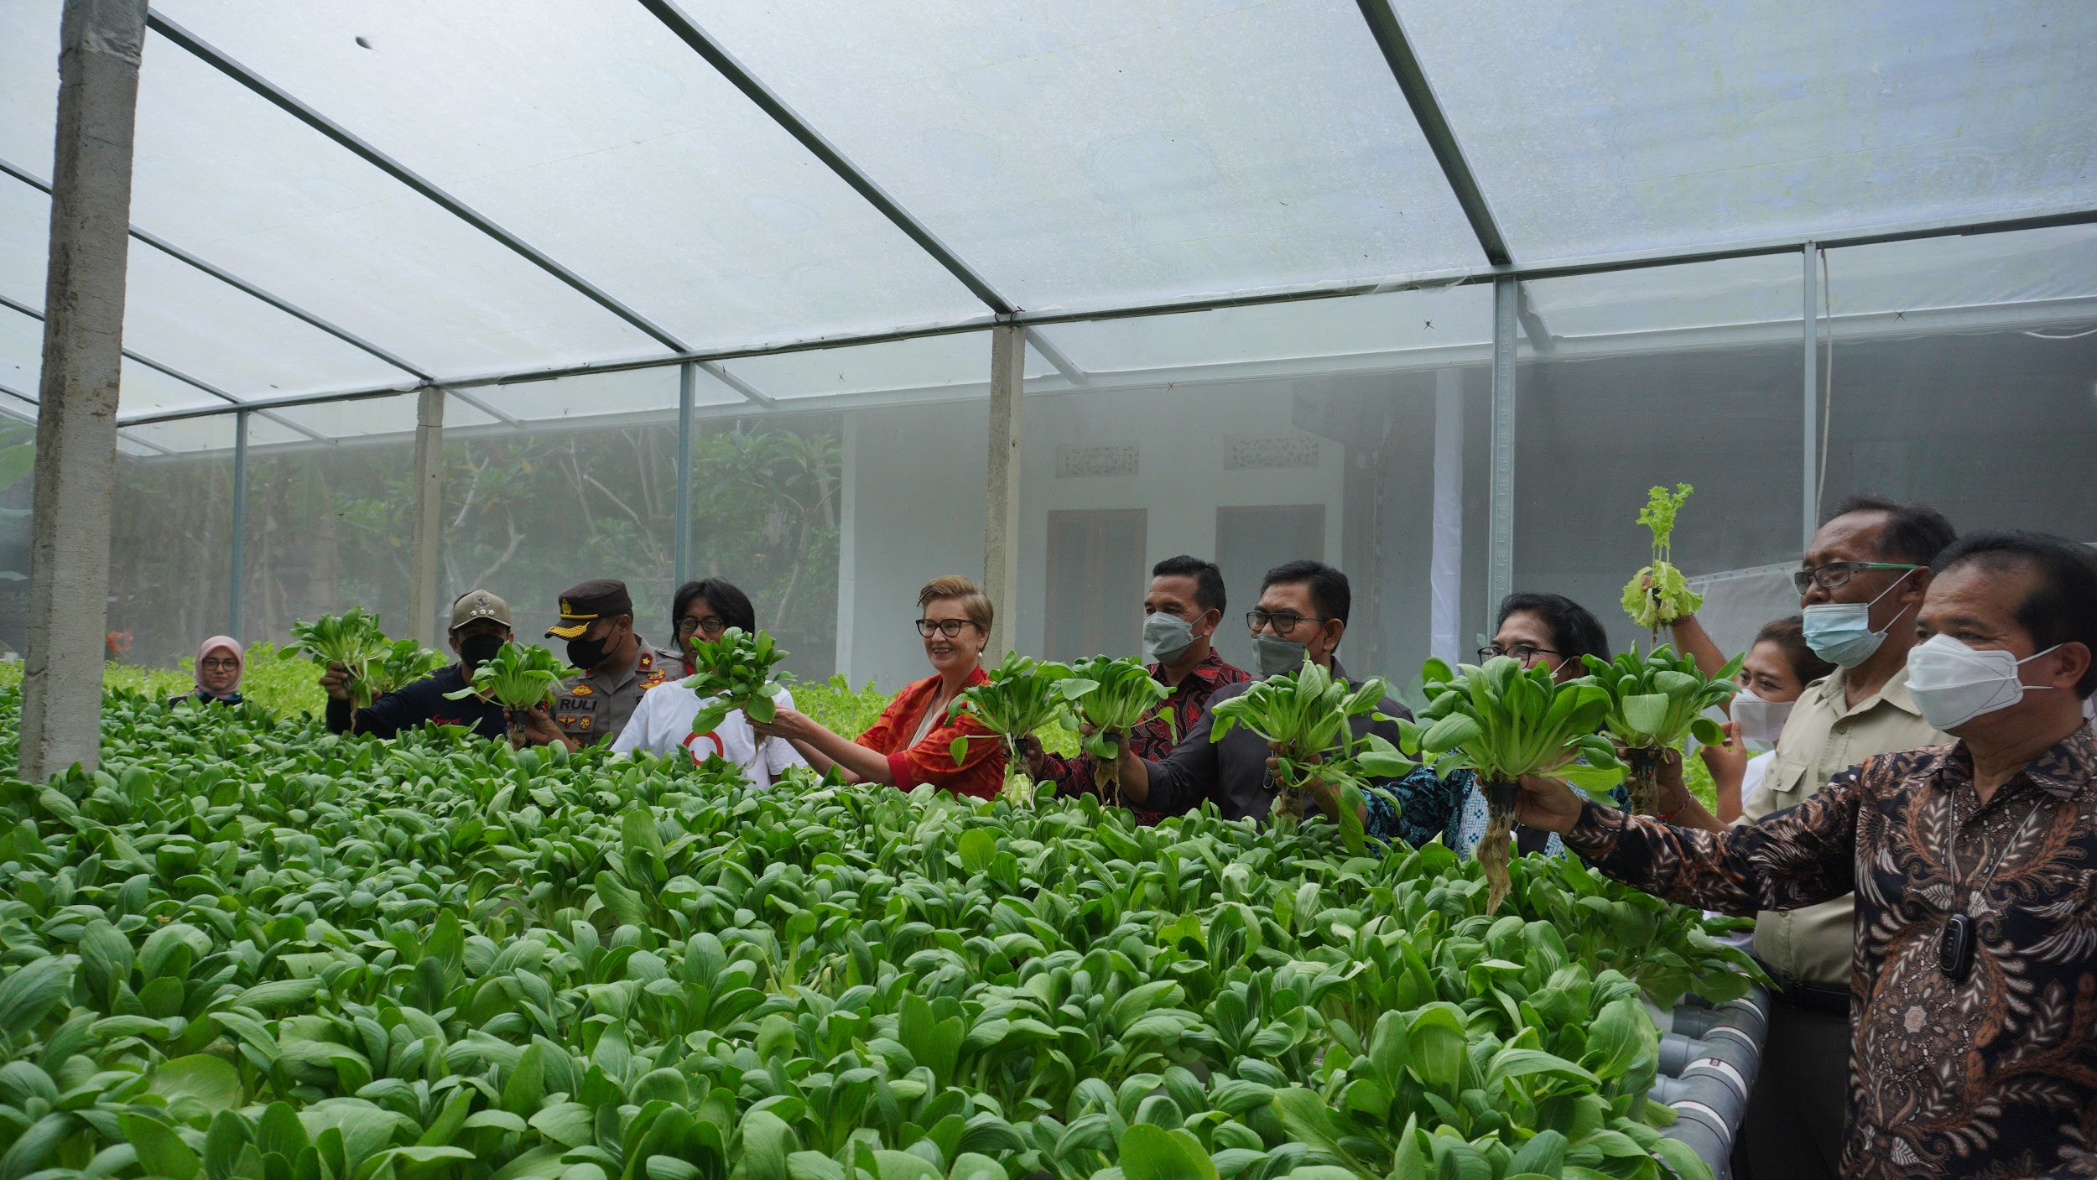

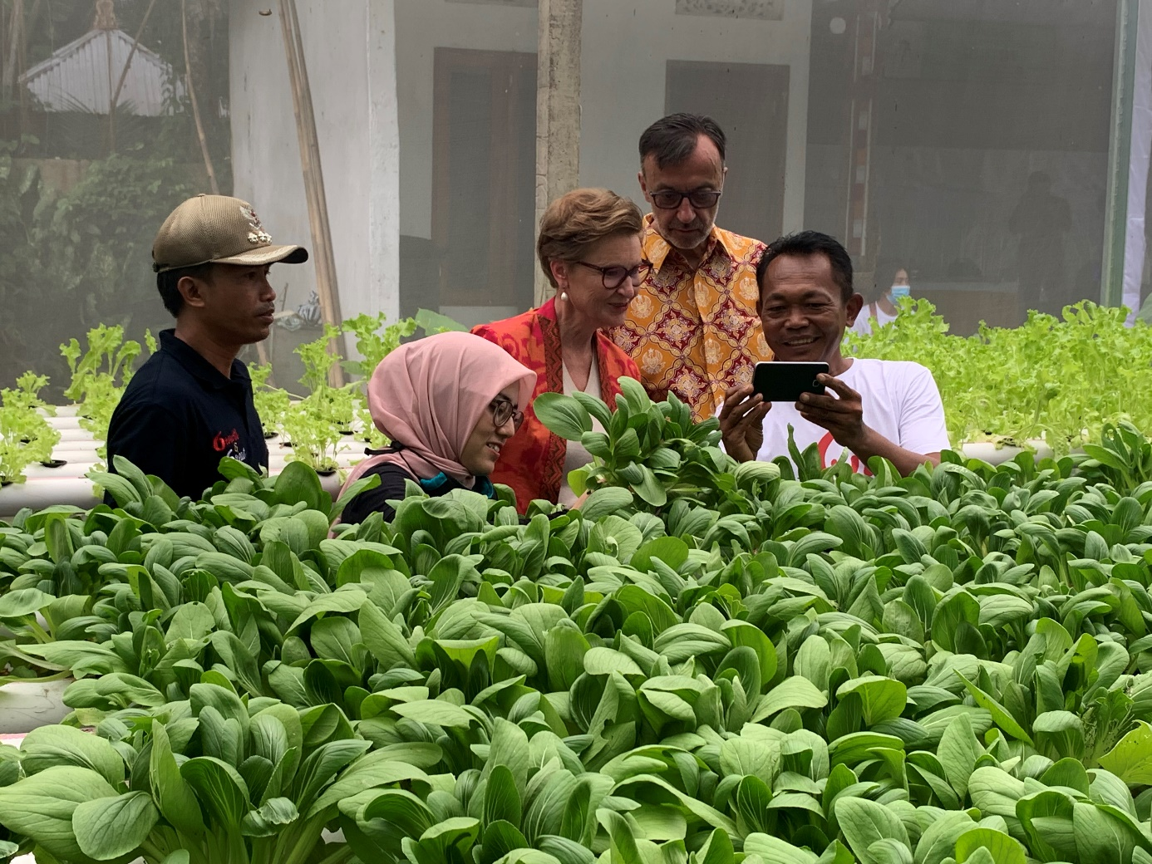

11 December 2021, Visit of the Ambassador of Poland Ms. Beata Stoczyńska. It coincided with a pak choi harvest
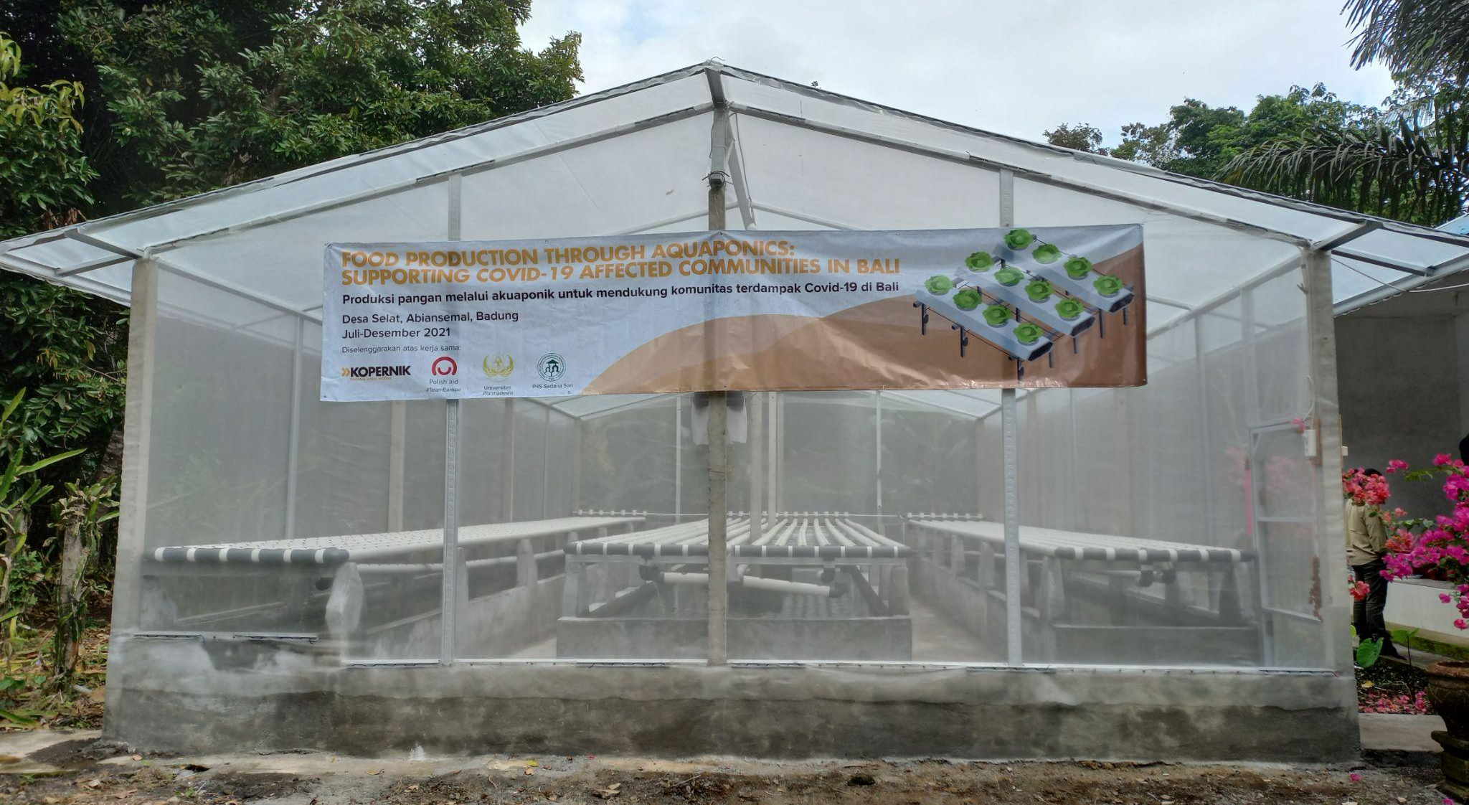
Aquaponic facility constructed in Selat village, Abiansemal, Bali.
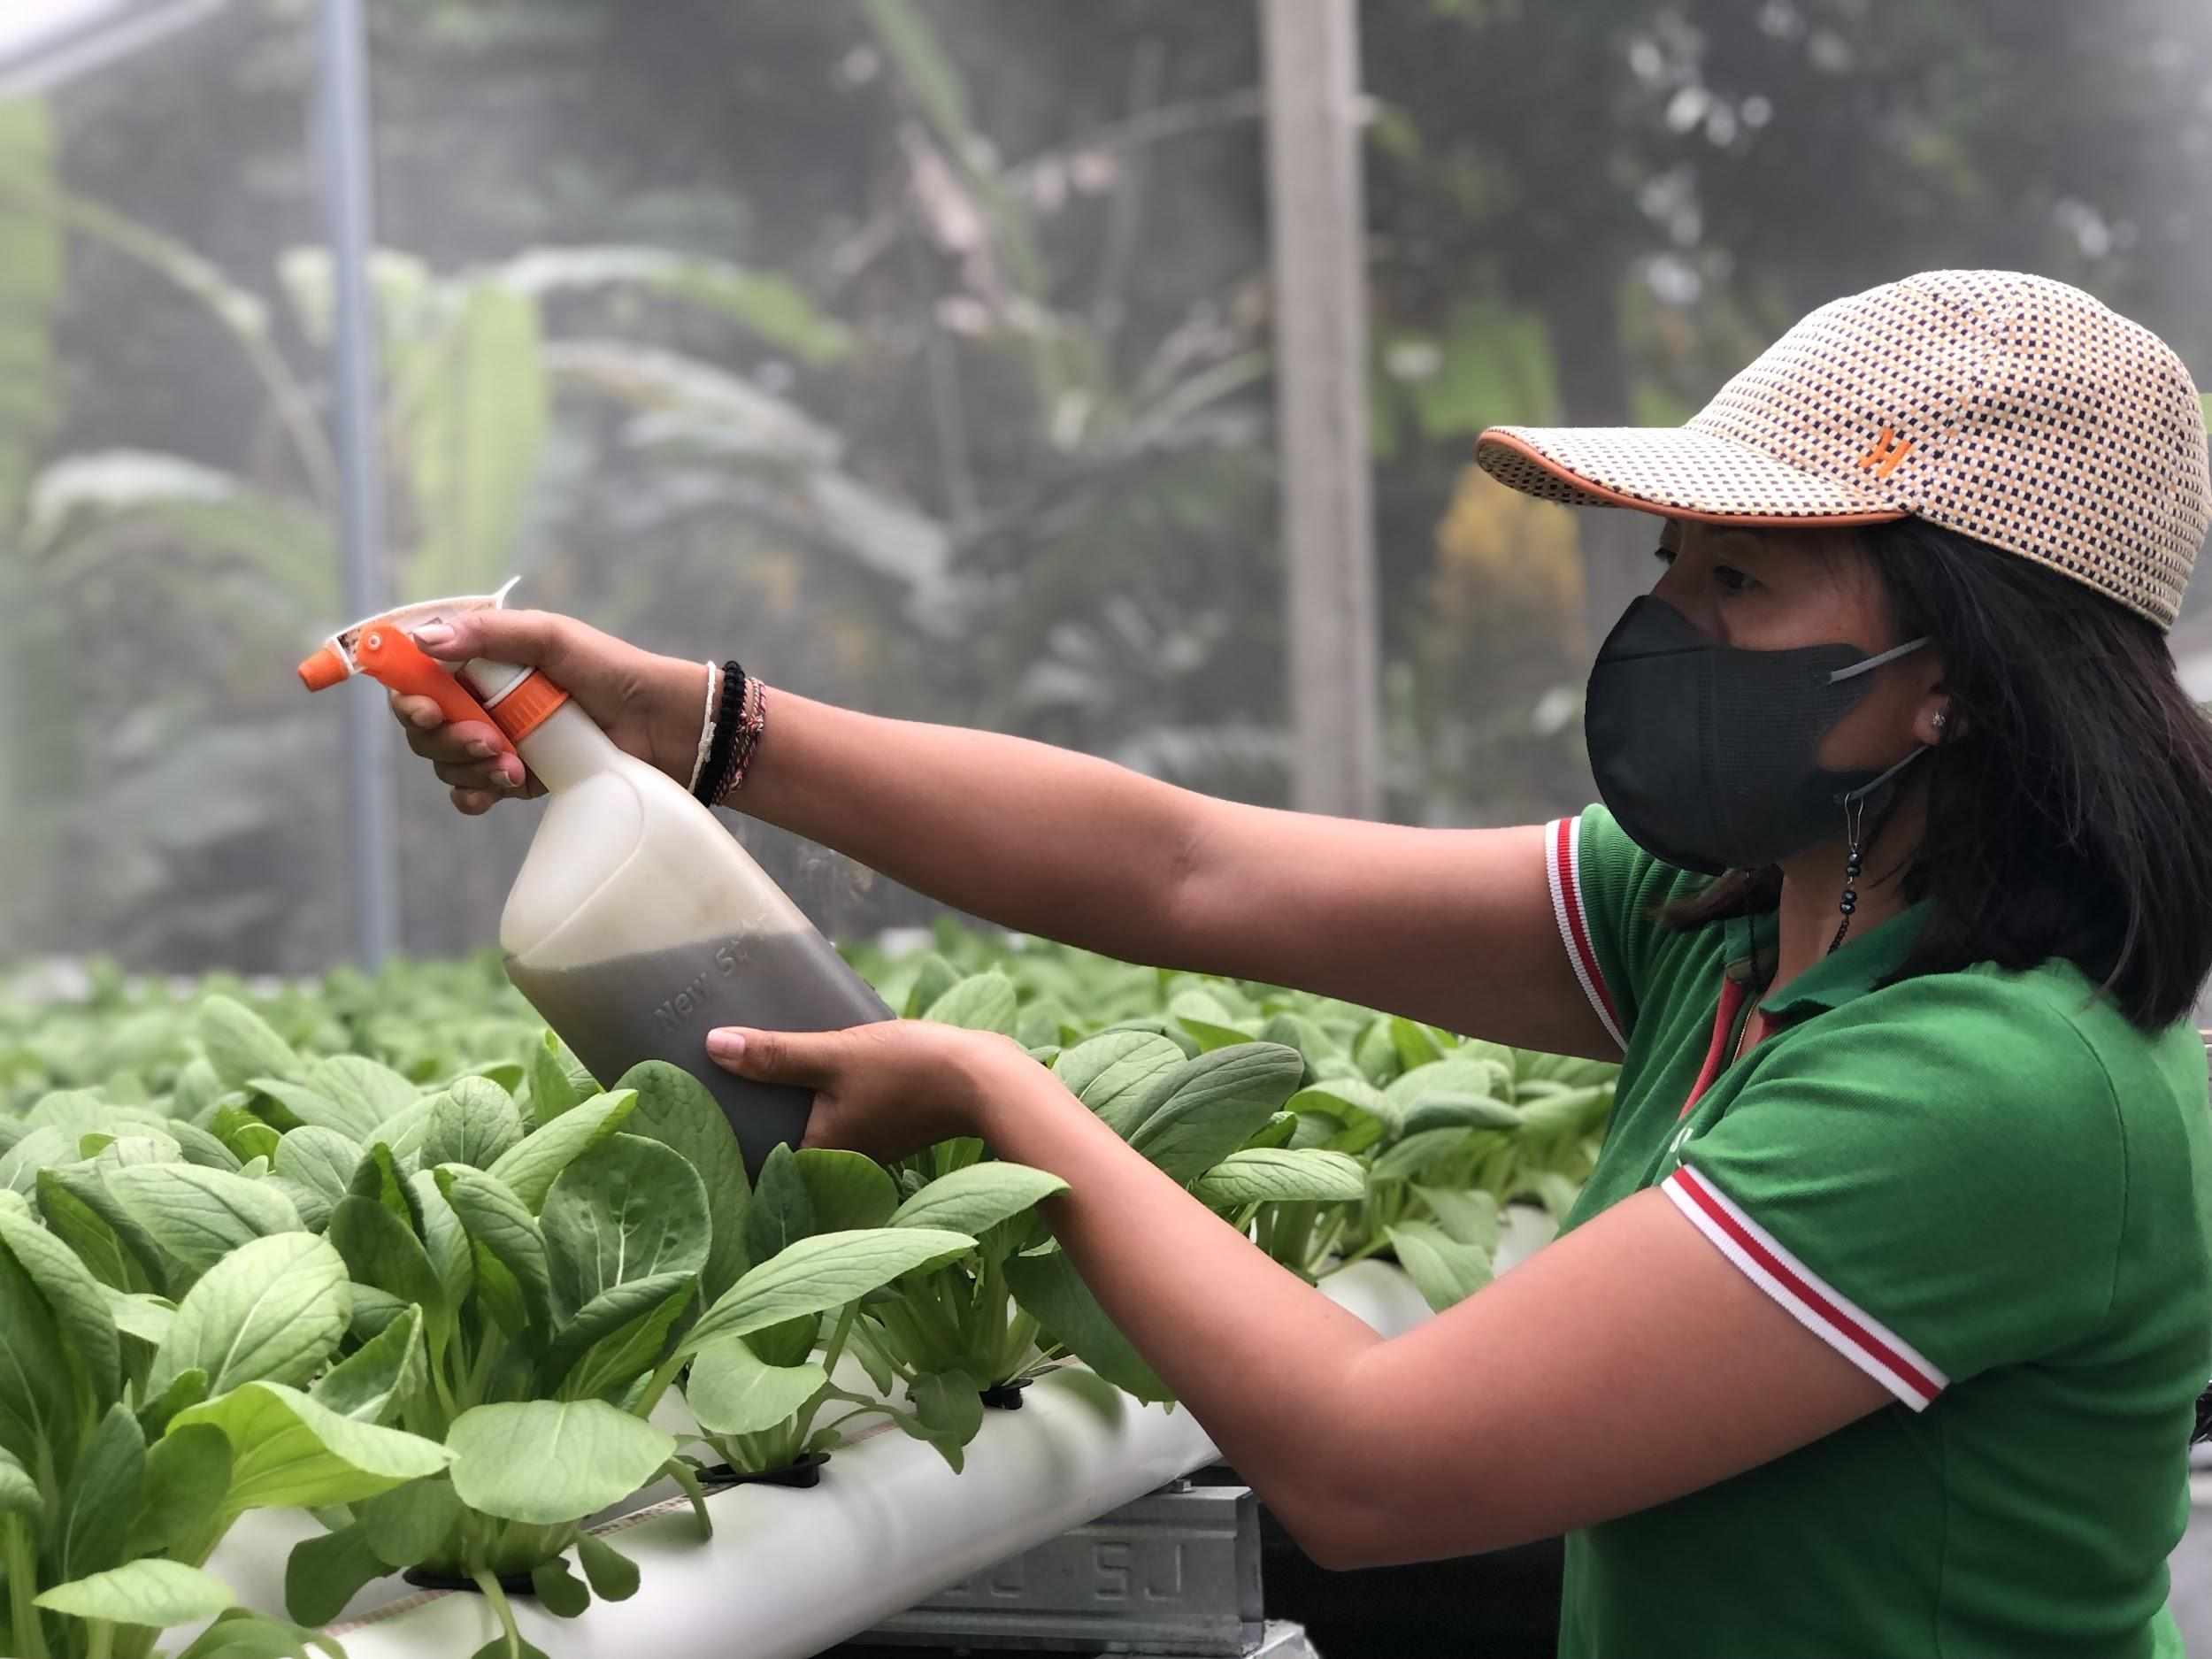
A training participant applied organic pesticide onto the vegetables.

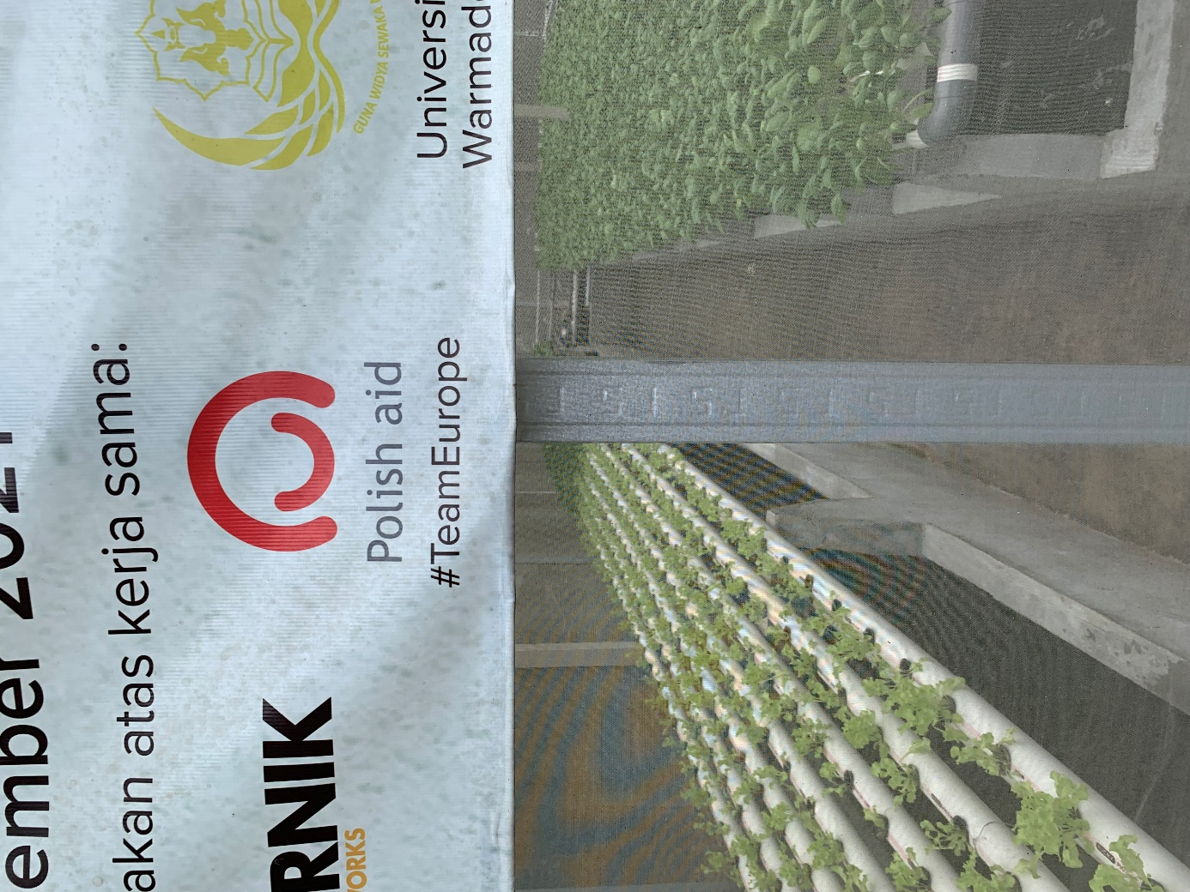

Kompas Dewata TV News coverage

