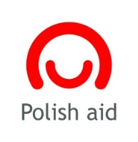 | 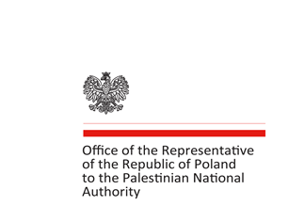

The Representative Office of Poland in Palestine
within the framework of the Polish Aid Development Program
would like to announce
the opening of a new grant cycle for 2021

Complete project proposals (including the budgets) must be submitted to polishaid.palestine@msz.gov.pl no later than April the 7th 2021,

The priorities of Polish Aid interventions in Palestine are determined by the “Development Cooperation Plan” developed by the Development Cooperation Department of Poland’s Ministry of Foreign Affairs. For the 2021 cycle, the priorities are as follows:

1. Equal opportunities – education:
a) Providing at all levels high-quality education, corresponding to contemporary challenges and modern standards, and increasing the number of people learning.
a) Removing all barriers - both physical and mental - in access to education at all levels, including equalizing educational opportunities for girls and young women and people at risk of exclusion due to disability.
b) Improving the quality and conditions of education, as well as the infrastructure of educational institutions, taking into account safe and hygienic conditions, access to water and electricity (in particular with the use of renewable sources).
2. Equal opportunities - entrepreneurship and decent work:
a) Creation of good-quality jobs, especially in the sectors of agriculture and processing, green technologies and IT, with particular emphasis on the situation of women, young people and people with disabilities.
b) Increasing access (especially of women and youth) to vocational training, career counseling and retraining.
c) Development and promotion of entrepreneurship, professional activity and employment, especially for women and young people, including in the scope of running sole proprietorships or family businesses.
d) Increasing the competitiveness, efficiency and innovation, especially of non-profit enterprises, producer groups, cooperatives and cooperatives, as well as small and medium-sized enterprises, especially in the agri-food sector.
3. Reduction of inequality:
Support for activities aimed at increasing access to social services for people with disabilities, in particular in non-urbanized regions, including by eliminating discriminatory policies and practices.

The submitted projects must be implemented within 7 months from June to December 2020.
Applicant must be registered as a legal entity for a minimum of 5 years and have a previous record of international grants. The grant ceiling is 30,000 EUR. Requested budget should be proportionate to the applicant’s previous grants. Grants can be disbursed only as reimbursements of expenses – no downpayments will be provided. Application form is attached below.

4. Health:
a) Construction and modernization of medical, sanitary and administrative systems and infrastructure of healthcare entities, as well as supporting the functioning of local health centers.
b) Ensure that all people have access to high-quality health care, including rehabilitation, with particular emphasis on people with disabilities and residents of areas with limited access to medical services.
c) Strengthening the health care system and improving the qualifications of medical personnel, including adaptation to contemporary challenges and technologies.
5. Climate and natural resources:
Support for activities for the preservation of biodiversity, including endemic species of plants and animals, as well as for the protection, restoration and sustainable use of ecosystems.

To read more about the Polish Aid go to: https://www.gov.pl/web/polishaid

Legal Reservations:
The Representative Office of Poland reserves the right not to award any grants in the current cycle. The results of the call for proposals will be communicated to all applicants in due time.
The grant contract shall be signed in compliance with the draft submitted by the Representative Office of Poland. Natural or legal persons, groups and entities designated under EU restrictive measures (www.sanctionmap.eu) are excluded from the procedure.

