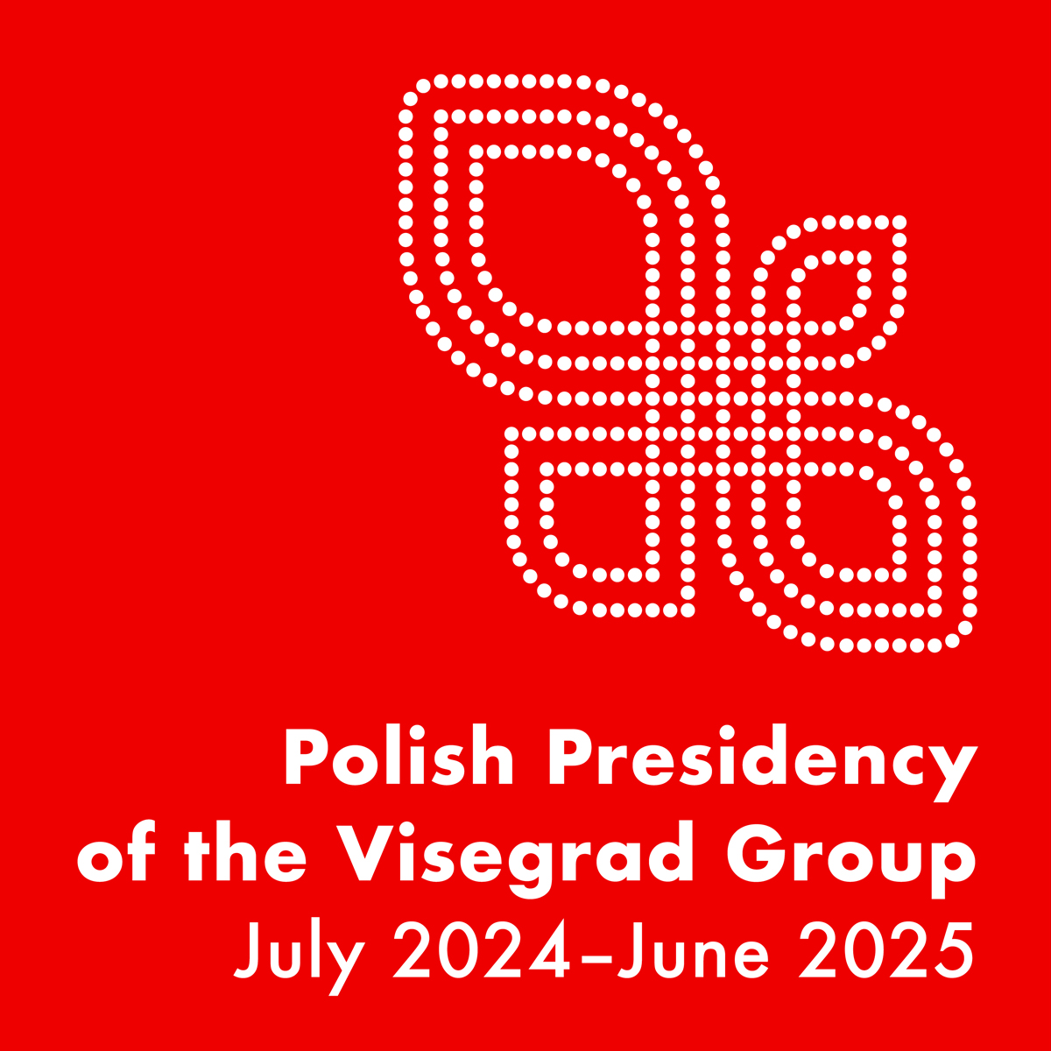

**PRESIDENCY PRIORITIES**



Warsaw, September 2024

**PRIORITIES OF THE POLISH PRESIDENCY OF THE VISEGRAD GROUP (V4)**

**(1 July 2024 – 30 June 2025)**

***V4: Back to Basics***

On 1 July 2024, Poland will begin its seventh one-year presidency of the Visegrad Group (V4). The goal of the Polish presidency is to continue cooperation to the benefit of our citizens through maintaining a platform for dialogue wherever the member states’ ambitions converge and preserving the V4’s valuable accomplishments.

The motto for the Polish presidency of the Visegrad Group is: ***“V4: Back to Basics”****.* It refers to the foundations of Visegrad cooperation such as freedom, human rights, and the rule of law. The presidency programme is based on the following pillars:

**“Citizens’ Safety”** – encompasseschallenges relating to security in its internal and external dimensions, including in particular: support for Ukraine; refugee and migration crises; border security; rescue services and protection of the population; countering hybrid threats; consular, police, and defence cooperation; cooperation in the administration of justice and cybersecurity know-how exchange among domestic institutions. The presidency will also promote initiatives in the areas of: health care; security of medical data and related modern technologies; support for small and medium-sized enterprises (SMEs) in their digital transition. Further parliamentary cooperation will also have an important role to play.

The Polish presidency of the Visegrad Group in the first half of 2025 will overlap with the Polish presidency of the EU Council (1 January – 30 June 2025), the focal priority of which will be various aspects of security.

**“Connectivity”** – covers initiatives strengthening regional infrastructural and energy connections. Emphasis will be placed on topics such as safety of road traffic, transport alongside the north-south axis, including in the context of the European Transport Corridors; railway transport, intermodal transport of goods, and public transport; promotion of connections between Polish sea ports and the V4 markets; problems, opportunities, and challenges faced by the industry at the time of transition to zero-emission transport. The Polish presidency will also focus on the V4 countries’ raw materials security, nuclear energy, power generation and gas, as well as oil and transport fuels. Other important areas of cooperation within this pillar include: digitisation, transformation of industrial sites, waste management, circular economy.

**“Unleashing the Potential”** – encompasses a discussion on regional horizontal topics such as: cohesion policy; agricultural policy; forestry; financial and fiscal cooperation; promotion of the UN Agenda 2030. Special attention will also be paid to: development assistance for border areas; strengthening academic cooperation and research and development; cooperation among research establishments aimed at strengthening R&D activity; activation of the youth; exchange of experiences in providing education for children in need, in particular Ukrainian refugees; actions in the area of administration of justice, social and family policy as well as policy towards persons with disabilities. This pillar also includes cooperation in the areas of: V4 region’s culture and cultural heritage; intellectual property (Visegrad Patent Institute), sports (including through annual meetings of the V4 Olympic Hopes Competition Steering Committee), tourism and statistics (cooperation among the V4 states’ statistical authorities).

**Support for Ukraine** as the strategic interest of the Visegrad Group will be an element inextricably intertwined within the three priorities. The Polish leadership of the Visegrad Group will also be committed to **supporting the process of the EU enlargement towards both the Western Balkan and the Eastern Partnership partners.**

The Polish presidency of the V4 will also support the activities of **the International Visegrad Fund** (IVF), which has contributed significantly to deepening cooperation among the V4 states’ societies thanks to the successful and efficient implementation of scholarship and grant programmes. From 2025 on, the IVF will have an increased annual budget of EUR 11 million.

In 2024, Poland has also assumed the annual presidency of the IVF, with the following key priorities: ensuring swift implementation of key IVF scholarship and grant programmes, continuation of the IVF assistance to Ukrainian society and its involvement in the Eastern Partnership and Western Balkan partners. The IVF’s Strategic Grants for 2024 cover actions aimed to assist Ukraine and the EU neighbourhood, countering disinformation and the spread of fake news, and promotion of the development of people-to-people contacts. Furthermore, the presidency will make efforts to facilitate the exchange of experience on the role of civil society, including in crisis situations.