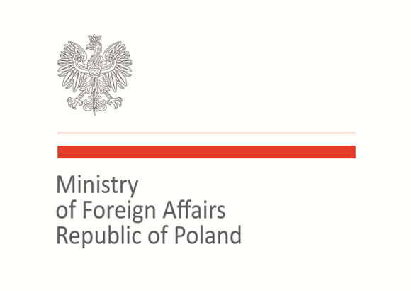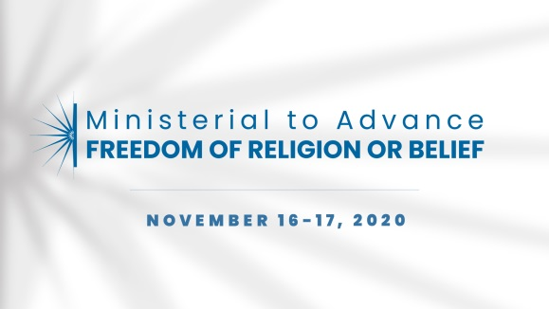

2020 Ministerial to Advance Freedom of Religion or Belief
Warsaw, November 16–17, 2020
Statement of Concern

Statement on preserving freedom of religion or belief during COVID-19 pandemic

As representatives of nations that include various cultures, religions, and beliefs, we recall the primary responsibility of governments to fully respect and protect human rights for all individuals, in line with the Universal Declaration of Human Rights, the International Covenant on Civil and Political Rights and the Declaration on the Elimination of All Forms of Intolerance and of Discrimination Based on Religion or Belief. Today, during the COVID-19 pandemic, meeting this responsibility is even more vital than ever before. We call on regimes that have introduced discriminatory and selective measures to restrict human rights under the pretext of fighting the pandemic to reverse these measures.
The global crisis caused by the COVID-19 pandemic cannot be an excuse to erode the functioning of state institutions, impose discriminatory practices, or constrain access to life-saving services and testing. It cannot be justification for measures aimed at silencing, oppressing, persecuting, or using violence. We observe that COVID-19 perpetuates and exacerbates existing inequalities and inappropriate practices faced by persons in vulnerable and marginalized situations, including individuals belonging to religious minority groups. Thus we underline that especially now all national efforts should be vigilant and focused on how to mitigate the impact of the pandemic on those most vulnerable and exposed to its negative effects.
We express concern that the pandemic is being used to justify oppressive changes to legislation or violent acts within societies. Temporarily restricting the freedom of religion or belief in order to protect public health must never be discriminatory or unlimited. We are especially concerned by the unprecedented rise of hate speech towards members of religious minority groups and the blaming of them for spreading the virus, which intensifies anti-Semitic, anti-Christian, anti-Muslim, or other negative sentiments and prejudices.
At the same time we draw attention to the devastating consequences of widespread misinformation that further stigmatizes minority groups. We call upon all states to establish effective and transparent strategies of communication to provide accurate and reliable information to the public, without discrimination.
Therefore, we commit to work collectively:
- To support religious and faith-based organizations and leaders in tracking and identifying gaps in the COVID-19 response;
- To provide transparent, accurate, and timely information on COVID–19, and to respect the right of every person to freedom of expression, including freedom to seek, receive and impart ideas and information through the media of one’s choice.

Co-signatories:
Australia, Azerbaijan, Brazil, Canada, Croatia, Denmark, Georgia, Hungary, Iceland, Italy, Japan, Kosovo, Latvia, Malta, Morocco, North Macedonia, Norway, Poland, Slovakia, Slovenia, Togo, Trinidad and Tobago, Ukraine, United Kingdom, United States of America, Uzbekistan

