

ANNEX 1
APPLICATION FORM

Candidate cities must clearly answer all the questions below. For each section (1 to 6) questions can be answered separately or jointly.

Candidate cities are also invited to be clear, concise and sharp in their answers. Furthermore great care should be given to ensure maximum readability of the applications; and bids should be written in no smaller than 10-pitch font.

Preselection questionnaire:

Introduction – General considerations (max. 3 pages).

- Why does your city wish to take part in the competition for the title of European Capital of Culture?

- Does your city plan to involve its surrounding area? Explain this choice.

- Explain briefly the overall cultural profile of your city.

- Explain the concept of the programme that would be launched if the city is designated as European Capital of Culture.

- Contribution to the long-term strategy

- Describe the cultural strategy that is in place in your city at the time of the application, including the plans for sustaining the cultural activities beyond the year of the title?

- Describe the city's plans to strengthen the capacity of the cultural and creative sectors, including through the development of long term links between these sectors and the economic and social sectors in your city.

- How is the European Capital of Culture action included in this strategy?

- If your city is awarded the title of European Capital of Culture, what do you think would be the long-term cultural, social and economic impact on the city (including in terms of urban development)?

- Outline briefly the plans for monitoring and evaluation.

- Cultural and artistic content

- What is the artistic vision and strategy for the cultural programme of the year?

- Give a general overview of the structure of your cultural programme, including the range and diversity of the activities/main events that will mark the year.

- Explain succinctly how the cultural programme will combine local cultural heritage and traditional art forms with new, innovative and experimental cultural expressions?

- How has the city involved, or how does it plan to involve, local artists and cultural organisations in the conception and implementation of the cultural programme?

- European dimension

- Give a general outline of the activities foreseen in view of:

- Promoting the cultural diversity of Europe, intercultural dialogue and greater mutual understanding between European citizens;
- Highlighting the common aspects of European cultures, heritage and history, as well as European integration and current European themes;
- Featuring European artists, cooperation with operators and cities in different countries, and transnational partnerships.

- Can you explain your overall strategy to attract the interest of a broad European and international public?

- To what extent do you plan to develop links between your cultural programme and the cultural programme of other cities holding the European Capital of Culture title?

- Outreach

- Explain how the local population and your civil society have been involved in the preparation of the application and will participate in the implementation of the year.

- Explain how you intend to create opportunities for participation of marginalised and disadvantaged groups.

- Explain your overall strategy for audience development, and in particular the link with education and the participation of schools.

- Management

a) Finance

- City budget for culture:

  - What has been the annual budget for culture in the city over the last 5 years (excluding expenditure for the present European Capital of Culture application)? (Please fill in the table below).

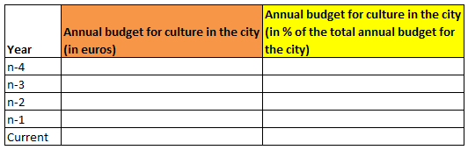

  - In case the city is planning to use funds from its annual budget for culture to finance the European Capital of Culture project, please indicate this amount starting from the year of submission of the bid until the European Capital of Culture year.

  - Which amount of the overall annual budget does the city intend to spend for culture after the European Capital of Culture year (in euros and in % of the overall annual budget)?

- Operating budget for the title year

  - Income to cover operating expenditure:

  - Please explain the overall operating budget (i.e. funds that are specifically set aside to cover operational expenditure). The budget shall cover the preparation phase, the year of the title, the evaluation and provisions for the legacy activities. Please also fill in the table below.

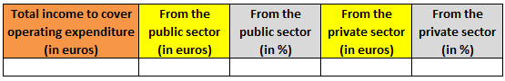

  - Income from the public sector:

  - What is the breakdown of the income to be received from the public sector to cover operating expenditure? Please fill in the table below:
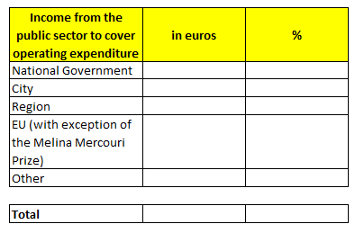

  - Have the public finance authorities (City, Region, State) already voted on or made financial commitments to cover operating expenditure? If not, when will they do so?

  - Income from the private sector:

  - What is the fund-raising strategy to seek support from private sponsors? What is the plan for involving sponsors in the event?

  - Operating expenditure:

  - Please provide a breakdown of the operating expenditure, by filling in the table below.

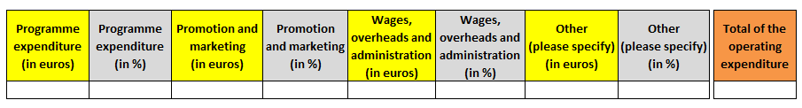

- Budget for capital expenditure :

  - What is the breakdown of the income to be received from the public sector to cover capital expenditure in connection with the title year? Please fill in the table below:

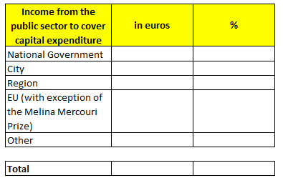

  - Have the public finance authorities (city, region, State) already voted on or made financial commitments to cover capital expenditure? If not, when will they do so?

  - What is your fund raising strategy to seek financial support from Union programmes/funds to cover capital expenditure?

  - If appropriate, please insert a table here that specifies which amounts will be spent for new cultural infrastructure to be used in the framework of the title year.

b) Organisational structure

- Please give an outline of the intended governance and delivery structure for the implementation of the European Capital of Culture year

c) Contingency planning

- What are the main strengths and weaknesses of your project? How are you planning to overcome weaknesses identified?

d) Marketing and communication

- Please provide with an outline of the city’s intended marketing and communication strategy for the European Capital of Culture year.

- How does the city plan to highlight that the European Capital of Culture is an action of the European Union?

- Capacity to deliver

- Please confirm and supply evidence that you have broad and strong political support and a sustainable commitment from the relevant local, regional and national public authorities.

- Please confirm and provide evidence that your city has or will have adequate and viable infrastructure to host the title. To do that, please answer the following questions:

- Explain briefly how the European Capital of Culture will make use of and develop the city's cultural infrastructure.

- What are the city's assets in terms of accessibility (regional, national and international transport)?

- What is the city's absorption capacity in terms of tourists' accommodation?

- In terms of cultural, urban and tourism infrastructure what are the projects (including renovation projects) that your city plan to carry out in connection with the European Capital of Culture action between now and the year of the title?

Selection questionnaire:

Introduction – General considerations

- Has the concept of the programme described for the ECoC year changed between the pre-selection and the selection stage? If yes, please describe the new concept and explain the reasons for the change.

- Contribution to the long-term strategy

- Describe any changes to the cultural strategy since the preselection stage, and the role of the ECOC pre-selection in these changes, if relevant. Indicate specifically which priorities of this strategy the European Capital of Culture action intends to contribute to, and how.

- Have your intentions in terms of long-term impact of the European Capital of Culture action on the city changed since pre-selection? If yes, please describe the changes or further impact foreseen.

- Describe your plans for monitoring and evaluating the impact of the title on your city and for disseminating the results of the evaluation. In particular, the following questions could be considered:

- Who will carry out the evaluation?
- What objectives and milestones will be included in your evaluation plan, between the designation and the year of the title?
- What baseline studies or surveys do you intend to use?
- What sort of information will you track and monitor?
- How will you define "success"?
- Over what time frame and how regularly will the evaluation be carried out?
- How will the results be disseminated?

To get guidance for answering this question, please read the Guidelines established by the European Commission for the cities' own evaluations at the following web address: https://ec.europa.eu/culture/sites/default/files/2021-04/ecoc-guidelines-for-cities-own-evaluations-2020-2033.pdf https://ec.europa.eu/culture/sites/default/files/2021-04/ecoc-guidelines-for-cities-own-evaluations-2020-2033.pdf

- Cultural and artistic content

- Describe in detail the artistic vision and the strategy for the cultural programme of the year outlined at pre-selection stage, explaining any changes brought in since pre-selection.

- Describe the structure of the cultural programme, including the range and diversity of the activities and the main events that will mark the year.

For each one, please provide with information about project partners and estimated budget.

- How will the events and activities that will constitute the cultural programme for the year be chosen?

- How will the cultural programme combine local cultural heritage and traditional art forms with new, innovative and experimental cultural expressions?

- How has the city involved local artists and cultural organisations in the conception and implementation of the cultural programme?

- Please give some concrete examples and name some local artists and cultural organisations with which cooperation is envisaged and specify the type of exchanges in question.

- European dimension

- Elaborate on the scope and quality of the activities:

- Promoting the cultural diversity of Europe, intercultural dialogue and greater mutual understanding between European citizens;

- Highlighting the common aspects of European cultures, heritage and history, as well as European integration and current European themes;

- Featuring European artists, cooperation with operators and cities in different countries, and transnational partnerships.

- Name some European and international artists, operators and cities with which cooperation is envisaged and specify the type of exchanges in question. Name the transnational partnerships your city has already established or plans to establish.

- Can you explain in detail your strategy to attract the interest of a broad European and international public?

- Describe the links developed or to be developed between your cultural programme and the cultural programme of other cities holding the European Capital of Culture title.

- Outreach

- Explain in detail how the local population and your civil society have been involved in the preparation of the application and will participate in the implementation of the year.

- How will the title create in your city new and sustainable opportunities for a wide range of citizens to attend or participate in cultural activities, in particular young people, volunteers and the marginalised and disadvantaged, including minorities? Please also elaborate on the accessibility of these activities to persons with disabilities and the elderly. Specify the relevant parts of the programme planned for these various groups.

- Explain in detail your strategy for audience development, and in particular the link with education and the participation of schools.

- Management

a) Finance

- Operating budget for the title year

  - Income to cover operating expenditure:

  - Please confirm or update the budget figures using the tables below. Explain any differences with regards to pre-selection.

  - Total operating budget (i.e. funds that are specifically set aside to cover operational expenditure)

  - Income from the public sector:

  - What is the breakdown of the income to be received from the public sector to cover operating expenditure? Please fill in the table below:

  - Have the public finance authorities (City, Region, State) already voted on or made financial commitments to cover operating expenditure? If not, when will they do so?

  - What is your fund raising strategy to seek financial support from Union programmes/funds to cover operating expenditure?

  - According to what timetable should the income to cover operating expenditure be received by the city and/or the body responsible for preparing and implementing the ECoC project if the city receives the title of European Capital of Culture?

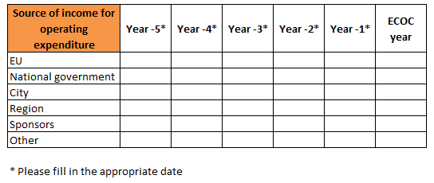

  - Income from the private sector:

  - What is the fund-raising strategy to seek support from private sponsors? What is the plan for involving sponsors in the event?

  - Operating expenditure:

  - Please provide a breakdown of the operating expenditure, by filling in the table below.

  - Planned timetable for spending operating expenditure:
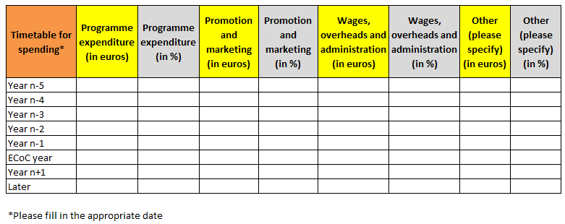

- Budget for capital expenditure :

  - What is the breakdown of the income to be received from the public sector to cover capital expenditure in connection with the title year? Please fill in the table below:

  - Have the public finance authorities (city, region, State) already voted on or made financial commitments to cover capital expenditure? If not, when will they do so?

  - What is your fund raising strategy to seek financial support from Union programmes/funds to cover capital expenditure?

  - According to what timetable should the income to cover capital expenditure be received by the city and/or the body responsible for preparing and implementing the ECoC project if the city receives the title of European Capital of Culture? Please fill in the table below.

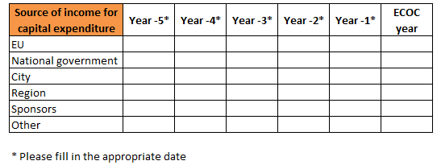

  - If appropriate, please insert a table here that specifies which amounts will be spent for new cultural infrastructure to be used in the framework of the title year.

b) Organisational structure

- What kind of governance and delivery structure is envisaged for the implementation of the European Capital of Culture year?

- How will this structure be organised at management level? Please make clear who will be the person(s) having the final responsibility for global leadership of the project?

- How will you ensure that this structure has the staff with the appropriate skills and experience to plan, manage and deliver the cultural programme for the European Capital of Culture project?

These two questions above could be answered by enclosing in particular diagrams, the statutes of the organisation, its staff numbers and the curricula vitae of those primarily responsible.

- How will you make sure that there is an appropriate cooperation between the local authorities and this structure including the artistic team?

- According to which criteria and under which arrangements have the general director and the artistic director been chosen – or will be chosen? What are – or will be – their respective profiles? When will they take up the appointment? What will be their respective fields of action?

c) Contingency planning

- Have you carried out/planned a risk assessment exercise?

- What are your planned mitigating measures?

d) Marketing and communication

- Could your artistic programme be summed up by a slogan?

- What is the city's intended marketing and communication strategy for the European Capital of Culture year, in particular with regard to the media strategy and the mobilisation of large audiences? This includes the use of digital communication channels.

- Please describe the partnerships planned or established with media with a view to ensuring wide coverage of the event

- How will you mobilise your own citizens as communicators of the year to the outside world?

- How does the city plan to highlight that the European Capital of Culture is an action of the European Union?

- Capacity to deliver

- Please supply evidence of the continuous political support and commitment from the relevant authorities.

- Please detail the state of play of the foreseen infrastructure projects detailed at pre-selection stage, including the planned timetable for the works. Please clarify the links with the European Capital of Culture project.

- Additional information

- Add any further information thatf you deem useful in relation with your application.

