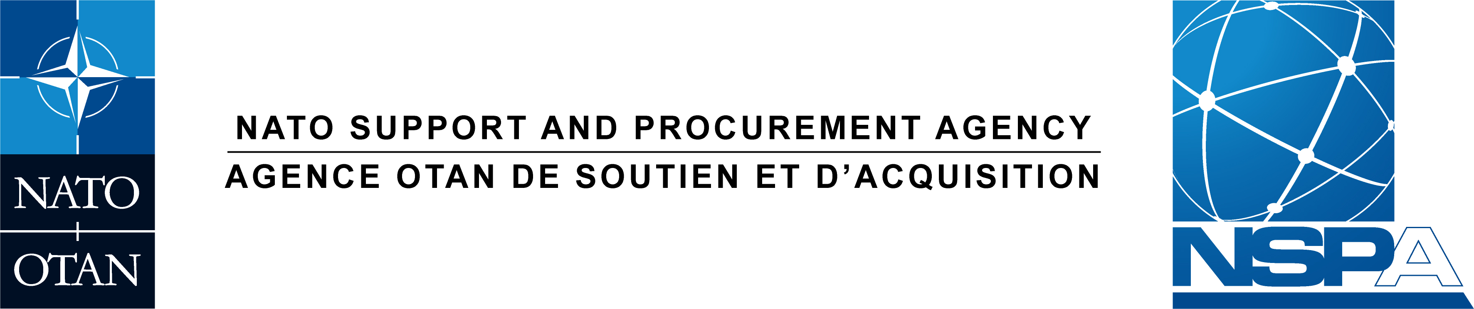

PROCUREMENT DIVISION
DIVISION DES ACHATS

REGISTRATION FORM SLOVAKIA PRE SOLICITATION CONFERENCE

To | : | ALL POTENTIAL BIDDERS
Subject | : | PRE SOLICITATION CONFERENCE - Project 080 - Refurbishment of Air Base Sliac, Slovakia: On-Site Quality Assurance Services
Opportunity ID: | : | TBD

Dear Sir/Madam,

- The NATO Support and Procurement Agency (NSPA) has an upcoming requirement for the implementation of design and build services for the subject project acting on behalf of its customer.
- NSPA is seeking qualified firms with the capability to perform quality assurance services in SLOVAKIA. In order to facilitate this, NSPA will hold a Non-Mandatory Pre Solicitation Conference at the Ministry of Defense in Bratislava, SLOVAKIA on the 19 MARCH 2024.
- The purpose of this Pre Solicitation Conference is to engage with qualified construction companies, to raise awareness of how to do business with NSPA, and provide technical details of the upcoming project. NSPA will give presentations on these topics, followed by a Q&A session.
- IMPORTANT NOTES – Spaces are limited. Companies may propose up to 2 individuals to attend using the registration form below. However due to conference room capacity, we may only allow 1 to attend. Preference will be granted for any companies not having done business with NSPA in the past. For any companies that cannot attend due to capacity limitations, all presentation slides, and materials will be provided at a later date.

- REGISTRATION INSTRUCTIONS:

- Using the registration form below, fill out the details for up to 2 individuals. If there are capacity limitations, Individual 1 will be considered first, and Individual 2 will be optional. Registration must be received by NSPA, No later than 1200 CET, 04 MARCH 2024.

- Confirmation of individual attendance and additional instructions on the event will be sent out by NSPA, No Later Than COB 13 MARCH 2024

- Only those individuals whose attendance has been confirmed will be permitted to attend.

Yours Faithfully,

James MILLER
Senior Procurement Officer

REGISTRATION FORM

Please fill out and return no later than 12:00 CET, 04 MARCH 2024 to
james.miller@nspa.nato.int

Subject: NSPA- SLOVAKIA PRE SOLICITATION CONFERENCE

ATTENDANCE PRE SOLICITATION CONFERENCE

- We intend to attend the Pre Solicitation Conference : YES/NO

- COMPANY NAME:

ADDRESS:

- COMPANY REGISTERED IN NSPA SOURCE FILE? YES/NO

 |  | 1st participant |  | 2nd participant (Optional)
Surname | :
First Name | :
Nationality | :
Company Role
ID NUMBER | :
Telephone | :
Email | :

