***Joint statement of the Ministers responsible for Culture and Audiovisual Affairs on additional measures concerning Russian invasion to Ukraine***

We, the Ministers responsible for culture and audiovisual affairs of the following countries: the Republic of Poland, the Czech Republic, the Republic of Estonia, the Republic of Latvia, the Republic of Lithuania, Romania, the Slovak Republic of and the Republic of Slovenia:

Appalled by the unprovoked attack by the Russian Federation on a sovereign state – Ukraine, a war that main modus operandi are crimes against the civilians and deeply touched by the human tragedy in Ukraine;

Concerned over the threat to European cultural heritage that this conflict entails;

Recalling the appeal of the Ukrainian Minister of Culture and Information Policy, Mr. Oleksandr Tkachenko during the informal meeting of the Council of European Ministers of Culture, that took place on March 7-8, 2022 in Angers (France), and the Declaration of the European Ministers in Charge of Culture, Culture, Audiovisual and Media adopted at that meeting;

United by the history and supporting common democratic values,

Through this Joint Statement expressing our full solidarity with Ukraine and the Ukrainian people and strongly condemning Russia’s aggression

declare as follows:

* we express our readiness to suspend state funded cultural relations with the Russian Federation;
* we express our position, that the Russian Federation should be suspended from international organizations and non-governmental organizations with the world-wide scope, acting in the field of culture, including UNESCO;
* we express our position that the Russian Federation should not hold and chair the 45th session of the UNESCO World Heritage Committee which should be held in Paris or in another member of the Committee instead of;
* we are in favour of preventing the use of digital platforms by the Russian Federation and the Russian state-controlled media, other media engaged in disinformation campaigns against Ukraine, as well as of banning the distribution of Russian and Belarusian state-controlled TV channels and replacing them with the Ukrainian national channels.

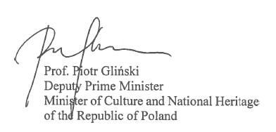

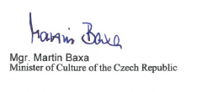

|  |  |
| --- | --- |
| Mr. Tiit Terik  Minister of Culture of the Republic of Estonia | Mr.          Mr. Nauris Puntulis  Minister of Culture of the Republic of Latvia |
| Mr. Simonas Kairys  Minister of Culture of the Republic of Lithuania |  |
|  | Mr. |

