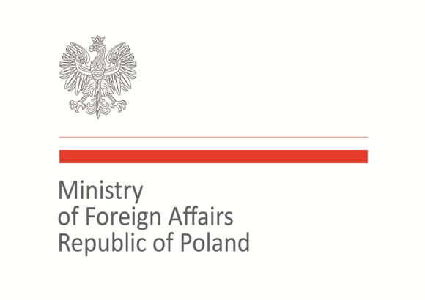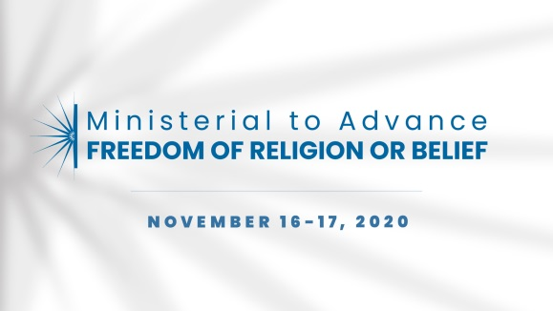

2020 Ministerial to Advance Freedom of Religion or Belief
Warsaw, November 16–17, 2020
Statement of Concern

Statement on the role of literacy on religion and belief

As representatives of the international community, we recognize that the concept of literacy on religion and belief is of utmost importance especially in today’s globalized world which has created a greater exchange between societies of different religions, beliefs and cultures. A lack of such literacy can foster stereotypes, hatred and prejudice and in consequence can lead to the violation of the freedom of religion or beliefs.
Literacy on religion and belief entails knowledge about religions and other belief systems and expressions of religion or belief, recognition of the diversity within different belief traditions, and understanding of contexts that shape religions and other belief systems.
We believe that literacy on religion and belief contributes to better understanding between communities and individuals, mutual respect and tolerance. The central role in enhancing religious literacy should be with local communities and civil society organizations. At the same time, it is important that a broad group of stakeholders is engaged in promoting the importance of literacy on religion and belief, including states, religious actors, non-governmental organizations, youth and the media. In this context, religious literacy should not be limited to education at schools but also include raising awareness in the media and the workplace.

Therefore, we encourage the following initiatives aimed at improving literacy on religion or belief:
- Provision of data concerning literacy on religion or belief;
- Exchanging best practices between countries on promoting the concept of literacy on religion or belief;
- Local communities initiatives on literacy on religion or belief;
- Increased knowledge about religion or belief by the media.

Co-signatories:
Armenia, Australia, Azerbaijan, Bangladesh, Brazil, Georgia, Hungary, Italy, Japan, Jordan, Kazakhstan, Kosovo, Malta, Morocco, North Macedonia, Poland, Slovakia, Togo, Trinidad and Tobago, Ukraine, Uzbekistan, United Kingdom

