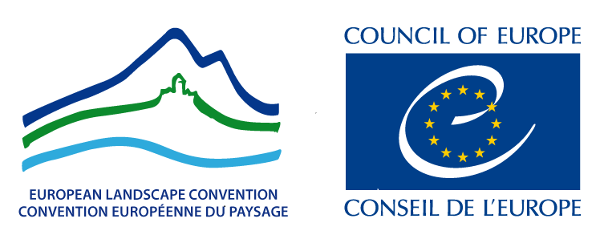
Załącznik Nr 1 do Regulaminu Konkursu na Polską Nagrodę Krajobrazową „Krajobrazowe inspiracje VI”

EUROPEAN LANDSCAPE CONVENTION

LANDSCAPE AWARD OF THE COUNCIL OF EUROPE

2022

APPLICATION FORM

*

I. AN ApplicaNT

- Applicant
Name of the local,
regional authority(ies)
or NGO(s)

Represented by
Ms / Mr

Address:

Telephone:

E-mail:

II. PRESENTATION Of the Projet

- Name of the Project

- Location of the Project

- Summary of the Project (10-12 lines)

- Photo representing the Project (high definition – JPEG 350 dpi) and name of the author of the photo please

- Website of the Project (if exists)

III. CONTENT OF THE PROJECT

- Start of the Project month year
The project must have been
completed at least three years previously

- Partners

- Financing bodies

- Central aims of the Project

- Outcome

IV. RESPECT OF THE CRITERIA OF THE ATTRIBUTION OF THE AWARD

- Sustainable territorial development
Is the project part of a sustainable development policy?
Does it contribute to the enhancement of environmental, social, economic, cultural or aesthetic values of the landscape? How?
Has it successfully countered or posed a remedy to any pre-existing environmental damage or urban blight? How?

- Exemplary value
Can the project be considered of exemplary value? Why?
Which are the good practices that it implemented?

- Public participation
Does the project actively encourage the public’s participation in the decision-making process? How?
Is the project in line with the wider policies implemented by national, regional or local authorities?

- Awareness-raising
Is the project effectively increasing public awareness of the importance of landscape in terms of human development, consolidation of European identity, or individual and collective well-being? How?

V. Additional material

Together with the printed version of the Application form, additional material in digital format should be included in one CD-Rom, DVD or USB key

- Text (20 pages max.): PDF format
- Photos (10 max.): JPEG 350 dpi high definition
- Posters (2 max.): PDF format high definition or JPEG 350 dpi high definition
- Video (15 min max.): mpeg 2 format - It is recommended to present a video (even of amateur quality).

*

