Teatr Powszechny im. Jana Kochanowskiego pl. Jagielloński 15, 26-600 Radom

tel. (+48) 0 48 386 52 86, faks (+48) 0 48 386 52 90

e-mail: [teatr@teatr.radom.pl](mailto:teatr@teatr.radom.pl) • teatr.radom.pl

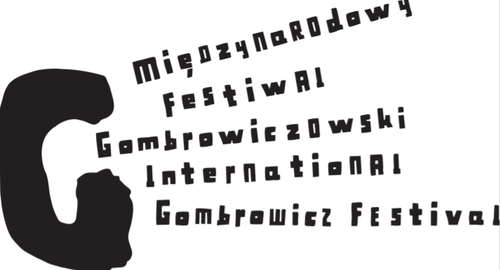

**XV International Gombrowicz Festival**

**From October 8 to 15 at the Jan Kochanowski**

**Powszechny Theatre in Radom!**

**Jan Kochanowski Powszechny Theatre in Radom will host the International Gombrowicz Festival for the 15th time this Saturday. This unique festival which is dedicated to Witold Gombrowicz's works has been held in Radom since 1993.**

This edition of the Festival promises to be really interesting! Between 8-15 October, performances from Poland, Argentina and Japan will be presented on the stage of the Popular Theatre in Radom.

The highlight of the Festival is a competition for the best stage production of Gombrowicz work. Also the Kochanowski Powszechny Theatre has prepared on this occasion an adaptation of "Crime with Premeditation" directed by Blazej Peszek.

In addition to the staging of the Gombrowicz works, fringe events have been planned. These include the opening of works entered in the competition for the most interesting Gombrowicz poster, an exhibition of drawings entitled "Yvonne, Princess of Burgundy" by Radom- based artist Urszula Świerczyńska, a literary debate and meetings with artists and creators.

The broadcast of the play "Ferdydurke", directed by Alina Moś - Kerger on the TVP Kultura channel is among the major events accompanying the festival. This performance inaugurated the 13th MFG in 2018. Thanks to the long efforts of director Malgorzata Potocka, the theatre can boast of success - the play "Ferdydurke" was realized by the Television Theater! To be seen on October 11 at 8 pm on TVP Kultura.

The Kochanowski Theatre will also bring back the play "Dancer," directed by Kinga Debska. The performance was created on the occasion of the 14th edition of the MFG.

The performances will be judged by people who have been active in the theatre world for years - critics, directors, theatrologists. This year it will include Bożena Sawicka - head of the Department of National Cultural Institutions of the Ministry of Culture and National Heritage, cultural expert and theatrical critic, Jacek Wakar - journalist and theatre critic, Tomasz Tyczynski - writer, journalist and head of the Witold Gombrowicz Museum, a branch of the Adam Mickiewicz Museum of Literature, Łukasz Maciejewski - Polish journalist, film expert, film critic, theatre critic, and Lena Frankiewicz - actress, television and theatre director.

Meetings with the creators will take place every day after the presentation of the competition performances in the Festival Club. It will be hosted by Rafal Turowski - journalist of Chillizet radio, theatre reviewer and Robert Utkowski - journalist, writer and associate of the Gombrowicz Museum in Wsola.

Just like two years ago, meetings with artists will be broadcasted online.

The event was carried out thanks to the financial support of the City of Radom

and the Ministry of Culture and National Heritage, as well as the Ministry of Foreign Affairs.

**PROGRAM OF THE 15TH INTERNATIONAL GOMBROWICZ FESTIVAL**

08.10. Saturday

17.00 – large stage

IVONA, PRINCESS OF BURGUNDIA, W. Siemaszkowa Theatre, Rzeszów

Inauguration ceremony of the XV International Gombrowicz Festival

Openning of the XV MFG accompanying exhibitions: the post-competition exhibition of Gombrowicz posters and the exhibition of "Ivona, Princess of Burgundia"

20.00 – large stage

A PREMEDITATED CRIME, Jan Kochanowski Powszechny Theatre in Radom PREMIERE

09.10. Sunday

14.00 – Kotłownia Stage –Fringe Event

literary debate "Is Gombrowicz an inspiration for young writers"

hosted by Michał Pabian

18.00 – large stage

DIARY, Andrzej Seweryn

10.10. Monday

18.00 – large stage

IVONA, PRINCESS OF BURGUNDIA – Ludowy Theatre, Kraków

11.10. Tuesday

18.00 – large stage

TRANS-ATLANTICO, The Ludwik Solski Theatre, Tarnów

12.10. Wednesday

18.00 - Chamber Stage

DANCER- Jan Kochanowski Popular Theatre, Radom

Directed by Kinga Dębska

13.10. Thursday

18.00 – large stage

DIARY – The Tadeusz Boy-Żeleński Bagatela Theatre, Kraków

14.10. Friday

18.00 – large stage

FERDYDURKE – Culitos Theatre, Buenos Aires

20.00 – Kotłownia stage– Fringe Event

STEFAN CZARNECKI'S DIARY – Resursa Theatre, Radom (amateur theatre)

Directed by Robert Stępniewski

15.10. Saturday

17.00 – large stage

DZIENNIKI/DIARY – Jerzy Mączyński, Katarzyna Dębska, Anastasia Valsamaki

Musical performance / as part of the "A universal Gombrowicz without borders" program

19.00 – chamber stage

COSMOS – Simul Theatre, Tokio, Japonia

*Announcement of the jury's verdict and the end of the Festival*

**More information on the fringe events can be found at www.teatr.radom.pl**

