**The National Headquarters of the State Fire Service**

Zdjęcie bramy wejściowej do kompleksu obiektów przy ulicy Podchorążych 38, w tym obiektów Komendy Głównej Państwowej Straży Pożarnej.


**The National Headquarters of the State Fire Service** is located at 38 Podchorazych Street in Warsaw.

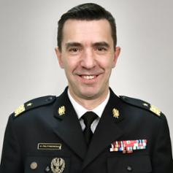

### The head of the National Headquarters of the State Fire Service is Commander-in-Chief Mariusz Feltynowski.

The Commander is assisted by the Deputy Commanders and other firefighters.

**What does the Commander-in-Chief of the State Fire Service do?**

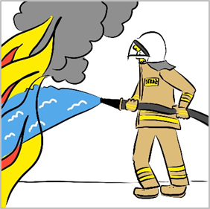

Commander-in-Chief manages the National Firefighting and Rescue System.

Commander-in-Chief is responsible for the training of firefighters in the State Fire Service.

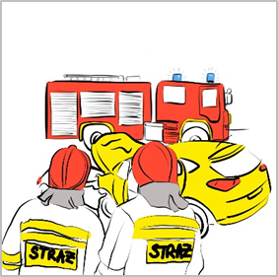

Commander-in-Chief controls the activities of the State Fire Service units.

Commander-in-Chief takes care of fire protection in the country.

**Access to the National Headquarters of the State Fire Service**

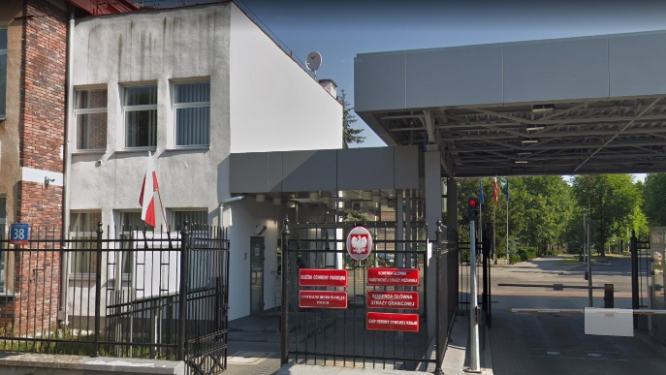The **National Headquarters** buildings are located in a closed area protected by the **State Protection Service**.

Entry and entrance to the National Headquarters of the State Fire Service area is accompanied by a designated employee.



To get to the National Headquarters of the State Fire Service, you must make an appointment in advance.

**Contact**



* **The National Headquarters of the State Fire Service Postal address:**

Podchorazych 38,

PL 00-463 Warsaw

* **Phone:** +48 22 523 39 00
* **E-mail:** kancelaria@kg.straz.gov.pl



**In case of emergency within Poland call**: 112

(assistance in various languages,

no SIM card required).