

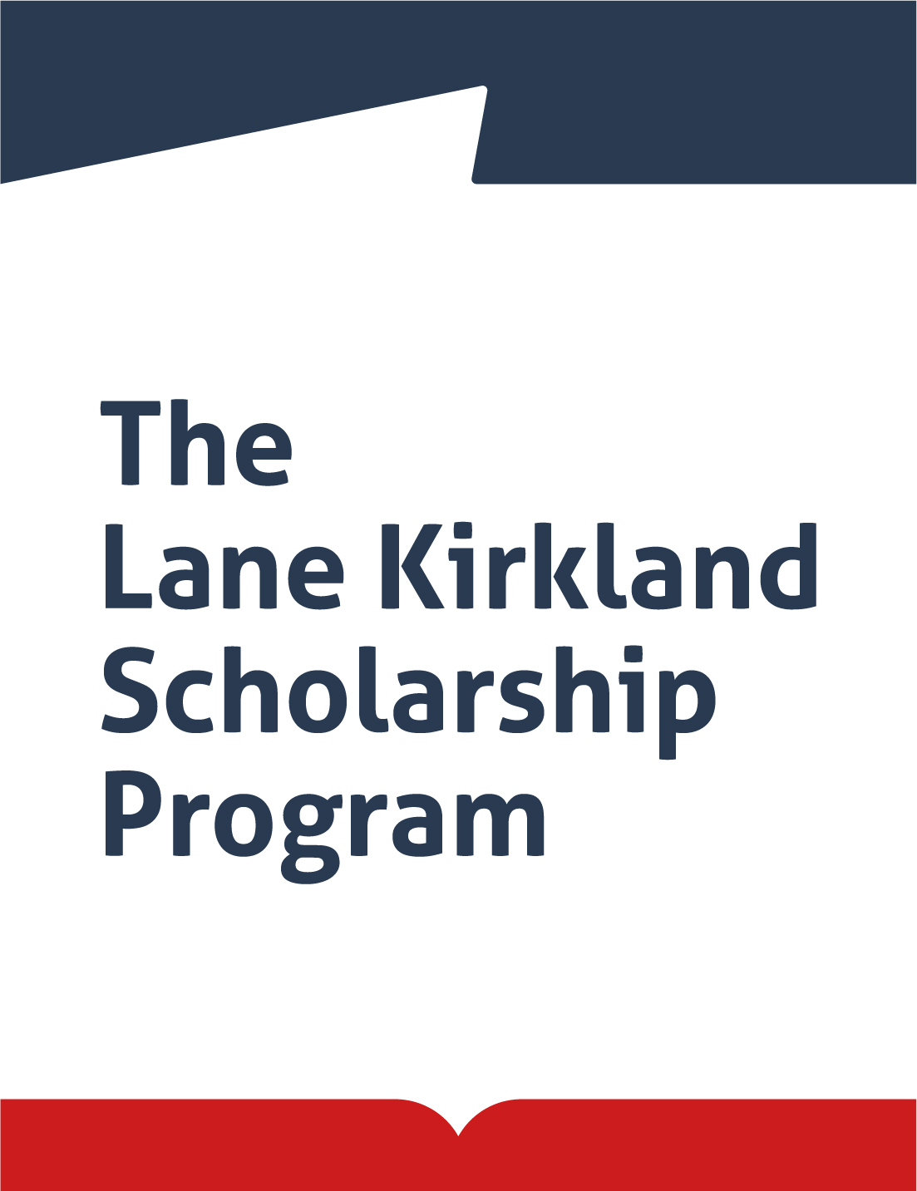

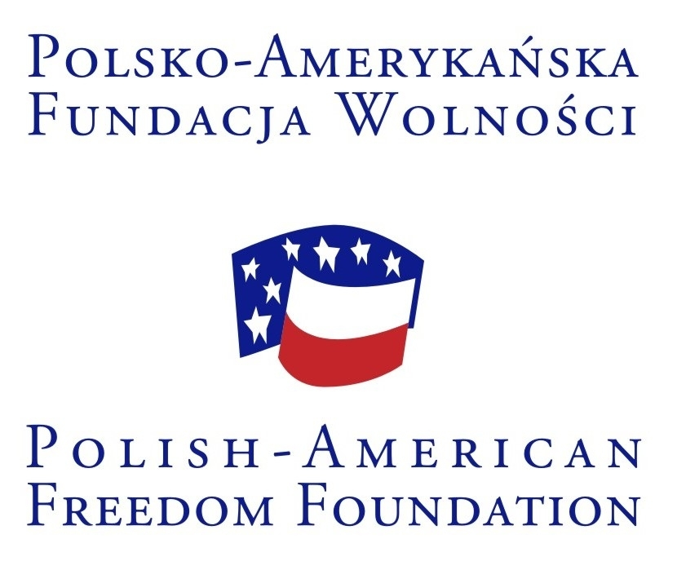

**Leaders of Change Foundation**

announces an open competition for candidates from

**Armenia, Azerbaijan, Belarus, Georgia, Kazakhstan, Kyrgyzstan,   
Moldova, Russia, Tajikistan, Ukraine and Uzbekistan**

for

# THE LANE KIRKLAND SCHOLARSHIPS in Poland in the 2021–2022 academic year

The L. Kirkland Scholarship Program has been supporting individual development of young, ambitious and active citizens of Eastern Europe, South Caucasus and Central Asia for 21 years. Since 2000, almost 900 alumni have taken part in the Program. The group of alumni includes members of government, parliamentarians, managers of large multinational corporations, managers of local government bodies and well-known social activists. The author and founder of the Program is the Polish-American Freedom Foundation. The Program is also financially supported by the Polish National Agency for Academic Exchange (NAWA).

The Program offers two semesters of studies in one of five Polish academic centers (Warsaw, Cracow, Wrocław, Poznań, Lublin) and at least two weeks of professional internship in state, private and non-governmental organizations. The program also offers an extensive training and workshop program.

The program is addressed to young leaders and experts, holding university degrees, interested in the development of democracy, economy and civil society in their countries and the region.

**FIELDS:**

* Economics and Management
* Administration / Management (i.e. business, NGOs, culture, education and healthcare)
* Public Administration (Central and Local Government Administration)
* Law
* Social Sciences (Social Psychology, Sociology)
* Political Science and International Relations
* Environmental and climate protection
* Security and cybersecurity
* Crisis management
* Development Policy and Humanitarian Aid

Candidates who are decided to return to their home country after the end of the scholarship, in order to implement there the project prepared under the scholarship and the knowledge they have gained in Poland, are invited to submit applications.

Detailed rules concerning participation in the Kirkland Program can be found in the Rules and Regulations of the Program.

**FINANCIAL INFORMATION**:

- Free access to university classes and support of academic advisor

- A stipend of PLN 18,000 (paid in 9 installments for 9 months).

In addition, the Program administrator provides the following (worth approx. 4200 PLN/month):

* accommodation during the whole stay in Poland
* health insurance for medical outpatient care, treatment costs in case of emergency and civil liability insurance
* one return ticket to Poland (up to agreed amount)
* public transportation cards;
* visa costs
* research materials
* participation in the introductory course, and grantees conventions,
* polish language course (October-May).

**SCHOLARSHIP PROGRAM:**

* Inauguration of the Program and introductory course (8-10 days, 2nd half of September 2021)
* Classes at universities (two semesters) in leading Polish academic centers, such as Warsaw, Kraków, Poznań, Lublin or Wrocław
* Preparation of two semester papers and one diploma paper
* Three or four conventions of all Kirkland grantees in different cities in Poland
* Professional internship (minimum 2 weeks)
* Personal development trainings and Polish language course (two semesters)
* Graduation ceremony – diplomas (end of June 2022)

The basis for obtaining a diploma of completion of the Program is the preparation and defense of the diploma paper. The diploma paper may be of a scientific or practical nature.

**CANDIDATES:**

The Kirkland scholarships are addressed to individuals who represent the following professional groups:

* civil servants, employees of central and local government institutions
* lawyers
* entrepreneurs,
* managers in business, NGOs, culture, education, environmental protection, healthcare
* leaders of non-governmental organizations, animators in culture and civic activity
* academic teachers
* journalists

**ELIGIBILITY CRITERIA:**

* Citizenship and permanent residence in one of the targeted countries (holders of residence card in Poland, and people living or working in Poland when applying for a scholarship are ineligible)
* Higher education (completed 5-year study)
* Up to 40 years of age
* At least two years of professional experience
* At least two years break from participation in a previous scholarship abroad, longer than 6 months

The Kirkland Program studies may be conducted in Polish or English. Studies in English are not possible for candidates from Belarus and Ukraine. Knowledge of the Polish language facilitates full use of the educational offer at Polish universities and the professional internship. Therefore, candidates from Belarus and Ukraine, as well as other candidates planning to study in Polish, must know Polish at the beginning of the scholarship at a level enabling them to take advantage of academic classes and write their diploma thesis (B2). During the interview, candidates should know Polish at least at B1 level. For candidates with insufficient knowledge of the Polish language, but who have obtained a high score, we allow for the possibility of passing the exam in mid-June 2021. The result of the examination determines the final qualification of the candidate for the scholarship

Candidates from Armenia, Azerbaijan, Georgia, Moldova, Kazakhstan, Kyrgyzstan, Russia, Tajikistan and Uzbekistan planning to study in English are required to indicate a specific educational offer in that language in the above-mentioned five academic centers. These persons are required, during the interview, to speak English at least at B2 level and have the basic knowledge of the Polish language - A1 level. Candidates who pass the qualification in terms of content, but not sufficiently know Polish, have the opportunity to continue learning the language (the Program administrator provides study materials) and pass the language exam organized in the mid-June 2021). The result of the exam determines the final qualification of the candidate for the scholarship.

**PREFERENCES:**

* candidates actively working in their professional and social fields
* candidates who have significant achievements
* candidates who have not yet studied in Poland
* candidates choosing studies in Polish

**SELECTION PROCESS:**

Approximately 45 best candidates will be selected in a 3-stage evaluation process of candidates:

1. Review of applications with regard to eligibility criteria
2. Review of candidates’ proposed projects of study by independent experts
3. Interviews (planned on 29 March-30 April 2021)

The candidates advanced to the third stage will be notified by e-mail by 25 March 2021. Information on the final nominations will be mailed to the candidates in May 2021.

Candidates, who will be selected to participate in the Program on condition that they improve their knowledge of the Polish language, will have the opportunity to pass the language exam organized in mid-June 2021.

**REQUIRED DOCUMENTS:**

1. Application form on-line

* detailed personal questionnaire
* reasons why the candidate wants to participate in the Program; a project of stay containing an outline of the paper to be prepared as a result of the scholarship as well as proposals concerning the implementation of the scholarship and plans to use the knowledge gained in Poland (4000-6000 characters with spaces).

1. Two letters of reference (in Polish, English or Russian), describing the achievements and qualifications of the candidate as well as the expectations connected with the candidate’s further development and work in her/his professional or social field – to be submitted by e-mail. Recommendation letters must not be written by the candidate's family members and/or spouses/life partners.
2. Copy of Master’s degree diploma (or PhD diploma) – to be submitted by e-mail.

**APPLICATION PROCEDURE:**

Description of the program and detailed application instructions can be obtained directly from the following website: [**www.kirkland.edu.pl**](http://www.kirkland.edu.pl)**.** They can also be requested bye-mail from the Program Office.

##### Application forms should be filled out on-line.

##### After the on-line application is submitted, the system will generate an application confirmation document that needs to be printed. The signed page together with the attached current photograph of the candidate should be scanned and sent by e-mail together with two reference letters and a copy of the graduation diploma to the following address: kirkland@kirkland.edu.pl

**APPLICATION DEADLINE**

Application forms and relevant documents should be received by the Program Office no later than:

#### March 1, 2021

**Applications received after the deadline will not be considered.**

**CONTACT:**

**Leaders of Change Foundation**

www.leadersofchange.pl

**L. Kirkland Scholarship Program**

Al. Jerozolimskie 133 m. 56, 02-304 Warsaw, Poland

E-mail: kirkland@kirkland.edu.pl

www.kirkland.edu.pl