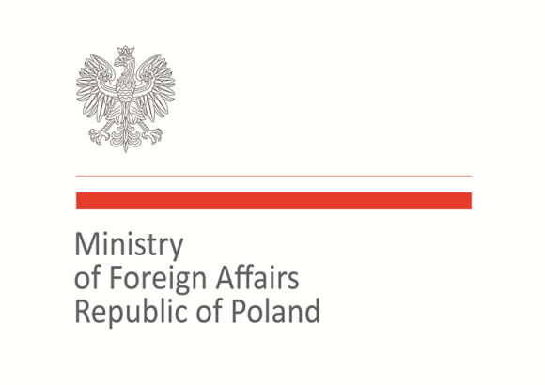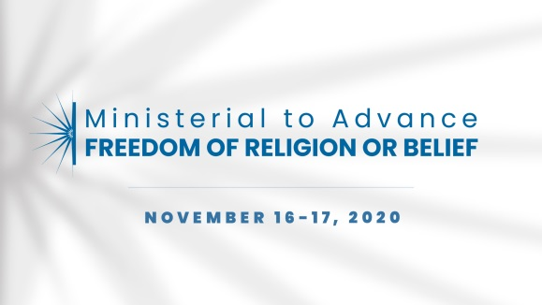

2020 Ministerial to Advance Freedom of Religion or Belief
Warsaw, November 16–17, 2020
Statement of Concern

Statement on protection of minorities persecuted based on religion or belief

As representatives of the international community we strongly condemn all acts of violence based on religion or belief, intimidation and mistreatment of people belonging to religious minority groups wherever and by whomever they are being perpetrated. We stand in solidarity with all victims and survivors of persecutions based or religion or belief. We commit ourselves to fulfilling obligations under the international human rights law to protect the right to freedom of thought, conscience, and religion, which is an inalienable right of every human being.
Alarming reports, as well as testimonies of survivors of violence, indicate that the scale of religious persecutions is on the rise. We are witnessing attacks on innocent people in places of religious worship in different parts of the world. We are concerned that negative stereotyping, stigmatization, hate speech, intolerance and communal violence based on religion or belief has grown in recent years. While the presence of such conditions can constitute early indicators of potential violence and conflict, they also can leave individuals exposed and vulnerable. The effective protection of members of religious minority groups is one of the essential issues for the maintenance of peace and sustainable development.

Therefore, we commit to work collectively to enhance the protection of members of persecuted minority groups by the following actions:
- Promoting: to create a favorable environment for freedom of religion or belief by fostering tolerance and respect for religious and cultural diversity within and among societies;
- Monitoring and reporting: to support data collection on the situation of freedom of religion or belief around the world, including the initiatives dedicated to providing information on this issue, improve the exchange of information about the situation of religious minorities;
- Sharing knowledge: to bring national laws in line with international human rights law protecting the right of religion or belief;
- Defending: collectively and individually reacting to individual cases of persecution using foreign policy tools;
- Supporting: enhancing judicial institutions responsible for prosecution of those responsible for persecution.

Co-signatories:
Australia, Azerbaijan, Brazil, Canada, Croatia, Demark, Georgia, Hungary, Iceland, Italy, Japan, Kazakhstan, Kosovo, Malta, North Macedonia, Norway, Poland, Slovakia, Togo, Trinidad and Tobago, Ukraine, United Kingdom, United States of America

