ANNEX 1
APPLICATION FORM

Selection questionnaire:

Introduction – General considerations

- Has the concept of the programme described for the ECoC year changed between the pre-selection and the selection stage? If yes, please describe the new concept and explain the reasons for the change.

- Contribution to the long-term strategy

- Describe any changes to the cultural strategy since the preselection stage, and the role of the ECOC pre-selection in these changes, if relevant. Indicate specifically which priorities of this strategy the European Capital of Culture action intends to contribute to, and how.

- Have your intentions in terms of long-term impact of the European Capital of Culture action on the city changed since pre-selection? If yes, please describe the changes or further impact foreseen.

- Describe your plans for monitoring and evaluating the impact of the title on your city and for disseminating the results of the evaluation. In particular, the following questions could be considered:

- Who will carry out the evaluation?
- What objectives and milestones will be included in your evaluation plan, between the designation and the year of the title?
- What baseline studies or surveys do you intend to use?
- What sort of information will you track and monitor?
- How will you define "success"?
- Over what time frame and how regularly will the evaluation be carried out?
- How will the results be disseminated?

To get guidance for answering this question, please read the Guidelines established by the European Commission for the cities' own evaluations at the following web address: https://ec.europa.eu/culture/sites/default/files/2021-04/ecoc-guidelines-for-cities-own-evaluations-2020-2033.pdf https://ec.europa.eu/culture/sites/default/files/2021-04/ecoc-guidelines-for-cities-own-evaluations-2020-2033.pdf

- Cultural and artistic content

- Describe in detail the artistic vision and the strategy for the cultural programme of the year outlined at pre-selection stage, explaining any changes brought in since pre-selection.

- Describe the structure of the cultural programme, including the range and diversity of the activities and the main events that will mark the year.

For each one, please provide with information about project partners and estimated budget.

- How will the events and activities that will constitute the cultural programme for the year be chosen?

- How will the cultural programme combine local cultural heritage and traditional art forms with new, innovative and experimental cultural expressions?

- How has the city involved local artists and cultural organisations in the conception and implementation of the cultural programme?

- Please give some concrete examples and name some local artists and cultural organisations with which cooperation is envisaged and specify the type of exchanges in question.

- European dimension

- Elaborate on the scope and quality of the activities:

- Promoting the cultural diversity of Europe, intercultural dialogue and greater mutual understanding between European citizens;

- Highlighting the common aspects of European cultures, heritage and history, as well as European integration and current European themes;

- Featuring European artists, cooperation with operators and cities in different countries, and transnational partnerships.

- Name some European and international artists, operators and cities with which cooperation is envisaged and specify the type of exchanges in question. Name the transnational partnerships your city has already established or plans to establish.

- Can you explain in detail your strategy to attract the interest of a broad European and international public?

- Describe the links developed or to be developed between your cultural programme and the cultural programme of other cities holding the European Capital of Culture title.

- Outreach

- Explain in detail how the local population and your civil society have been involved in the preparation of the application and will participate in the implementation of the year.

- How will the title create in your city new and sustainable opportunities for a wide range of citizens to attend or participate in cultural activities, in particular young people, volunteers and the marginalised and disadvantaged, including minorities? Please also elaborate on the accessibility of these activities to persons with disabilities and the elderly. Specify the relevant parts of the programme planned for these various groups.

- Explain in detail your strategy for audience development, and in particular the link with education and the participation of schools.

- Management

a) Finance

- Operating budget for the title year

  - Income to cover operating expenditure:

  - Please confirm or update the budget figures using the tables below. Explain any differences with regards to pre-selection.

  - Total operating budget (i.e. funds that are specifically set aside to cover operational expenditure)
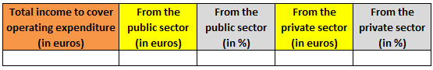

  - Income from the public sector:

  - What is the breakdown of the income to be received from the public sector to cover operating expenditure? Please fill in the table below:
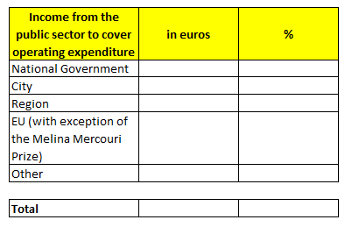

  - Have the public finance authorities (City, Region, State) already voted on or made financial commitments to cover operating expenditure? If not, when will they do so?

  - What is your fund raising strategy to seek financial support from Union programmes/funds to cover operating expenditure?

  - According to what timetable should the income to cover operating expenditure be received by the city and/or the body responsible for preparing and implementing the ECoC project if the city receives the title of European Capital of Culture?

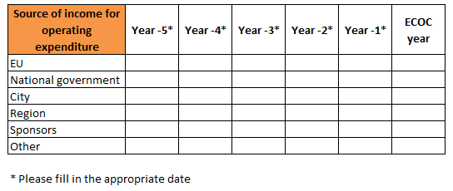

  - Income from the private sector:

  - What is the fund-raising strategy to seek support from private sponsors? What is the plan for involving sponsors in the event?

  - Operating expenditure:

  - Please provide a breakdown of the operating expenditure, by filling in the table below.

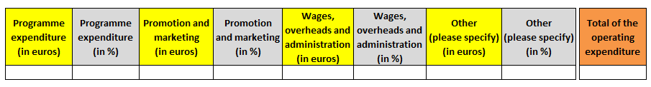

  - Planned timetable for spending operating expenditure:
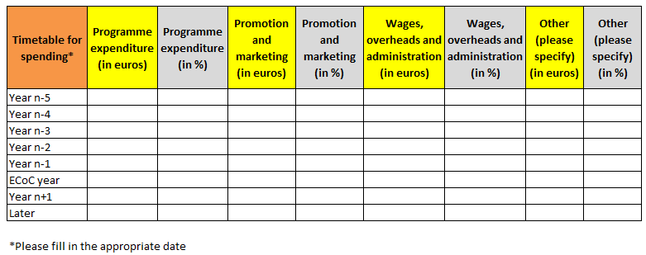

- Budget for capital expenditure :

  - What is the breakdown of the income to be received from the public sector to cover capital expenditure in connection with the title year? Please fill in the table below:

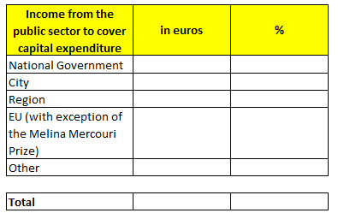

  - Have the public finance authorities (city, region, State) already voted on or made financial commitments to cover capital expenditure? If not, when will they do so?

  - What is your fund raising strategy to seek financial support from Union programmes/funds to cover capital expenditure?

  - According to what timetable should the income to cover capital expenditure be received by the city and/or the body responsible for preparing and implementing the ECoC project if the city receives the title of European Capital of Culture? Please fill in the table below.

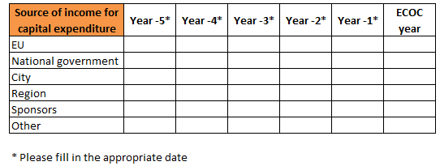

  - If appropriate, please insert a table here that specifies which amounts will be spent for new cultural infrastructure to be used in the framework of the title year.

b) Organisational structure

- What kind of governance and delivery structure is envisaged for the implementation of the European Capital of Culture year?

- How will this structure be organised at management level? Please make clear who will be the person(s) having the final responsibility for global leadership of the project?

- How will you ensure that this structure has the staff with the appropriate skills and experience to plan, manage and deliver the cultural programme for the European Capital of Culture project?

These two questions above could be answered by enclosing in particular diagrams, the statutes of the organisation, its staff numbers and the curricula vitae of those primarily responsible.

- How will you make sure that there is an appropriate cooperation between the local authorities and this structure including the artistic team?

- According to which criteria and under which arrangements have the general director and the artistic director been chosen – or will be chosen? What are – or will be – their respective profiles? When will they take up the appointment? What will be their respective fields of action?

c) Contingency planning

- Have you carried out/planned a risk assessment exercise?

- What are your planned mitigating measures?

d) Marketing and communication

- Could your artistic programme be summed up by a slogan?

- What is the city's intended marketing and communication strategy for the European Capital of Culture year, in particular with regard to the media strategy and the mobilisation of large audiences? This includes the use of digital communication channels.

- Please describe the partnerships planned or established with media with a view to ensuring wide coverage of the event

- How will you mobilise your own citizens as communicators of the year to the outside world?

- How does the city plan to highlight that the European Capital of Culture is an action of the European Union?

- Capacity to deliver

- Please supply evidence of the continuous political support and commitment from the relevant authorities.

- Please detail the state of play of the foreseen infrastructure projects detailed at pre-selection stage, including the planned timetable for the works. Please clarify the links with the European Capital of Culture project.

- Additional information

- Add any further information thatf you deem useful in relation with your application.

